**EPAS REPORT**

To date there are currently 64 students in Cólasite Cholmcille actively engaged with the EPAS programme23/24.

Some of the activities that we have been involved in are:

1. A board with papers on it

   Description automatically generated**September - October 2023** Learning about the European Union – the students have completed work in their Student Workbook in Module 1 and used this along with research online to complete a profile on each of the 27 member states. Thee information on the profile included capital city, location, flag, languages spoken, bordering countries/seas, famous landmarks, famous people, population, popular food, Head of State and National anthem. These were shared with the wider school community when displayed on the EPAS noticeboard.

TY students, coordinated by the MFL department organised a Food Tasting event to celebrate the European Day of Languages on 26/9/23. This event reached out to the entire school community and was enjoyed by many.

1. **November 2023** The European Union and you: How the European Union affects your life – the students have been investigating this module through many of the Online resources available. Some that the students engaged really well with have been:
2. [What Europe does for me - #EUandME (what-europe-does-for-me.eu)](https://what-europe-does-for-me.eu/en/portal) How does Europe impact my life, my education, my region?
3. [www.europa.eu](http://www.europa.eu/) Interactive games
4. <https://youth.europarl.eu>

Active lessons about the European Union – completed Online Quiz about the EU; The EU Member States (match country picture and decoder sheet); EU History and Facts; EU in our Daily Lives (students decide EU or not EU laws); EU values (card game)

1. **December 2023** In the run up to Christmas, we looked at how Christmas is celebrated across the EU member states – they students completed research on Christmas Traditions to include when it is celebrated and how, food associated with Christmas and weather in the country at Christmastime. We prepared signs on how to say Happy Christmas in different languages and this was displayed on the EPAS noticeboard.

Junior Ambassadors appointed and a Microsoft Team set up for the Junior Ambassadors

1. **January 2024** Linking in with the ERASMUS+ project – students have been preparing posters on our Year 1 Values: Dignity, Diversity, Ethics, Inclusion, Performance, Determination, Body, Perfection, Universal, Fair play, Joy, Fraternity. These will be displayed throughout the school during Erasmus Week, Mobility Weeks and Europe Day.

In addition an indoor soccer tournament was organised by the TY students in which each team name was an EU country. The information for this tournament which was organised for 1st and 2nd Year students was displayed on the EPAS noticeboard.

On Tuesday 30th January, the Junior Ambassadors (9 students), together with Senior Ambassador, Mrs C Carroll, took part in a Webinar with the *MEP Ciáran Cuffe*. He was in Brussels and spoke to the students about his role as an MEP in the European Parliament. He outlined to the students the role that the European Parliament has in making new laws, for example the end of roaming charges, consumer rights with regards to faulty electrical equipment together with Erasmus student exchanges – this linked in with Module 2 which the students had been completing in class before Christmas.

Contact was made with the Central Library in Letterkenny which is a *Europe Direct Centre* via the Executive Librarian, Kevin McCaul. He offered to partner with the school providing a wall display and up to date EU Literature, booklets and information about all of the opportunities available for young people to be displayed on the EPAS noticeboard. This was delivered to school 31/1/24.

1. **February 2024**

EPAS monitoring zoom call 23/02/24 with Cathy Ann Fox at 11.55am about progress to date

EPAS students led by the JUNIOR AMBASSADORS heading up making of value posters for the upcoming hosting week/ ERASMUS WEEK/ EUROPE DAY EVENT – covering the following actions:

RESPECT

* DIGNITY
* DIVERSITY
* ETHICS
* INCLUSION

ENGAGE

* PERFORMANCE
* DETERMINATION
* BODY
* PERFECTION

SHARE

* UNIVERSAL
* FAIR PLAY
* JOY
* FRATERNITY

1. March 2024

Erasmus + Visit – students help decorate the noticeboards with posters, handprints and welcome signs

In advance of the Erasmus visit.

Students also helped with the Erasmus students when they were visiting and helped serve the food at the party at the Farewell Erasmus + party.

1. April – May 2024

Prepared Powerpoint for EPAS Awards ceremony and worked on its presentation. Attended Awards Ceremony on Thursday 2nd May 2024 in the Model Arts Centre, Sligo.

A new noticeboard is being prepared to encourage the older students and staff members to vote in the upcoming elections…a countdown to the election is also included.

 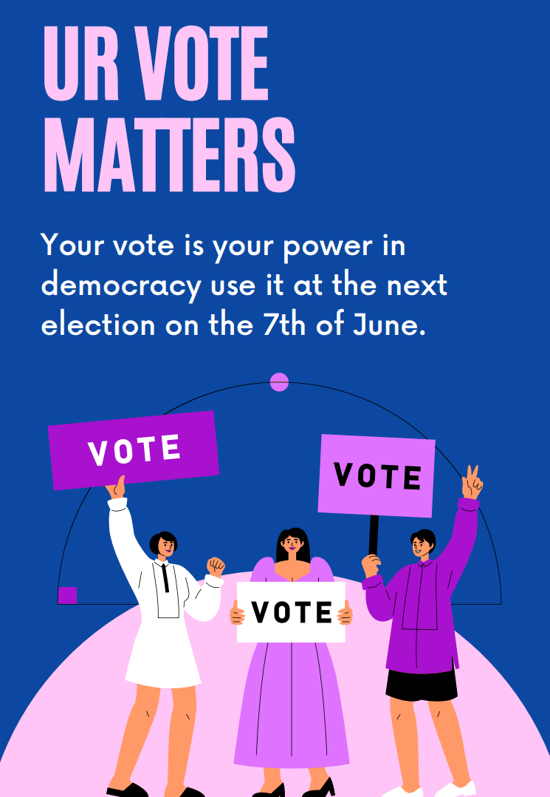  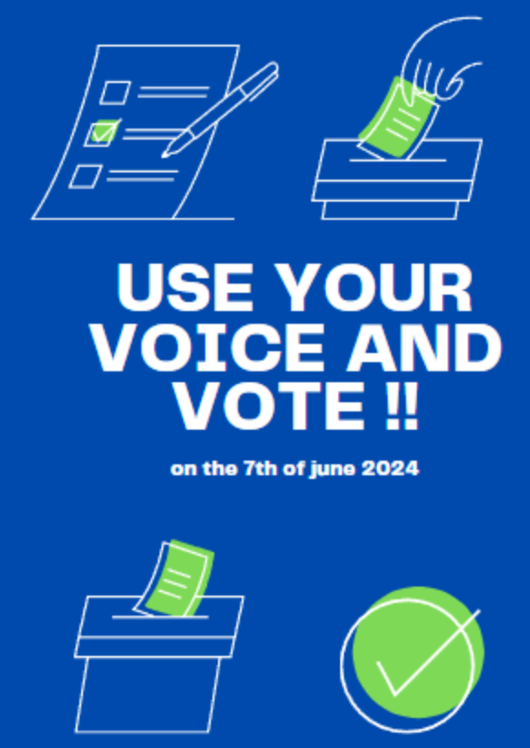

**UPCOMING ACTIVITIES THAT THE EPAS JUNIOR AMBASSADORS WILL SUPPORT**

