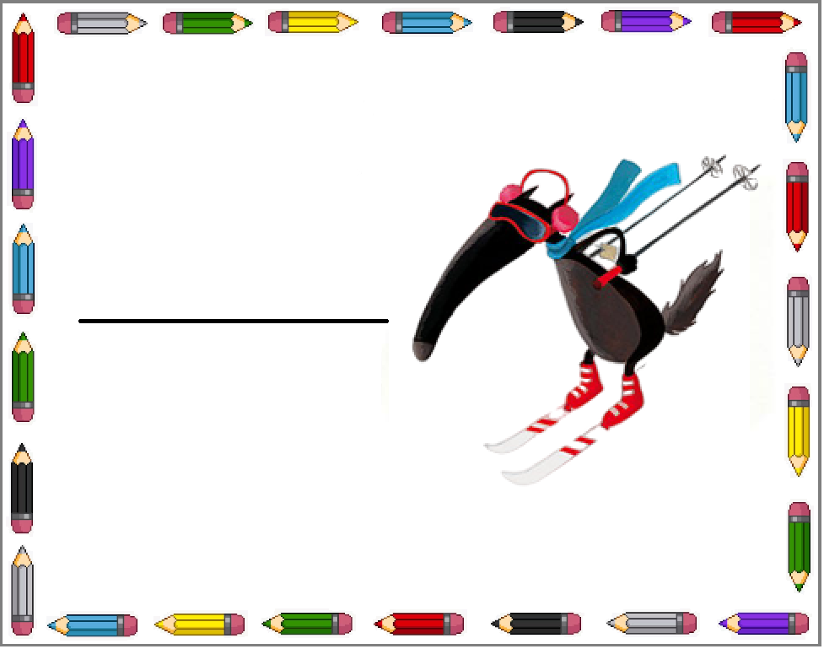   
   
 

Younès

Louis

Nathan

Emma

Imen

Maya