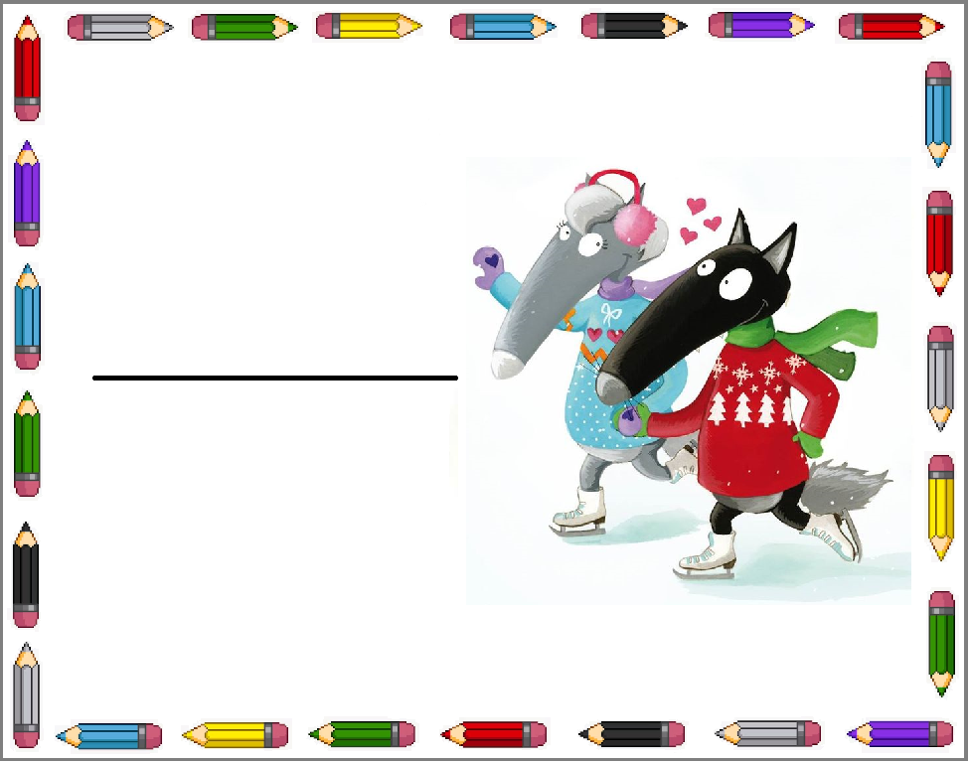   
   
 

Emma

Anaïs

Imen

Maya

Léa

Inaya