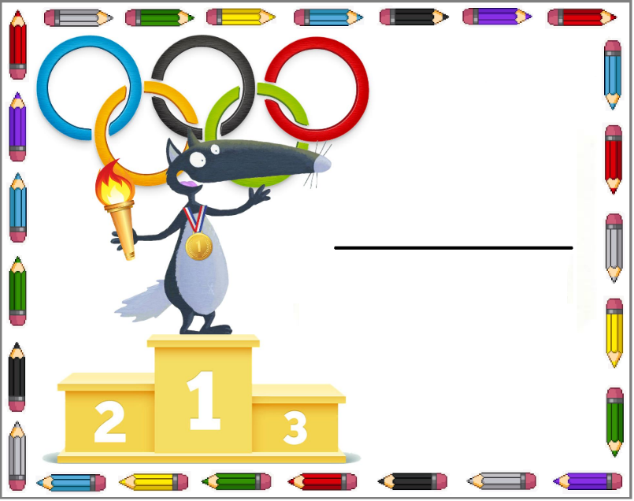   
   
 

Younès

Emma

Imen

Louis

Nathan

Maya