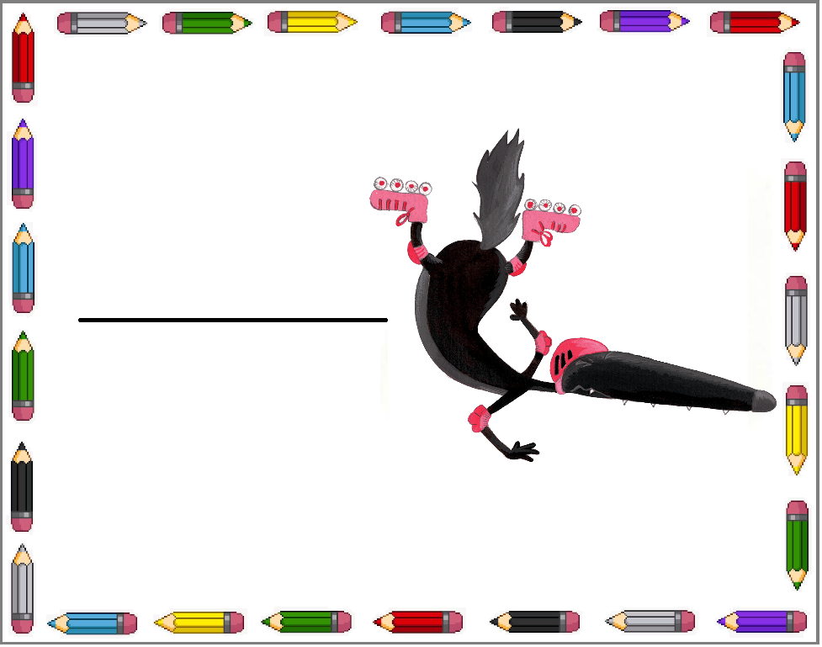   
   
 

Emma

Younès

Imen

Louis

Nathan

Maya