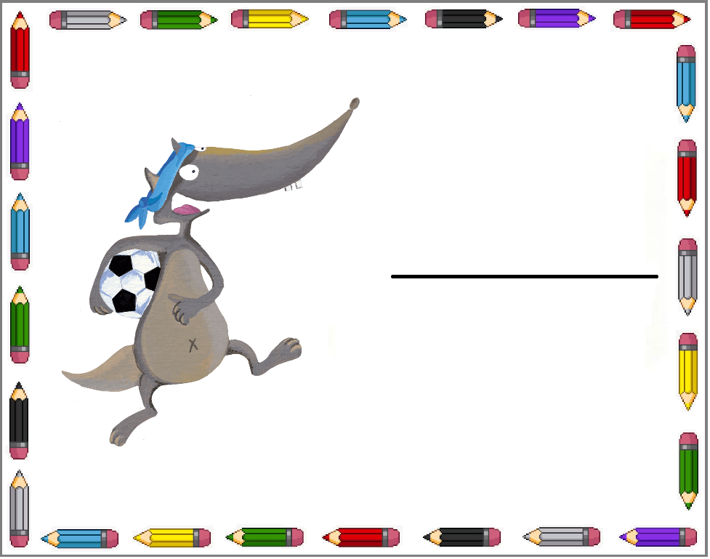   
   
 

Younès

Emma

Louis

Imen

Nathan

Maya