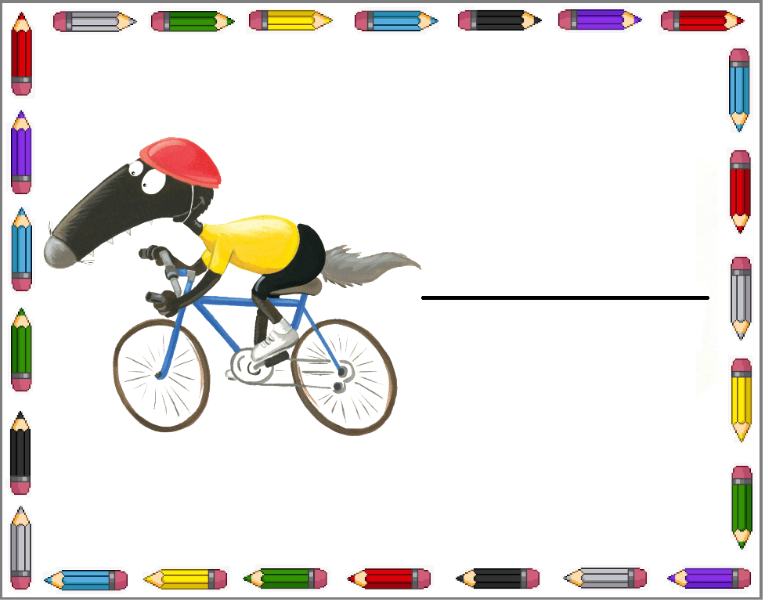   
   
 

Younès

Imen

Nathan

Maya

Emma

Louis