**L’épreuve écrite en anglais au bac, l’exercice d’expression écrite.**

**Ghislain Edzang Essono, Certified EFL Teacher.**

Cet exercice est très redouté par les élèves car ils ne s’y préparent pas depuis leurs premières années d’apprentissage de l’anglais. Le nombre très élevé des candidats qui choisissent l’anglais à l’oral au bac en est la preuve. Quelques astuces pour aider les candidats de LV1 à mieux préparer leur examen écrit, avec à la fin, les mots de liaison pour une meilleure rédaction.

For most second language and foreign language learners, writing can be a very tough activity for learners when they are not well prepared. Here are some tricks followed by activities for teachers and learners, with linking words at the end.

**Level: Advanced Level A1/2/B LV1/LV2**

**The rationale is to familiarize learners with writing activities. They will**

* **Know what writing is**
* **identify different types of writings**
* **know what an essay is**
* **identify different types of essays**
* **define a paragraph**
* **write a paragraph**
* **write an essay**
* **use linking words**

**writing**

**definition:**

Writing is a method of representing language in visual or tactile form.

**What is good writing?**

Good writing is once the reader meets a voice that's distinct, a voice that's individual and acceptable. The reader meets an individual's who shares with him some necessary components of her life experiences, ideas, and thoughts.

Good writing makes the reader feel richer once reading.

Good writing makes the reader wish to read additional.

Good writing generally is brief, generally long.

Good writing uses the correct word. The correct word may be many various words or combos of words. The word selection of excellent writing is restricted and unforgettable.

Good writing reveals a structure or organization that is logical and effective. The order of concepts and also the method the author moves from one plan to succeeding is felt natural.

The sentences are straightforward to grasp.

**essay writing**

### **Types of Essays**

Essays are very personalized. An essay is generally a short piece of writing outlining the writer’s perspective or story. The type of essay will depend on what the writer wants to convey to his reader. There

1. ***Narrative Essays:*** This is when the writer is narrating an incident or story through the essay. So these are in the first person. The aim when writing narrative essays is to involve the reader in them as if they were right there when it was happening. So you must involve the reader in the story.
2. ***Descriptive Essays***: In this type of essay, the writer describes a place, an object, an event or a memory. But it is not just only describing things, the writer must paint a picture through his words.
3. ***Expository Essays:*** Here, the writer presents a balanced study of a topic. To write such an essay, the writer must have real and extensive knowledge about the subject. It is completely based on facts, statistics, examples etc. There are sub-types here like contrast essays, cause and effect essays etc.
4. ***Persuasive Essays***: The object of that essay is to get the reader to your side of the argument. A persuasive essay is not just a presentation of facts but an attempt to convince the reader of the writer’s point of view. Both sides of the argument have to be presented in these essays. But the ultimate aim is to persuade the readers that the writer’s argument carries more weight.

## 

## **Format of an Essay**

Actually there is no rigid format of an essay. It is a creative process so it should not be confined within boundaries. However, there is a basic structure that is generally followed while writing essays. So let us take a look at the general structure of an essay.

### **Introduction**

This is the first paragraph of your essay. This is where the writer introduces his topic for the very first time. You can give a very brief synopsis of your essay in the introductory paragraph. Generally, it is not very *long*.

There is plenty of scopes to get creative in the introduction of essays. This will ensure that you hook the reader, i.e. draw and keep his attention. So to do so you can start with a definition. Another interesting strategy to engage with your reader is to start with a question.

### **Body**

This is the main crux of your essays. The body is the meat of your essay sandwiched between the introduction and the conclusion. So the most vital and important content of the essay will be here. This need not be confined to one paragraph. It can extend to two or more paragraphs according to the content.

Usually, we have a lot of information to provide in the body. And the mistakes writers generally make is to go about it in a manner which leaves the reader confused. So it is important to organize your thoughts and content. Write the information in a systematic flow so that the reader can comprehend. So, for example, you were narrating a football match, the best manner to do this would be to go in a chronological order. (*The city, the stadium, the teams, the beginning, the goals, the scorers, the reaction of the fans, the final score etc.*)

### **Conclusion**

This is the last paragraph of the essay. Sometimes a conclusion will just mirror the introductory paragraph but make sure the words and syntax are different. A conclusion is also a great place to sum up a story or an argument. Make sure you complete your essays with the conclusion, leave no hanging threads.

## **Tips for Essay Writing**

* Keep your language simple and crisp. Unnecessary complicated and difficult words break the flow of the sentence.
* Do not make [grammar mistakes](https://www.toppr.com/bytes/common-grammar-mistakes/), use correct [punctuation and spellings](https://www.toppr.com/guides/business-communication-and-ethics/essential-of-good-english/spelling-and-pronunciation/). If this is not done it will distract the reader from the content
* Before beginning the essay organize your thought and plot a [rough draft](https://www.toppr.com/guides/business-correspondence-and-reporting/meetings/drafting-minutes-of-meeting-atr/). This way you can ensure the story will flow and not be an unorganized mess.

### **How to Write Paragraphs**

In order to write a good paragraph, students need to understand the four essential elements of paragraph writing and how each element contributes to the whole. The four elements essential to good paragraph writing are: **unity, order, coherence,**and **completeness**.

### **What is a paragraph?**

Paragraphs are composed of sentences, but not random sentences. A paragraph is a group of sentences organized around **a central topic**. In fact, the principal rule of paragraph writing is to focus on one idea. A solidly written paragraph takes its readers on a clear path, without detours.

### **How do you write a paragraph?**

A basic paragraph structure usually consists of five sentences: the topic sentence, three supporting sentences, and a concluding sentence.

1. **Element #1: Unity.** Unity in a paragraph begins with **the topic sentence**. Every paragraph has one single, controlling idea that is expressed in its topic sentence, which is typically the first sentence of the paragraph. A paragraph is unified around this main idea, with **the supporting sentences** providing detail and discussion.
2. **Element #2: Order.** Order refers to the way you organize your **supporting sentences**. Whether you choose chronological order, order of importance, or another logical presentation of detail, a solid paragraph always has a definite organization. Order helps the reader grasp your meaning and avoid confusion.
3. **Element #3: Coherence.** Coherence is the quality that makes your writing understandable. Sentences within a paragraph need to connect to each other and work together as a whole. One of the best ways to achieve coherency is to use transition words. These words create bridges from one sentence to the next. You can use transition words that show order (*first, second, third)* or logic (*furthermore, in addition, in fact*).
4. **Element #4: Completeness.** Completeness means a paragraph is well-developed. If all sentences clearly and sufficiently support the main idea, then your paragraph is complete. If there are not enough sentences or enough information to prove your thesis, then the paragraph is incomplete. Usually three supporting sentences, in addition to a topic sentence and concluding sentence, are needed for a paragraph to be complete. The concluding sentence or last sentence of the paragraph should summarize your main idea by reinforcing your topic sentence.

**Writing activities.**

The **topic** is one to two words that explain the subject being discussed.  
The **main idea** is one sentence that tells the big idea for the paragraph.  
**Details** are pieces of information that tell about the main idea.

**Activity: Write a complete sentence.**

1. Write an opinion using the word *politics*. 2 sentences
2. Write a fact using the word *students*. 2 sentences

**Activity: Put the group of sentences in order.**

1. By the river, they began a new colony.
2. They called the colony Jamestown.
3. In America, they sailed up the James River.
4. Then they were in America.
5. The three ships sailed for months

**Activity: Read the paragraph and then select the main idea for the paragraph.**

* The frog sat on the side of the pond. He was very still. His green colour made him hard to see. A bug flew near him. His tongue zipped out, and he gobbled it up. Then the frog was still again. He waited for the next bug.  
  **The main idea in this passage is:**

|  |  |  |
| --- | --- | --- |
| http://www.edhelper.com/clipart/bubblea.jpg |  | Frogs are green. |
| http://www.edhelper.com/clipart/bubbleb.jpg |  | Frogs eat bugs. |
| http://www.edhelper.com/clipart/bubblec.jpg |  | Frogs do not move. |
| http://www.edhelper.com/clipart/bubbled.jpg |  | Frogs live in ponds. |

**Activity: Write the main idea of the paragraph and then underline the details that support the main idea.**

* The frog sat on the side of the pond. He was very still. His green colour made him hard to see. A bug flew near him. His tongue zipped out, and he gobbled it up. Then the frog was still again. He waited for the next bug.  
  **The main idea in this passage is :**

**Activity: Read the paragraph and then write the main idea of the paragraph.**

* It was backward day at school. The students had to do things backward. Some of them wore their T-shirts backward. They took a test before they studied the lesson! Dessert was served first instead of last. They tried to walk home backward, but they bumped into each other and fell down.  
  **The main idea in this passage is:**

|  |  |  |
| --- | --- | --- |
| http://www.edhelper.com/clipart/bubblea.jpg |  | Dessert is supposed to come last. |
| http://www.edhelper.com/clipart/bubbleb.jpg |  | The students had a backward day. |
| http://www.edhelper.com/clipart/bubblec.jpg |  | It is hard to do things backward. |
| http://www.edhelper.com/clipart/bubbled.jpg |  | Students failed their tests. |

**Activity: Read the paragraph and then write the main idea of the paragraph.**

* Nando held the ball in his hands. He bounced it slowly on the ground. Once. Twice. He crouched low and then jumped. The ball flew into the air. Up, up, up, it went. Then down, down, down, into the basket. "Yes!" he yelled. "Nothing but net!"

The main idea in this passage is:

|  |  |  |
| --- | --- | --- |
| http://www.edhelper.com/clipart/bubblea.jpg |  | How to throw a basketball. |
| http://www.edhelper.com/clipart/bubbleb.jpg |  | Nando could jump. |
| http://www.edhelper.com/clipart/bubblec.jpg |  | Nando liked basketball. |
| http://www.edhelper.com/clipart/bubbled.jpg |  | Nando makes a basket. |

**Activity: Read the paragraph and then write the main idea of the paragraph.**

* My favourite dress is yellow. It has a white ribbon that ties in the middle. It has lace by the neck. It also has lace at the bottom. I wore it for my aunt's wedding. I was the flower girl. Mom said I looked as pretty as the bride!  
    
  The main idea in this passage is:

**Activity: Read the paragraph and the main idea for the paragraph. Underline the details that support the main idea.**

* **Main Idea**: A new school is being built.  
  They are building a new school. It is near my house. Every day, I watch the workers. They drive huge tractors. I watch them push a ton of dirt. They have a big crane. It helps them place tall beams. The workers build walls. They are using brick. Every day, it looks more like a school. Mom says I will go there in the fall!
* **Main Idea**: Nando makes a basket.  
  Nando held the ball in his hands. He bounced it slowly on the ground. Once. Twice. He crouched low and then jumped. The ball flew into the air. Up, up, up, it went. Then down, down, down, into the basket. "Yes!" he yelled. "Nothing but net!"

**Activity:** Read the paragraph. **Write the topic, the main idea, and two details that support the main idea.**  
Nando held the ball in his hands. He bounced it slowly on the ground. Once. Twice. He crouched low and then jumped. The ball flew into the air. Up, up, up, it went. Then down, down, down, into the basket. "Yes!" he yelled. "Nothing but net!"

topic (1-2 words):

main idea

detail #1:

detail #2:

* The frog sat on the side of the pond. He was very still. His green color made him hard to see. A bug flew near him. His tongue zipped out, and he gobbled it up. Then the frog was still again. He waited for the next bug.

topic (1-2 words)

main idea

detail #1:

detail #2

**Activity: Write one positive and one negative effect for each cause (when possible). Use your imagination and write complete sentences.**



**Cause:** the man crossed the street without looking at the traffic lights.

Positive effect:

Negative effect:

**Cause:** I ate a lot after class.

Positive effect:

Negative effect:

**Cause:** Ada brushed her teeth.

Positive effect:

Negative effect:

**Cause: The Independence parade will not take place this year.**

Positive effect:

Negative effect:

**Cause:** Shannole slept earlier last Saturday.

Positive effect:

Negative effect:

**Useful Linking Words (Mots de liaison) and Phrases to Use in Your Essays**

Linking words and phrases are used to show relationships between ideas. They can be used to join two or more sentences or clauses. We can use [linking words](https://7esl.com/linking-words/) to **give a result**, **add information**, **summarize**, **give illustrations**, **emphasize a point**, **sequence information**, **compare**or to **contrast idea**.

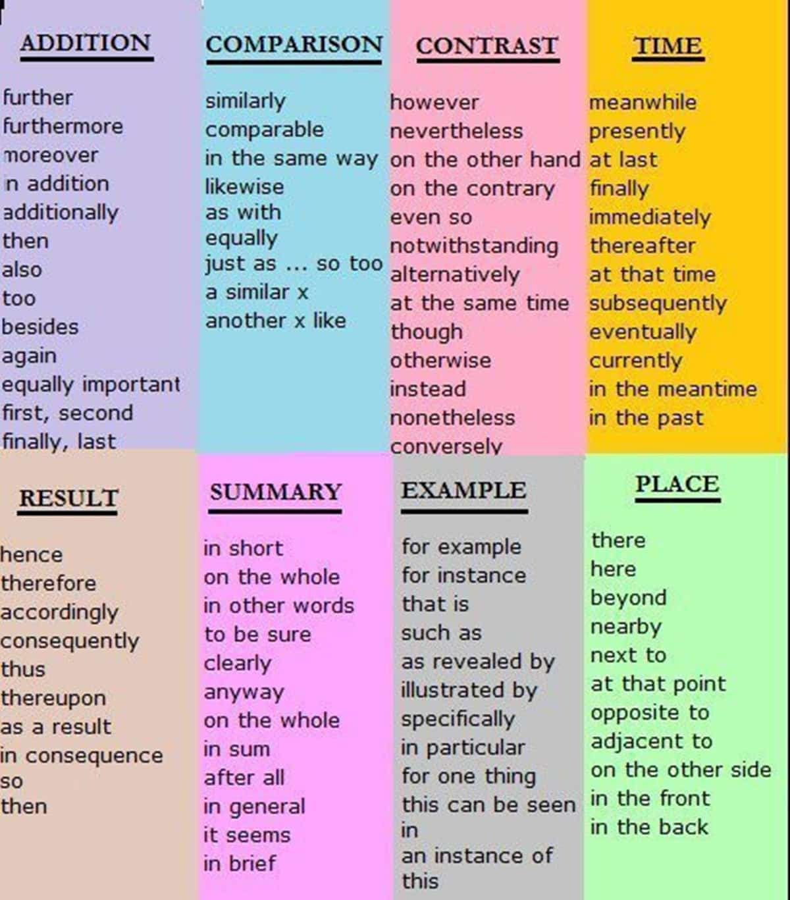

### **Giving a Result**

**Usage**: To provide the result of what has been stated or has occurred

**Linking Words**:

* As a result
* As a consequence
* Therefore
* Thus
* Consequently
* Hence
* For this reason
* Due to

**Examples:**

* His wife left him. ***As a result***, he became very depressed.
* She has lived in France, and ***as a consequence***she speaks French fluently.
* We do not have enough money. ***Therefore*** we cannot afford to buy the new car.
* We do not own the building. ***Thus***, it would be impossible for us to make any major changes to it.
* There has been a great deal of rain and ***consequently*** the reservoirs are full.
* The customer was displeased with her meal, ***hence*** the chef prepared a replacement.
* ***For this reason***, they are not a good choice for exterior use.
* ***Due to*** a broken wing, this bird can’t fly.

### **Adding Information**

**Usage**: To add to what has been previously stated

**Linking Words:**

* Additionally / an additional
* Furthermore
* Also
* Too
* As well as that
* Along with
* Besides
* In addition
* Moreover
* In addition to this
* Apart from this

**Examples:**

* **Additionally**, the bus service will run on Sundays, every two hours.
* He said he had not discussed the matter with her. ***Furthermore***, he had not even contacted her.
* We are unable to repair this watch. ***Also***, this is the fourth time this has happened.
* I love wearing earrings. I design and make them ***too***.
* We went to the park today. ***As well as that***, we did some shopping.
* ***Along with*** parties and parliaments, elections have lost their charm.
* I can’t afford to go to the concert. ***Besides***, I don’t really like classical music.
* You haven’t paid the rent yet.  ***In addition***, you owe me money.
* The report is badly presented. ***Moreover***, it contains inaccuracies.
* John’s grades are terrible because he has been so lazy these days. ***In addition to this***, his relationship to his parents got worse.
* ***Apart from this*** paragraph, the report contains a number of sensible initiatives.

### **Summarizing**

**Usage**: To sump up what has been previously stated

**Linking words**:

* In conclusion
* To summarize
* Altogether
* In short
* To sum up
* In summary
* Briefly
* To conclude

**Examples:**

* **In conclusion**, walking is a cheap, safe, enjoyable and readily available form of exercise.
* ***To summarize***, this is a clever approach to a common problem.
* ***To sum up***, there are three main ways of tackling the problem…
* ***In summary***, this was a disappointing performance.
* ***Briefly***, our team is now one of the best in the world.
* ***To conclude***, I want to wish you all a very happy holiday season.

### **Giving Examples**

**Usage**: To provide examples

**Linking words:**

* For example/ For instance
* Such as
* Including
* Namely
* In this case
* Proof of this
* Like

**Examples:**

* There are many interesting places to visit in Oyem, [***for example***](https://www.eslbuzz.com/30-ways-to-say-for-example/)***/ for instance***, Kwartosh City or the Central Bank
* I prefer to wear casual clothes, ***such as*** jeans and a sweatshirt.
* We need to concentrate on our target audience, ***namely*** secondary school students.
* I also make other jewellery***like*** rings and bracelets.

### **Emphasizing a Point**

**Usage**: To put forward a point or idea more forcefully

**Linking words:**

* Undoubtedly
* Indeed
* Obviously
* Particularly / in particular
* Especially
* Clearly
* Importantly
* Absolutely
* Definitely
* Without a doubt
* Never
* It should be noted
* Unquestionably
* Above all
* Positively

**Examples:**

* **Undoubtedly**, the story itself is one of the main attractions.
* I don’t mind at all.***Indeed***, I would be pleased to leave with you.
* ***Obviously***, we don’t want to spend too much money.
* I love silver earrings, ***in particular*** ones from Mbigou.
* The car is quite small, ***especially*** if you have children.
* ***Clearly***, this will cost a lot more than we realized.
* He’s an ***absolutely*** brilliant cook.
* I ***definitely*** remember sending the letter.
* ***It should be noted*** thatif you have something to note, then note it
* ***Unquestionably***, teaching has been a paramount part of his career.
* ***Above all***, this forest is designed for wear and tear.
* This is ***positively*** the worst thing that I can even imagine.

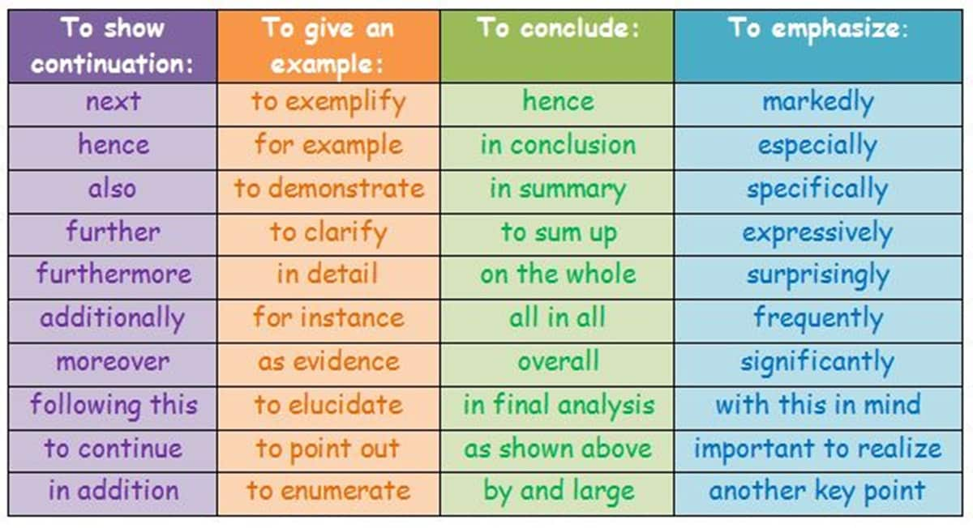

### **Sequencing Ideas**

**Usage**: To indicate the order of what is being said

**Linking words:**

* First/ firstly (Second/ secondly, Third/ thirdly, Finally)
* At this time
* Following
* Previously
* Before
* Subsequently
* Above all
* Lastly and most importantly
* Last but not least
* First and foremost

**Examples:**

* **Firstly**, I prefer traveling by car because I can see the landscape.
* They arrived on Monday evening and we got there the ***following*** day.
* I had visited them three days ***previously***.
* Your name is ***before*** mine on the list.
* ***Subsequently***, new guidelines were issued to all students.
* ***Lastly, and most importantly***, you should be optimistic about your Bac examination this year.

### **Comparing Ideas**

**Usage:**To show how things are similar

**Linking words:**

* Similarly
* Equally
* Likewise
* Just as
* Just like
* Similar to
* Same as
* Compare / compare(d) to(with)
* By the same token
* In the same way
* Correspondingly

**Examples:**

* **Similarly**, the basketball and hockey games draw nearly full attendance.
* ***Equally***, not all customers are honest.
* Her second marriage was ***likewise*** unhappy.
* She’s ***just as***smart as her sister.
* Having a power is not ***the same as***using the power.
* He gets the ball off quickly ***compared to*** two years ago.
* Teenagers should be more respectful;***by the same token***, parents should be more understanding.
* Mr. Edzang enjoys telling jokes; ***in the same way/similarly/likewise***, his students adore funny stories.

### **Contrasting Ideas**

**Usage**: To show how things are different

**Linking words:**

* Unlike
* Nevertheless
* On the other hand
* Nonetheless
* Despite / in spite of
* In contrast (to)
* Alternatively
* Conversely
* Even so
* Differing from
* Contrary to

**Examples:**

* **Unlike** most systems, this one is very easy to install.
* There is little chance that we will succeed in coming to class again. ***Nevertheless***, it is important that we try other means of teaching.
* Laptops are convenient; ***On the other hand***, they can be expensive.
* ***Despite/ In spite of*** the rain, I went to school.
* The agency will make travel arrangements for you. ***Alternatively***, you can organize your own transport.

