Contents

Chapter 1 Overview 1
Chapter 2 Technical arameters 2
2.1 Millivoltmeter 2
2.2 Frequency meter 2
Chapter 3 Introduction to panel 4
3.1 Front panel 4
Chapter 4 User operation guide 6
4.1 Work before measurement 6
4.2 Measurement function setting 6
4.3 Operation guide for voltage measurement 6
4.4 Calculation function 8
4.5 Operation guide for frequency measurement 9
4.6 Precautions 10
Chapter 5 Programming operation guide 11
5.1 SCPI command grammar 11
5.2 Summary of instrument SCPI commands 12
5.3 Detailed explanation of RS232 command 12
5.4 Steps for RS232 use: 13
Chapter 6 Precautions and overhaul 14
6.1 Precautions 14
6.2 Maintenance 14
Chapter 7 Instrument and equipment and accessories 15

Chapter 1

Overview

Brief Introduction to SP1930 Digital AC Millivoltmeter

SP1930 is a kind of universal intelligent digital AC millivoltmeter. The instrument adopts the amplification-detection working principle and the high-grade single chip microcomputer control technology, which is suitable for measuring the RMS voltage of sine wave with frequency 5Hz to 3MHz and voltage of 100uVrms to 400Vrms. The instrument adopts green LED display with clear reading, good vision and long life. Meanwhile, it has the advantages of high measurement accuracy, fast measurement speed, high input impedance, small frequency response error and so on. The whole machine has low power consumption, small size and light weight, is provided with automatic / manual measurement function, and indicates the voltage value, dBV/dBm value, measuring range and channel state. It has clear and intuitive display, is convenient for use, and can be widely used in factories, laboratories, scientific research units, forces and schools. It is the basic instrument necessary for voltage measurement and testing.
The instrument can be equipped with a 5Hz~3MHz frequency meter plug-in; can be used as a 5Hz~3MHz frequency meter, so that the instrument can be dual-purpose.

Chapter 2

Technical arameters

2.1 Millivoltmeter
2.1.1 Frequency range of the measured voltage: 5Hz to 3MHz
2.1.2 Range of the measured voltage: 100uVrms to 400Vrms
dBV measuring range: -80dBV to 52.04dBV (0dBV=1Vrms)
dBm measuring range: -77dBm to 54.25dBm (0dBm=1mW, 600Ω)
2.1.3 There are two functions of automatic measuring range and manual measuring range for voltage
measurement, and manual measuring range can improve the voltage reading resolution.
2.1.4 Voltage measuring range
4mVrms/40mVrms/400mVrms/4Vrms/40Vrms/400Vrms
2.1.5 Voltage measuring error (The minimum value of the measured voltage shall be larger than 2% of the
nominal value of the measuring range, 1kHz as the benchmark at the ambient temperature of 20℃)
100Hz to 100kHz ±2% reading ±8 characters
50Hz to 500kHz ±3% reading ±10 characters
10Hz to 2MHz ±4% reading ±15 characters
5Hz to 3MHz ±6% reading ±20 characters
2.1.6 For the measuring error of dBV and dBm, refer to the voltage measuring error.
2.1.7 Input resistance: 10MΩ
2.1.8 Input capacitance: not larger than 30PF
2.1.9 Noise: 0 character in case of input short circuit
2.1.10 Working environment
2.1.10.1 Operating voltage: 220V±10%, 47Hz to 63Hz
2.1.10.2 Operating temperature: 0℃ to 40℃
2.1.10.3 Humidity: Less than 90%RH
2.1.10.4 Atmospheric pressure: 86KPa to 104 KPa

2.2 Frequency meter
2.2.1 Frequency measuring range: 5Hz to 3MHz
2.2.2 Input characteristics:
2.2.2.1 Minimum input voltage: 10mVrms
2.2.2.2 Maximum allowed input voltage: 400Vrms at the attenuation state, and 4Vrms at the non-attenuation
state.
2.2.2.3 Low-pass filter: to frequency about 100kHz, internal attenuation: ≤3dB, external
attenuation: ≥30dB
2.2.2.4 Attenuator: about 100 times
2.2.2.5 Input impedance: 1M
2.2.2.6 Coupling mode: AC coupling
2.2.2.7 Gate time: 100mS
2.2.2.8 Display digits: 5 digits (Gate=100mS)
2.2.2.9 Measuring error: time-based error ± trigger error (the trigger error is less than 3‰ when the signal-noise ratio is better than 40dB)
2.2.3 Time-based: better than 5×10⁻⁵ (22℃±5℃)
2.3 External dimensions: 210mm×80mm×230mm (W×H×D)
2.4 Weight: 2kg

Chapter 3

Introduction to panel

3.1 Front panel
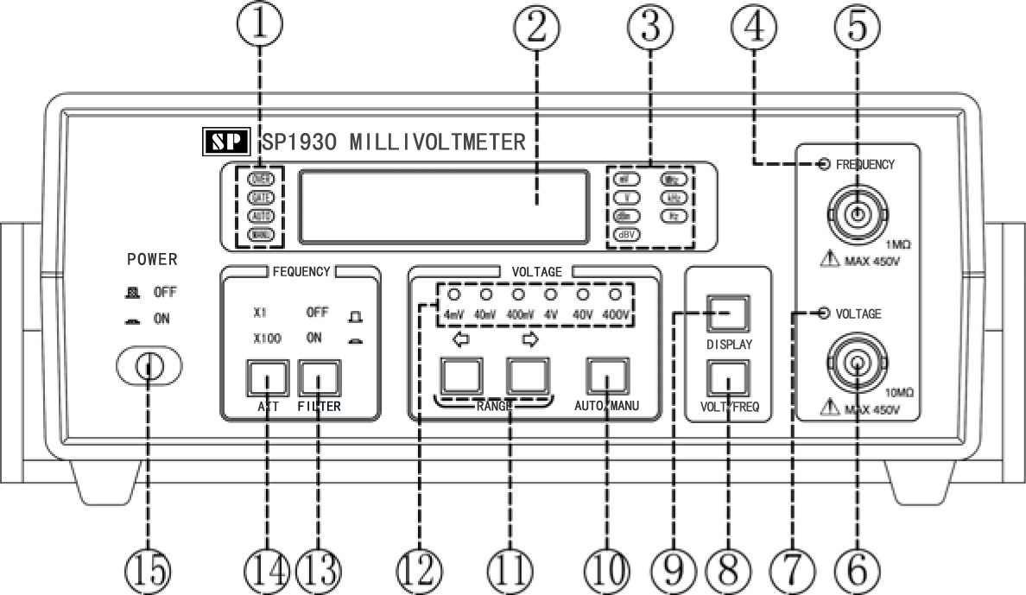

Measuring state indicator lamp [Display] function key
Nixie tube display [automatic / manual] function key
Measuring unit indicator lamp [measuring range] toggle function key
Frequency measuring channel indicator lamp measuring range indicator lamp
Frequency measuring channel “low pass” key
Voltage measuring channel “attenuation” key
Voltage measuring channel indicator lamp “POWER” key, power switch
[Voltage / frequency] function key

3.2 Back panel
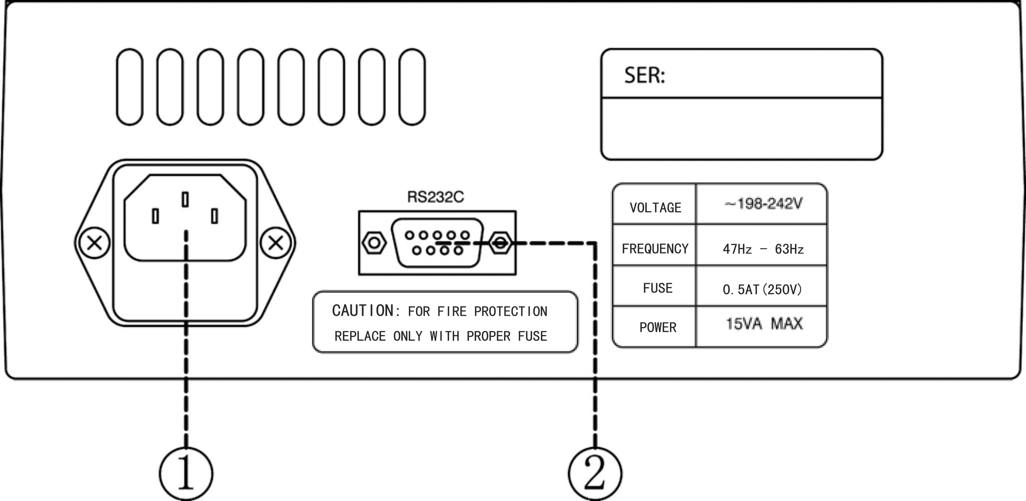

AC power input socket, used for input of 220V power supply.
RS232 universal serial interface, used as the connecting end during RS-232 communication

Chapter 4

User operation guide

4.1 Work before measurement
4.1.1 Preparation before measurement
Carefully check whether the supply voltage is within the range of supply voltage required for the instrument to work, and then insert the power cord into the power socket on the back panel of this instrument after it is confirmed correct.
4.1.2 Instrument startup
Press the power switch, and the instrument enters product prompt and initialization state, and enters the measurement state after initialization. The default measurement state is voltage measurement state.

4.2 Measurement function setting
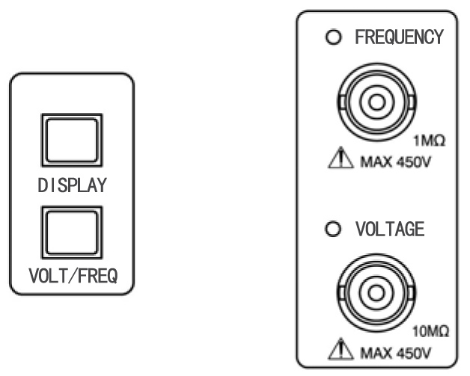

Use the [voltage / frequency] key
The instrument has two functions of voltage measurement and frequency measurement, the default measurement mode is voltage measurement function, and one shall press the [voltage / frequency] key for frequency measurement. Two measurement functions can be freely switched by pressing the [voltage / frequency] key, which are mutually independent and free of interaction.

4.3 Operation guide for voltage measurement
4.3.1 Measurement warning
When measuring the high voltage signal higher than 36V, one must be careful and prudent, and pay attention to safety, so as to avoid personal injuries or damage to the instrument. Some safety measures shall be taken if necessary. For example, wearing the insulating electric-proof gloves, using the insulated cable connecting line and so on; meanwhile, one must guarantee correct and reliable test connection, place this instrument at the suitable gear manually at best, connect the tested component with this instrument, power on, and input the measured signal to the voltage measuring channel of the instrument for test.
4.3.2 Use the voltage measuring channel function menu key
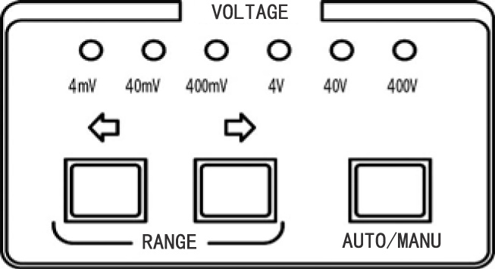

If the current measurement is at the frequency measurement state, press the [voltage / frequency] key to enter the voltage measurement state. At the moment, the voltage measuring channel indicator lamp turns on, representing that the instrument is at the voltage measurement state at present.
4.3.2.1 Use the [automatic / manual] key
Instructions for the measuring range indicator lamp of the voltage measuring channel:
(1) For "4mV" gear indicator lamp, when the current measured voltage is at 4mV gear, the lamp is on;
otherwise, it is off.
(2) For "40mV" gear indicator lamp, when the current measured voltage is at 40mV gear, the lamp is on;
otherwise, it is off.
(3) For "400mV" gear indicator lamp, when the current measured voltage is at 400mV gear, the lamp is on;
otherwise, it is off.
(4) For "4V" gear indicator lamp, when the current measured voltage is at 4V gear, the lamp is on; otherwise, it is off.
(5) For "40V" gear indicator lamp, when the current measured voltage is at 40V gear, the lamp is on; otherwise, it is off.
(6) For "400V" gear indicator lamp, when the current measured voltage is at 400V gear, the lamp is on;
otherwise, it is off.
4.3.2.2 The [automatic / manual] key is used to select the manual measurement and automatic measurement
mode.
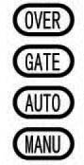

The voltage measurement mode of the instrument is automatic measurement mode at default. At the moment, "AUTO" lamp is on, and the instrument can automatically select the suitable measuring range according to the measured signal. To perform manual measurement, press the [automatic / manual] key at the automatic measurement state to enter the manual measurement mode, and "MANU" lamp is on at the moment.
When the instrument is set as manual measurement mode, the reading can be immediately indicated as long as the measuring range is appropriately selected after the measured signal is added at the input end. However, when the instrument is set as the automatic measurement mode, reading display is slightly lower than that of the manual measurement mode, so as to perform automatic judgment of the measuring range.
4.3.2.3 Use the [measuring range] key
When the instrument is in the manual measurement state, the [measuring range] key is valid, and the user is allowed to freely set the measuring range. [<=] key represents decrease in measuring range, whole [=>] represents increase in measuring range. Note: when the manual measurement mode is adopted, please select the suitable measuring range before the signal is added.
4.3.2.4 Over-range
When the instrument is set as manual measurement mode, the user can set the measuring range according to the instrument prompt. When the measured voltage is higher than 115% of the maximum measured voltage of the current measuring range, the "OVER" lamp flashes, representing over-range. If the voltage display area indicates HHHHH at the moment, it represents too high voltage, and one shall manually switch it to the measuring range higher than the current measuring range.
When the instrument is at 400V gear for measurement, if "OVER" lamp flashes, it represents excessive input signal, which has exceeded the maximum voltage measured by the instrument. The user shall immediately disconnect the input voltage, so as to prevent the instrument from being burnt.
4.3.3 Use the [display] key
4.3.3.1 There are three kinds of voltage measurement display units of the machine: RMS (V or mV), dBm value and dBV value; the default display unit is RMS (V or mV). To display dBm value or dBV value, one can only press the [display] key for switching. each unit is indicated by the corresponding indicator lamp. When it is valid, the corresponding lamp will be on for indication.
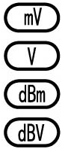

(1) For "mV" indicator lamp, when the current voltage measurement is selected as mV unit for display, the lamp is on; otherwise, it is off.
(2) For "V" indicator lamp, when the current voltage measurement is selected as V unit for display, the lamp is on; otherwise, it is off.
(3) For "dBm" indicator lamp, when the current voltage measurement is selected as dBm unit for display, the lamp is on; otherwise, it is off.
(4) For "dBV" indicator lamp, when the current voltage measurement is selected as dBV unit for display, the lamp is on; otherwise, it is off.
4.3.3.2 At the program-controlled measurement state, press the [display] key to return to the local measurement state.

4.4 Calculation function
dBm and dB measurements are obtained through calculation according to RMS of the input voltage

4.4.1 Calculation of dBm value:
$\text{dBm}=\text{10}×{\text{log}}_{\text{10}}\left(\frac{{{\text{Vin}}^{2}}/{\text{Rref}}}{1\text{mW}}\right)$
Where, Vin is the voltage of input AC signal.
Rref is the reference resistance value set by the user; the reference resistance value Rref set for this instrument =600Ω. Therefore, 0dBm=1mW.
4.4.2 Calculation of dBV value:
$$\text{dBV}=\text{20}×{\text{log}}_{\text{10}}\left(\frac{\text{Vin}}{\text{Vref}}\right)$$
Where, Vin is the voltage value of input AC signal.
Vref is the reference voltage value set by the user; the voltage reference value Vref set for this instrument Vref=1V_{RMS}. Therefore, 0dBV=1V_{RMS}.

4.5 Operation guide for frequency measurement
4.5.1 If the current instrument is at the voltage measurement state, the frequency measurement function can be direct switched to by pressing the [voltage / frequency] key. At the moment, the frequency channel indicator lamp turns on, representing that the instrument is at the frequency measurement state at present.
4.5.2 When the instrument is at the frequency measurement function, related keys of the voltage measurement
does not work.
4.5.3 When the instrument is at the frequency measurement function, there is only automatic measurement
mode, and "GATE" flashes at the moment.
4.5.4 Frequency measurement display
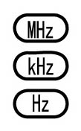
There are three kinds of frequency measurement display units of the machine: Hz, KHz and MHz. The instrument automatically selects the display unit according to the measurement results, and each kind of unit is indicated by the corresponding indicator lamp. When it is valid, the corresponding lamp will be on for indication.

For "MHz" indicator lamp, when the current frequency measurement is selected as MHz unit for display, the lamp is on; otherwise, it is off.
For "KHz" indicator lamp, when the current frequency measurement is selected as KHz unit for display, the lamp is on; otherwise, it is off.
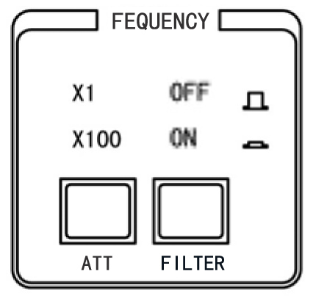
For "Hz" indicator lamp, when the current frequency measurement is selected as Hz unit for display, the lamp is on; otherwise, it is off.
4.5.5 Use the [attenuation] and [low pass] keys

4.5.5.1 Use the [attenuation] key
During measurement of the substantial signal, if the measured voltage is higher than 3Vrms, one must press the "attenuation" key. Especially during measurement of over 36V high-voltage signal frequency, one shall be more careful and prudent. Press the "attenuation" key, turn on the attenuator (i.e., select attenuation X100 gear), i.e., attenuate the signal by about 100 times, and then input the measured signal to the frequency input channel of the instrument for measurement, so as to avoid instrument burning or personal injuries.
4.5.5.2 Use the [low pass] key
During measurement of low frequency, when the measured frequency is lower than 100KHz, press the [low pass] key, turn on the low-pass filter, and measurement accuracy can be improved.

4.6 Precautions
4.6.1 The instrument shall be placed at the dry and ventilated place, maintained clean, and covered with the plastic sheath when
unused for a long term.
4.6.2 The supply voltage used for the instrument is 220V, 50Hz, which shall not be too high or too low.
4.6.3 One shall be careful and prudent during measurement of voltage and frequency of the high-voltage signal, and pay attention to input the signal from the correct input channel and correct measurement settings (such as measurement gear settings, state setting and so on). In addition, during measurement of frequency of the high-voltage signal, one must manually press the "attenuation" key, and set the instrument at the measurement state of attenuation by 100 times.
4.6.4 The ground of this instrument is connected with the ground through the ground of the power socket. To measure the isolated ground voltage signal or suspended voltage signal, one shall pay attention to disconnect the ground of the power cord of the instrument from the ground, and adopt the two-wire access method to connect the supply voltage to the instrument before measurement. Otherwise, measurement is incorrect.
4.6.5 During use of the instrument, do not input the over-range voltage for a long term.
4.6.6 During automatic measurement of the instrument, transient over-range will appear during switching of the measuring range. At the moment, the reading can be stable as long as the input voltage does not exceed the measuring range.
4.6.7 This instrument belongs to the measuring instrument, and the laypeople shall not be subject to disassembly, repair or correction, so as to avoid influence on measurement accuracy.

Chapter 5

Programming

operation guide

5.1 SCPI command grammar
The programmable command of the millivoltmeter is compatible with SCPI language of standard command of the programmable instrument, and the representation way of the programmable command is also consistent with SCPI language.
5.1.1 Meaning of some SCPI command symbols
[ ] The character in the brackets is optional.
< > Command parameter
{ON|OFF} represents either of them, ON or OFF.
RANGe represents that the command can only be the part with the uppercase characters, and can also be the complete characters. For example: the following writing methods of RANGe command symbol are correct, RANG or RANGE. Both uppercase and lowercase for command are acceptable, and both rang and RANG are correct commands.
5.1.2 Instrument SCPI command
SCPI command includes setting query of all functions, and the tree-like hierarchical command structure is adopted. The sub-keyword and the higher-level keyword are connected with ":". For example RANGe: AUTO?, RANGe: AUTO? are connected with ":", representing that AUTO? is the next-level keyword of RANGe.
The general SCPI command includes the query command, and the command added with "?" is the query command of the command. For example, RANGe:AUTO <Boolean> is to set automatic gear shift of voltage measurement, while RANGe:AUTO? is to inquire whether automatic gear shift is turned on. However, there is no query command for some setting commands, and some commands only have query command.
5.1.3 Command parameter
The command parameter and the command keyword are separated with blank space, the parameter value and the unit are separated with blank space, and two parameters are separated with comma.
5.1.4 Command terminator
The programmable command takes the line break (ASCII symbol 10, hexadecimal system 0x0AH) as the terminator. The information returned from the instrument also takes the line break as the terminator.
5.1.5 Example of command writing format
The correct command is as follows
calc:func max
calculate:function maximum
The incorrect command is as follows
calcu:func max (calcu includes the lowercase character in the command keyword CALCulate, but is not the whole of the command keyword. If the lowercase part of the command keyword is included in the command, the complete command keyword must be written)
calc:fun max (fun is not the abbreviation of the command keyword FUNCtion, or its complete writing)

5.2 Summary of instrument SCPI commands
Command | Parameter form | Description
*IDN? |  | Only the query command, return the instrument model
*RST |  | No query command, reset the instrument to the initial state
RANGe  :AUTO | {4mV|40mV|400mV|4V|40V|400V }  {<ON|OFF>} | Set the measuring range  Set the automatic measuring range
CALCulate  :UNIT | {dBm|VRMS|dB|mVRMS} | Set the calculation unit
READ? |  | Only the query command, return the current measurement results
CHANnel | {VOLTage|FREQuency} | Set and inquire measurement channel

5.3 Detailed explanation of RS232 command
Instructions for configuration parameters of RS232 of this instrument: COM communication port can be selected at discretion (COM1 at default). The baud rate is fixed as 9600, and the check bit is fixed as the non-parity 8-digit data bit.
Notice: when other testing software are used or the user compiles the communication software, 0X0A character shall be added behind the command provided by the machine.
5.3.1 *IDN?
The command only has the query command to inquire the instrument identification code.
Query return:
SHENGPU SP1930 DIGITAL AC MILLIVOLTMETER
5.3.2 *RST
Reset command, set the instrument to the initial state.
The command has no query command.
5.3.3 RANGe subcommand system
5.3.3.1 RANGe?
Inquire the measuring range of the instrument.
Query return: 4mV|40mV|400mV|4V|40V|400V.
5.3.3.2 RANGe {4mV|40mV|400mV|4V|40V|400V}
Set the measuring range of the instrument during manual measurement.
Return: SET OK!
5.3.3.3 RANGe:AUTO？
Inquire the automatic measuring range of the instrument.
Query return:
1. Automatic measuring range: AUTO ON
2. Manual measuring range: AUTO OFF
5.3.3.4 RANGe:AUTO {<ON|OFF>}
Set the automatic measuring range of the instrument.
Parameter range: ON or OFF.
Return: SET OK!
5.3.4 CALCulate subcommand system
5.3.4.1 CALCulate:UNIT {dBm|VRMS|dB|mVRMS}
5.3.4.1.1 CALCulate:UNIT?
Inquire the unit used for calculation function of the instrument.
Query return: dBm, VRMS, mVRMS, dB.
5.3.4.1.2 CALCulate:UNIT {dBm|VRMS|dB|mVRMS}
Set the unit used for calculation function of the instrument.
Return: SET OK!
5.3.5 READ?
Only query command. Inquire the measurement results of the instrument
Query return:
1. Voltage measurement: return the actual measured value of the voltage.
2. Frequency measurement: return the actual measured value of the frequency.
5.3.6 CHANnel {VOLTage|FREQuency}
5.3.6.1 CHAN?
Inquire the measurement channel of the instrument.
Query return: CHANNEL VOLT|FREQ
5.3.6.2 CHANnel {VOLTage|FREQuency}
Set the measurement channel of the instrument.
Return: SET OK!
5.3.7 Error return
Return COMMAND ERROR when the command error is sent.
5.3.8 Return local
At the program-controlled measurement state, press the [display] key to return to the local measurement state.

5.4 Steps for RS232 use:
5.4.1 Install RS232 communication measurement program on the computer.
5.4.2 Connect SP1930 and the computer with RS232 communication cable.
5.4.3 Open RS232 communication software, and enter the correct command in the command column of the communication software interface for instrument control and data reading.

Chapter 6 Precautions and overhaul

6.1 Precautions
· The instrument adopts the large-scale CMOS integrated circuit and high-speed TTL circuit. In order to prevent accidental damage, do not use the electric soldering iron with two-core power cord during repair. The shell of the testing instrument or other equipment shall be well grounded.
· Strictly prohibit live operation during repair and welding. As long as the power cord is inserted into the instrument, the power components start work, and the power cord of the instrument must be unplugged during welding.
· Eliminate the external failure and intuitive failure during repair, such as open circuit, short circuit or improper parameter setting. Secondly, measure whether the various of various groups in the machine is normal. When the voltage of various groups is normal, check whether the static work point of the circuit with failure is normal, and whether there is any false welding. The integrated circuit shall be eliminated after prudent judgment.
· The oscillograph probe or the universal meter pen shall contact the test point during overhaul. Do not touch various adjacent points, and prevent failure expansion.
· If the failure cause cannot be determined, please timely contact the authorized repair point of the company, so as to timely eliminate the failure.

6.2 Maintenance
6.2.1 If the instrument has no display after startup, one shall check whether there is any power supply, or unplug the power cord and check whether the fuse in the power socket has been burnt.
6.2.2 If the power supply and the fuse are in good conditions, but the failure is not removed, one can open the cover, and check the socket connector and the connecting cable in the machine for shedding and looseness. If any, they shall be well connected before power-on and measurement.

Chapter 7

Instrument and equipment

and accessories
7.1 Standard configuration

Host of SP1930 digital AC millivoltmeter 1
Power cord 1
Operation instructions 1
Test cable Q9-Q9 1
RS232 interface 1
Installation CD of the communication interface 1
RS-232 communication cable 1
0.5A/220V fuse (installed in the socket) 2

7.2 Optional configuration

 Frequency meter 1
Test cable Q9-Q9 1

Nanjing SHENGPU Instrument Technologies Co., Ltd. reserves the right to change the hardware and software mentioned in the manual at any time without prior statement.

