**Is Gascony the Most Delicious Corner of France?**

Even a week or so spent eating and drinking your way around this rural area of southwestern France is enough to spark a lifelong love affair.

Vineyards striped with other cultivated crops are common in Gascony, “the other South of France.”Credit...Andy Haslam for The New York Times

By David McAninch

March 15, 2017

*This week, we roam France, sampling three regional cuisines: the richness of Gascony (below),* [*the earthy pleasures of Médoc*](https://www.nytimes.com/2017/03/14/travel/medoc-france-fine-wines-country-cooking.html)*, and* [*the new vibrancy of Bordeaux*](https://www.nytimes.com/2017/03/15/travel/food-and-wine-in-bordeaux-france.html)*. Also check out the Food section’s* [*guide to French cooking*](https://cooking.nytimes.com/new-essentials-french-cooking) *and our survey of* [*five classic specialties*](https://www.nytimes.com/2014/05/25/travel/tasting-france-through-5-signature-dishes.html)*, from bouillabaisse to galettes.*

Look closely at a map of southwestern France and you’ll notice it: a blank spot just west of Toulouse where the place names thin out and the train lines and expressways veer away, like a stream flowing around a boulder. That blank spot is Gascony, one of the most rural regions in all of France. Gascons are for the most part proud of their provinciality, and many of them have developed the curious habit of describing their bucolic land in terms of all the things it doesn’t have: big cities, mass tourism, traffic, urban stress, high-speed rail service, autoroutes, soaring real estate prices, hordes of Parisians snapping up summer homes and so on. I spent most of a year there to gather material for a culinary memoir and can confirm the absence of all those things.

One sometimes hears Gascony referred to as “the other South of France” by boosterish types mindful of the immense popularity of Provence and the Côte d’Azur, which lie some 250 miles to the east. And to be sure, if you plant yourself on a restaurant “terrasse” on the main square of Auch (pronounced OWE-sh) — Gascony’s historical capital — in, say, late September, you might easily convince yourself you’re in Mediterranean France, what with the date palms and the nice-looking people in sunglasses sipping rosé and talking in the bouncy accent of the Midi.

But then your meal arrives, and the illusion vanishes faster than a cold pastis on a hot day. For Gascon food is richer than the sunny cuisine of Provence. It is unabashedly, defiantly rich. Duck fat, not olive oil, is the local currency. Everything gets cooked in it: potatoes, sausages, eggs, and — in the case of confit, that pillar of Gascon farmhouse cooking — duck itself. Gascons consume foie gras, which is made on family farms all over the region, with casual regularity, and consider the delicacy about as decadent as a pork chop.

For those needing further convincing that they’re not in [Peter Mayle’s South of France](http://www.nytimes.com/1991/06/09/books/a-little-truck-stop-in-the-south-of-france.html), I will suggest simply sticking around Auch for a few more of those autumn days. It would eventually start to rain. And if you hop in the car, the traffic will disappear and you will find yourself in a decidedly un-Mediterranean landscape: undulating fields of corn and rapeseed, vineyard parcels intercut with lush grazing pastures, hedgerows of broom and honeysuckle, tidy groves of oak and hemlock, emptied-out villages and, around almost every curve, signs advertising farm-made foie gras and duck confit. Eventually you will probably get stuck behind a tractor.

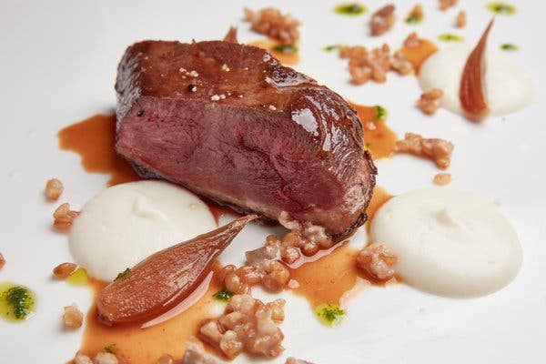

Duck breast is paired with fig and spelt at the Hôtel de France in Auch.Credit...Andy Haslam for The New York Times

Gascony is not merely distinct from Provence and the Côte d’Azur. It is, in my estimation, better. Gascony is more open, more soulful, more deeply French, and, in its un-self-conscious devotion to tradition, more pleasurably frozen in time. Its cuisine is arguably less sophisticated than Provence’s, and yet it is more firmly rooted in the land it sprang from, and it is, I put to you, enjoyed with lustier abandon.

You don’t have to live in Gascony for many months, as I did, to discover these truths. Even a week or so spent eating and drinking your way around the Gers, the 60-mile-wide département that constitutes Gascony’s heartland, is enough to spark a lifelong love affair.

The Gers is not very big, but it gives travelers room to breathe. Only 840,000 tourists visited the département in 2015. (By comparison, a staggering 11 million visited the Alpes-Maritimes, which includes Nice and Cannes.) Though the Gers is not France’s most sparsely populated district, it is the most agricultural, with more of its land under cultivation than that of any other French district. Humans in the Gers are vastly outnumbered by livestock, especially ducks.

Also — interesting fact — the humans who do live there live a long time. The administrative region encompassing the Gers boasts one of the country’s highest rates of life expectancy at birth, and its residents have fewer heart attacks than almost any other regional population in France.

Both those facts tend to be met with incredulity by visitors encountering Gascon cooking for the first time. It is a cuisine best eased into — perhaps at the [Hôtel de France](http://www.hoteldefrance-auch.com/) in Auch, a grand old dowager on the main square that has recently been given a face-lift. The hotel is the onetime fief of Gascony’s most famous chef, [André Daguin](http://www.dartagnan.com/chef-andre-daguin.html), who is no longer at the stoves but still lives down the street. In the postwar years Mr. Daguin vociferously promoted Gascon food and wine all over France, and the Hôtel de France menu still reflects the touchstones of the cuisine: roasted magret, duck confit with Tarbais beans, a salad topped with cured duck breast slices and confited duck gizzards, a terrine of foie gras.

The wine to drink with this fare, indisputably, is Madiran. Made from tannat grown along the Gers’s western fringe, the wine is dark and tannic and tastes of earth and cooked plums. With dessert: a late-harvest Pacherenc, Madiran’s white counterpart, a sweet wine of a depth and structure to rival that of Sauternes. To wind things up: a snifter of Armagnac, Gascony’s barrel-aged grape brandy, and perhaps some chocolate. Even a casually upscale Gascon meal, it must be said, requires a certain fortitude.

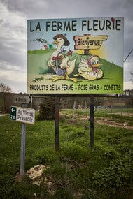

Signs advertise foie gras and duck confit made locally in the Gers, the most agricultural district in France.Credit...Andy Haslam for The New York Times

Gascony — unlike Paris or the Loire Valley, say — is not a popular destination for bucket-listers seeking grand chateaus, opulent palaces and soaring basilicas. The region’s patrimonial treasures are often tucked out of sight, as if waiting to be given their moment. Take Auch’s cathedral. Just down the street from the Hôtel de France, the 16th-century Cathédrale Ste.-Marie is a fine enough specimen, with its handsome twin bell towers and restored stained-glass windows. But its pièce de résistance lies hidden in a vaulted-ceiling choir entered via an internal doorway that admits visitors for the price of 2 euros ($2.12).

Arrayed along the choir’s perimeter are 113 thronelike “stalles” of intricately carved oak. Comprising thousands of painstakingly rendered figures and scenes depicting the life of Jesus and other biblical episodes, some of them in gruesome detail, the stalles constitute the most jaw-dropping feat of woodworking craftsmanship I have ever seen. According to what little literature on the cathedral I have come across, the names of all but one of the carvers, an artisan from Toulouse named Dominique Bertin, have been lost to time.

Most of the Gers’s other guidebook-approved attractions — and touristy restaurants, what few there are — are concentrated north of Auch, along a well-beaten trail that stretches between the picturesque hilltop town of Lectoure and the fortified village of Fourcès. The route also encompasses the popular medieval bastion of Larressingle and the imposing 14th-century cloister at La Romieu, as well as the prosperous village of Montréal du Gers, where, at an inviting restaurant called [L’escale](http://www.lescale-gers.fr/), you can have a swank al fresco meal of roasted capon in a foie gras and morel sauce while seated beneath the graceful arcades of the town square.

Those destinations are certainly worthy ones, particularly on a weekday between October and May, when you will have a decent chance of having them nearly all to yourself. I especially like Lectoure, with its single thoroughfare that arcs over a high ridgeline, turning every side street into a picture frame for the rolling Gascon countryside far below. Most tourists move on after paying a visit to Lectoure’s small cathedral and its handful of gift shops, or they book a room and a table at the fancy-ish [Hôtel de Bastard](http://www.hotel-de-bastard.com/?lang=en), which serves an excellent appetizer of foie gras accompanied by slices of Lectoure melon, a variety of cantaloupe for which the town is famous. But to my mind Lectoure’s singular point of interest, its very raison d’être — and why I go back again and again — is the Café des Sports.

Times travel coverage. When our writers review a destination, they do not accept free or discounted services or, in most cases, reveal that they work for The Times. We want their experience to be what you can expect.

[Here’s more on our standards and practices.](https://www.nytimes.com/editorial-standards/ethical-journalism.html#rulesForSpecializedDepartments)

This is, unequivocally, my favorite bar in France. The high-ceilinged, slightly gone-to-seed establishment is festooned with rugby ephemera — the sport being as sacred to Gascons as duck fat — and is furnished with a long wood bar, a couple of rickety barstools, and, teetering slightly on the beer-stained wood-slat floor, a dozen or so zinc-topped tables. On any given evening a mix of thuggish jocks, crusty-looking paysans, well-heeled retirees, urbane day-trippers from Toulouse, teenagers and children can be found tucking into cheap entrecôtes and duck legs.

At the bar’s far end, an ancient-looking glass-and-wood partition protects a private meeting space that could well have been the origin of the expression “back-room deal.” On one recent visit, I could see a dozen men seated around a banquet table, plotting who knows what. On another visit — and this is an anecdote that speaks volumes about Gascons’ trusting nature — a stranger in a rugby shirt nonchalantly deposited his kindergarten-age child at the table I was sharing with my wife and then-7-year-old daughter. “You don’t mind watching her for a minute?” he said, and dashed out. Before I could worry too much, he was back. Seeing that his daughter and mine were getting on fine, he lingered at the bar to chat with some friends.

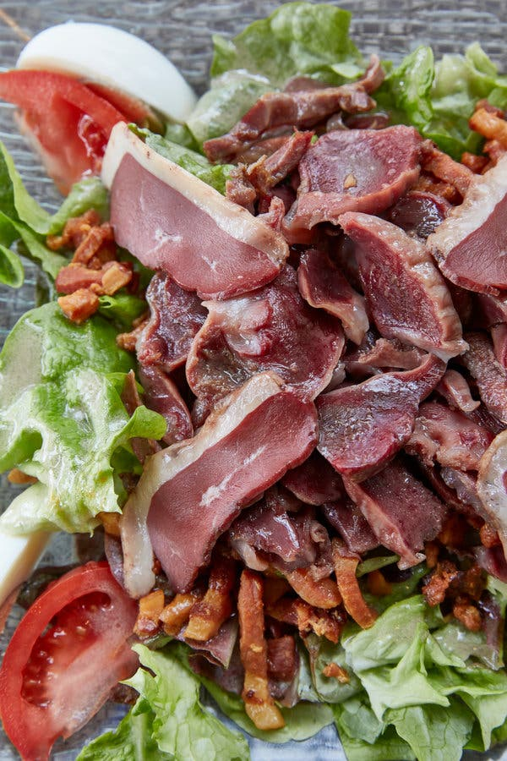

Gascon salad of sliced duck breast with eggs, salad leaves and tomatoes at Le Divan.Credit...Andy Haslam for The New York Times

The Café des Sports aside, Lectoure is a typical prim and prettified French village, and in this respect is an anomaly in the Gers. The principal towns of the Gascon heartland are for the most part unprepossessing: gritty market hubs that, on the face of it, hold little appeal for the tourist. And yet they offer the patient and curious visitor a chance to tune in to the rhythms of a rural lifestyle that is [dying out](https://www.nytimes.com/2017/02/28/world/europe/france-albi-french-towns-fading.html) elsewhere in France. To spend a market-day morning in, say, Fleurance, Mirande or Nogaro is to witness old-fashioned Frenchness in a very pure distillation — a collective affirmation of the things the French hold most sacred: fraternité, gastronomie and, to a lesser extent, morning drinking, cigarette smoking and cheek-kissing.

To wit: Mirande’s Monday market. Held in a covered hall, the marché brings this drab burg of 3,500 souls to crackling life. The vibe is like that of a small county fair, except with much better food. A tour of the stalls offers a crash course in Gascon cookery: confit duck legs nestled in chilled rendered fat, putty-colored fattened duck livers, goose and pork rillettes, pâté de tête, Basque chorizo, immense rounds of tangy Tommes des Pyrénées cheese, fresh brook trout, all manner of nuts and dried fruit, gariguette strawberries, greengage plums, and on and on.

The real education, though, is to be found in the gusty banter between vendors and customers — a uniquely Gascon admixture of chops-busting, gossip, rugby talk and, almost without fail, recipe swapping. Nowhere outside Gascony have I had to summon more patience while waiting in line at a rural market. The conversations, as a rule, are supercharged by lots of coffee and, often, lubricated by glasses of wine, beer or Floc (an Armagnac-spiked aperitif) purchased at the buvette, or drinks counter — a fixture of any respectable Gascon market.

The procuring of provisions always concludes with lunch. Virtually every substantial Gascon town has its bustling, market-adjacent chalkboard-menu joint. Mirande’s is called, prosaically, Le Grand Café Glacier. On my most recent visit there, a wine-braised pork cutlet with haricots verts and a gratin dauphinois set me back 8 euros; a half-carafe of the house red cost a few more. The meal bargains to be had in Gascony’s no-frills market cafes — the Café du Centre in Maubourguet, the Café du Centre in Fleurance (no relation), Le Divan in Éauze — harken back to a bygone era, as do the menus, which on rush-rush market days frequently consist of the plat-du-jour and little else. Often, the only question asked by your harried server is which color of wine you want.

Gascony is fundamentally a rural place, and to imbibe its true essence you have to leave the towns behind and venture deep into the countryside, preferably on foot. This is an easy thing to do, for the Gers is laced with thousands of miles of walkable farm roads and hiking trails, making village-to-village jaunts an appealing proposition. Such excursions are in my opinion the best possible way to work up your appetite.

The French divide hikes into two categories: grandes randonnées and petites randonnées. The former are for the type of person who thinks nothing of carrying a 50-pound pack up a mountain and can discuss at length the wicking properties of various synthetic fabrics. The latter are for dabblers, like me, who get kvetchy when an outdoor activity starts to eat into the dinner hour. Though the Gers does have one grande randonnée route — a multiday loop that starts and ends in Auch — the département is a paradise for day hikers.