Move forward | Move backward | Distance one step | Distance two steps
 |  | 1 | 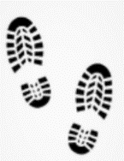  2
Distance three steps | Distance four steps | Distance five steps | Distance six steps
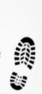  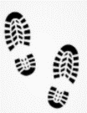  3 | 4 | 5 | 6
Distance seven steps | Distance eight steps | Distance nine steps | Distance ten steps
7 | 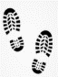  8 | 9 | 10
Rotate slight left | Rotate slight right | u-turn right | u-turn left

Slow | Medium | Fast | Very fast
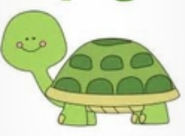 |  | 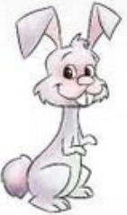
Zigzag | Spin left | Spin right | Skate
Small circle | Big circle | Turn top light off | Set top red light
Set top white light | Set top yellow light | Set top purple light | Set top blue light

Set top green light | Set top orange light | Set top pink light | Police car lights
Rainbow | Traffic lights | Disco | Christmas tree
 | 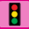
firework | repeat
 | X 2

