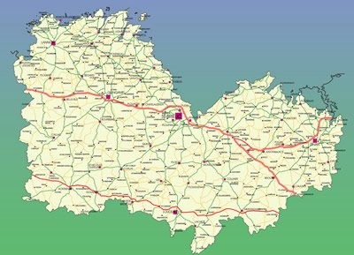

Anne LE BRAS - Trébry

06.26.63.06.17

Sébastien DUROS – Quessoy

06.86.78.23.90

Benjamin CHRETIEN – Sévignac

06.79.06.10.48

Philippe GILLOT – Planguenoual

06.81.87.86.83

Gaetan PALARIC – Le Haut Corlay

06.23.74.70.41

Stéphane LE DRUILLENNEC- Gurunhuel

06.87.03.59.61

Françoise NOGRE - Graces

06.31.44.34.73

Gilles CALLAREC – Trémel 06.63.06.96.20

Francis DERRIEN - PHF

06.80.41.82.51

Didier THAREAU – PHF

06.32.38.76.77

Pierre LE TINNIER – PHF

06.74.73.22.06

Denis CARFANTAN – PHF

07.86.29.11.84

Joseph LE TINNIER – Merléac

06.85.92.74.30

Florent ROBERT – Langourla

06.76.56.30.54

Frédéric BOTREL – Plénée Jugon

06.89.35.24.88

Olivier PANSART–Hénanbihen

06.74.82.45.73

Philippe HEURTEL– Lantic

06.87.38.40.85

Michel FOLLEZOU – Plévin

06.08.28.27.04

François CARFANTAN - St Potan 06.80.07.20.60

Anthony PELLERIN – Corseul

06.80.82.61.16