Move Your Body, Move Your Brain: Training for Neuroplasticity
Chandler Stevens
Coach

The connection between mind and body is critical to athletic performance. Sensory maps in the brain control our patterns of movement, but forming the connection between mind and body is more complex than simply whipping out an atlas of the mind.

The structures of these neural maps are constantly changing throughout our lives to optimize our day-to-day functionality. An organism will adapt to the demands placed upon it. This ability of neural structure to change is called neuroplasticity. Simply put, every movement of the body provides sensory feedback for the brain to process and adapt to.

"An organism will adapt to the demands placed upon it. This ability of neural structure to change is called neuroplasticity."
If you want to maximize your movement potential (i.e. increase strength and boost mobility) you need to understand how to tap into this feedback loop to optimize your training time.

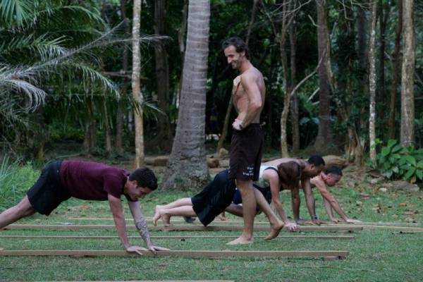
MovNat founder Erwan Le Corre teaches crawling at a MovNat training.

Training With the Brain
Although the term neuroplasticity may be new to you, the concept is likely familiar. If you’ve ever worked to grease the groove of a movement for more weight or reps, you’ve tapped into your neuroplasticity (thanks, Pavel). In the absence of pain and fatigue, increased repetitions serve to carve out these neural pathways, making the pattern more efficient.¹ This increase in neuromuscular efficiency paves the way to more strength and less pain. Not a bad combination.

"In MovNat, we tap into these primal patterns because they are the foundation of more advanced movements like walking, running, and climbing."
The MovNat system has a strong emphasis on restoring potential for natural movement.Although inherently human, many of the fundamental movements like crawling and climbing have become unfamiliar for many of us in our modern, adult lives. We can therefore imagine that the neural maps for these patterns are a bit fuzzy or even completely absent.

When it comes to efficient patterning, it’s unfortunately use it, or lose it. When was the last time you really crawled? Most of us haven’t revisited this pattern since our earliest years, which is a shame because crawling makes for a powerful athlete. In MovNat, we tap into these primal patterns because they are the foundation of more advanced movements like walking, running, and climbing.

To relearn these movement patterns, we’ll need to redraw our neural maps. Luckily the brain-body connection is amazingly resilient. With a bit of mindfulness and attention, we can harness the power of neuroplasticity to regain our true movement potential.

The Learning Curve
The natural movement method uses a simple framework to give a practical view of what’s going on when we learn new patterns. Allow me to introduce the competency curve in four parts, using the ever-important crawling pattern as our guide.

1. Unconscious Incompetence
Ignorance is bliss. At this stage, we’re unaware of our lack of ability. You may not have even considered crawling as an option for movement. The maps for such unfamiliar patterns will necessarily be fuzzy or incomplete until there is a demand to perform.

2. Conscious Incompetence
A humbling stage. At this level of learning, we’re well aware of our limitations. This is where we tangle our own limbs when relearning to crawl. You might have trouble moving opposite limbs smoothly and efficiently.

Although unable to complete the movement easily (if at all), you are setting the foundation of neuromuscular efficiency. Fortunately, sensory inputs from novel movements receive a lot of attention in the brain. As you learn new patterns, pay close attention to available inputs such as muscular tension and posture.

3. Conscious Competence
Here is where we start to make some serious progress with our patterning. This stage is characterized by successful completion of a movement with conscious awareness and attention. So-called aha moments abound.

In practical terms, this means when you concentrate, you find it easier to move opposite limbs together and perhaps even pick up speed as you do. A bit of extra thought goes a long way. The brain is bombarded with sensory feedback, so out of necessity, it’s going to tune out much of it. With focused attention, we are able to increase the efficacy of our movement practice.² This results in more efficient carving of neural pathways. So, bring your brain to the gym. You’ll be that much stronger for it.

4. Unconscious Competence
This is the stage where our movement happens out of habit. Consider walking, reaching, and getting up and down from a chair. For most of us, the mental maps of these patterns are so ingrained that they require little, if any, thought. This is the stage where you can drop down into a crawl without batting an eye. Of course, we want these unconscious patterns to be efficient, so mindful practice is still a critical piece of the foundation.

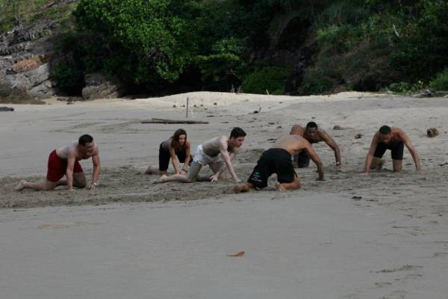
Practice crawling on different surfaces to build efficient movement patterns.

Put It to Work
The brain evolved largely to control complex movement, so it makes sense to give it some brain food. Taking up a new skill can have tremendous returns on your performance as both an athlete and a human.

"When you start learning these new skills, the emphasis should always be on controlled, mindful movement."
MovNat provides a strong framework with a focus on practical movements such as locomotion and manipulation. You might consider developing your ability to crawl or take the time tomaster the tuck pop up. When you start learning these new skills, the emphasis should always be on controlled, mindful movement. Moving poorly and doing so often is a sure-fire way to carve out inefficient patterns of movement.

With any new skill, put in the work to master the fundamentals, paying conscious attention to internal and external cues as you do. Your mind and body will thank you.

You'll Also Like:
How to Use Manual Therapy to Restore Essential Gait Mechanics
Beyond Crawling: Cross Patterning for Athletes
Ground Control: How to Move Efficiently on All Fours
What's New on Breaking Muscle Today

References:
1. Sale, Digby G. "Neural Adaptation to Resistance Training." Medicine & Science in Sports & Exercise 20.Sup 1 (1988): S135-145.
2. Seitz, Aaron R., and Hubert R. Dinse. "A Common Framework for Perceptual Learning." Current Opinion in Neurobiology 17.2 (2007): 148-53.

Photos courtesy of MovNat.
Topic: Natural Movement
See more about: natural movement, movnat, mind body, mind-body connection, brain, neuromuscular power
CHANDLER STEVENS

