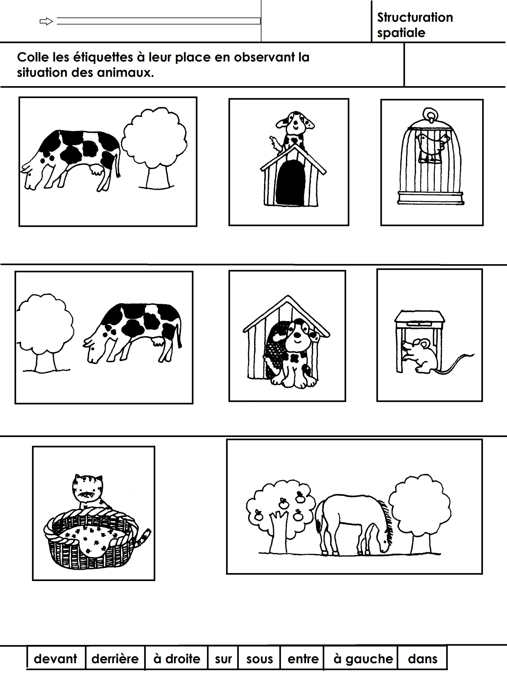

**Lecture**

|  |  |  |  |
| --- | --- | --- | --- |
| **devant** | **derrière** | **à droite** | **sur** |
| **sous** | **entre** | **à gauche** | **dans** |