**La rivière a emporté les lettres dans des tourbillons. Colle le mot que tu peux composer et le dessin qui va avec.**

**Langage écrit**

Le

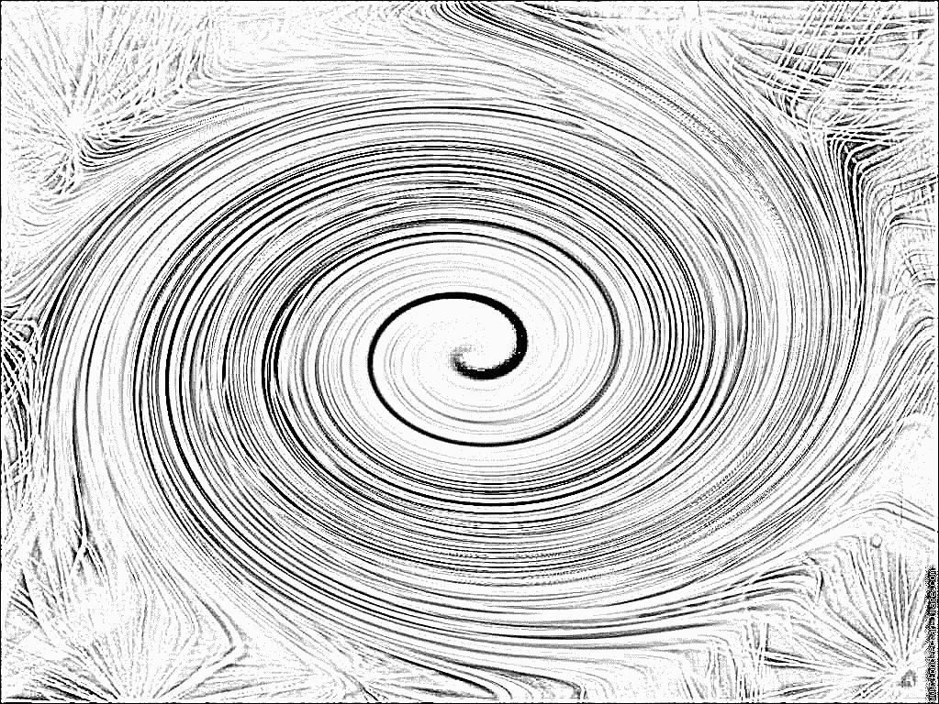

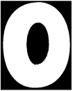















|  |  |  |  |
| --- | --- | --- | --- |
| **PAPOTE** | **PLUME** | **BRINDILLE** | **TCHICO** |
|  |  |  |  |

|  |  |  |  |
| --- | --- | --- | --- |
| **PAPOTE** | **PLUME** | **BRINDILLE** | **TCHICO** |
|  |  |  |  |

|  |  |  |  |
| --- | --- | --- | --- |
| **PAPOTE** | **PLUME** | **BRINDILLE** | **TCHICO** |
|  |  |  |  |

|  |  |  |  |
| --- | --- | --- | --- |
| **PAPOTE** | **PLUME** | **BRINDILLE** | **TCHICO** |
|  |  |  |  |