TOM

Tom

Tom

GS

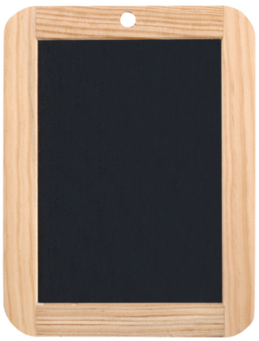

PS

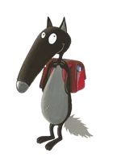

Alice

TOM

Tom

Tom

GS



PS



Alice

TOM

Tom

Tom

GS



PS



Alice

TOM

Tom

Tom

GS



PS



Alice