TOM

Tom

Tom

GS

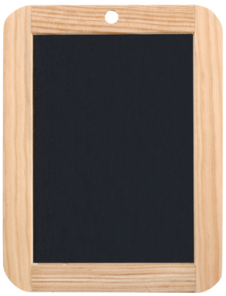

MS

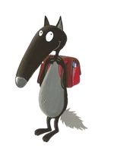

Alice

TOM

Tom

Tom

GS



MS



Alice

TOM

Tom

Tom

GS



MS



Alice

TOM

Tom

Tom

GS



MS



Alice