TOM

Tom

Tom

GS

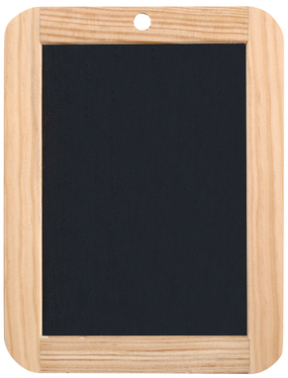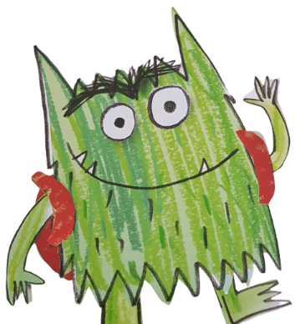

GS



GS



GS



GS

TOM

Tom

Tom

TOM

Tom

Tom

TOM

Tom

Tom

TOM

Tom

Tom



JEANNE

MS

J



JEANNE

MS

J



JEANNE

MS

J



JEANNE

MS

J