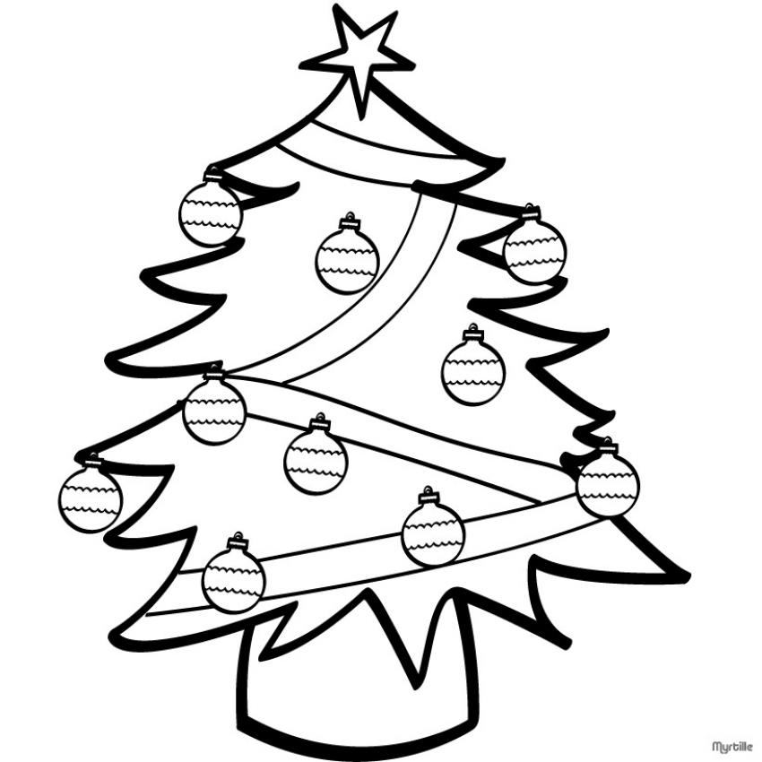

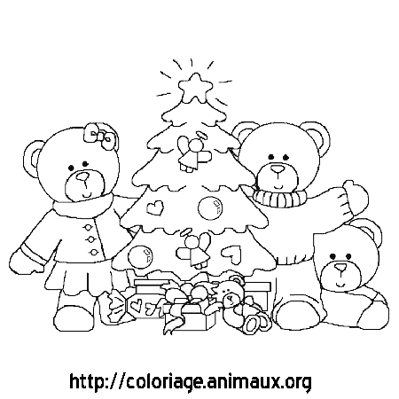

[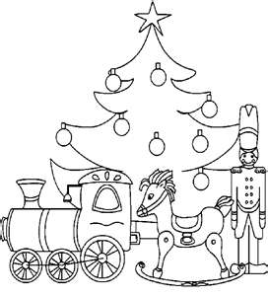](http://www.bing.com/images/search?q=sapin+de+noel+dessin&view=detail&id=4B993BC5C8E08930E61A37AD3D728C7B3C7CE4B4&first=0&qpvt=sapin+de+noel+dessin&FORM=IDFRIR)

[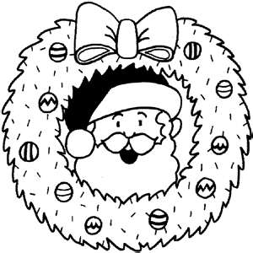](http://www.bing.com/images/search?q=sapin+de+noel+dessin&view=detail&id=BC913D72B7C439AA46FEEFE42AD870D9DAF7B046&first=61&FORM=IDFRIR)

[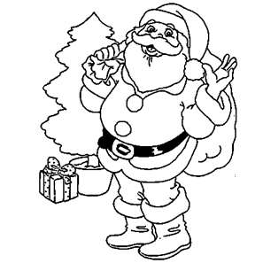](http://www.bing.com/images/search?q=sapin+de+noel+dessin&view=detail&id=BE69DBDD47800CD5A50135DB20A462155DC4CF71&first=121&FORM=IDFRIR)

[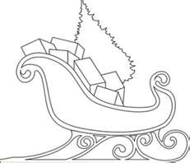](http://www.bing.com/images/search?q=sapin+de+noel+dessin&view=detail&id=835EB488BFE6262455779AA8258C5D9BC86EFF0F&first=541&FORM=IDFRIR)