As I was walking abstract in the street, I bumped into a wonderful residential complex. While I was fascinated by these magnificent houses, a small house caught my eye... it was really inappropriate with the other houses. Its design was too old. It seemed to me that the house had originated from the past and someone had placed it in this dissimilar modern area, with these stunning houses.

Well….here it is the neighborhood before…
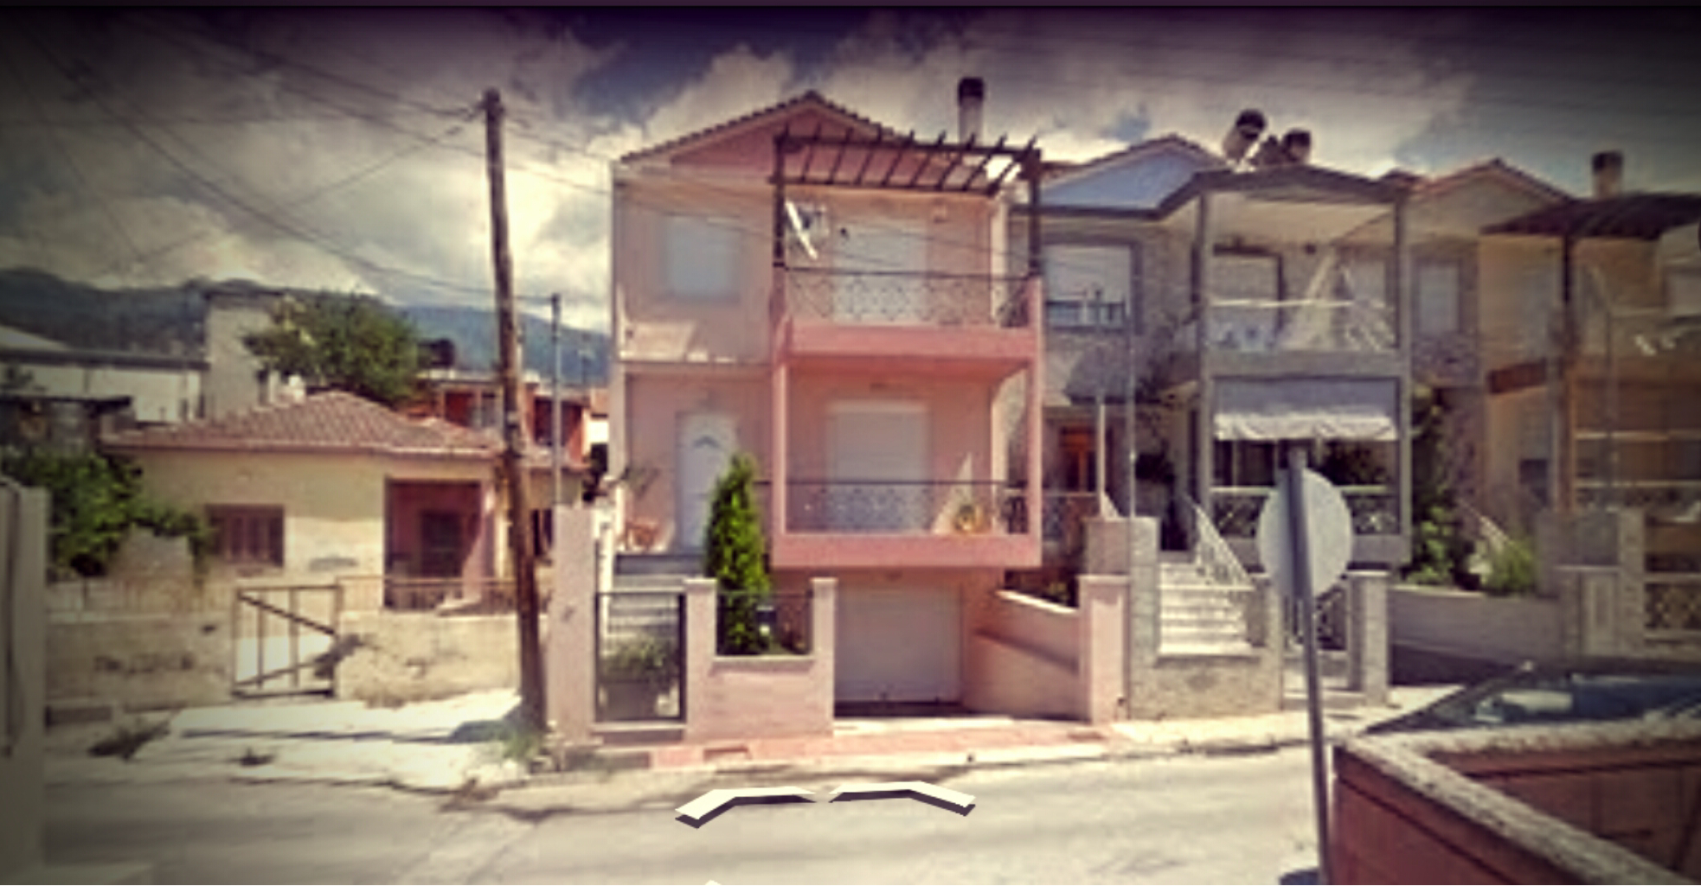

And after a long work….

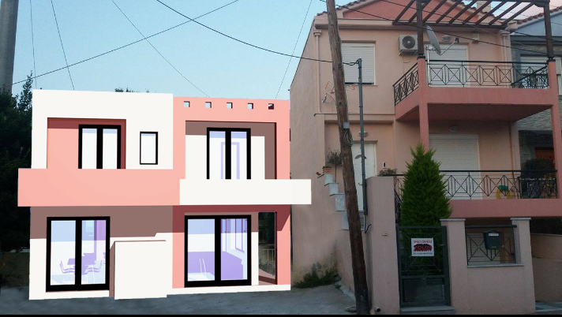

Information about my project!!!

- Here is the house that I made in 3D…
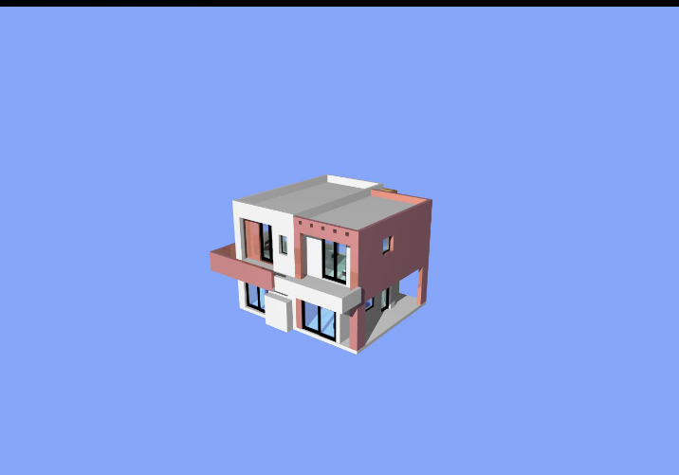

- In this day and age, most people would agree that the environment is polluted by the most dangerous being in the world..... ''Humans''. With their products and their buildings, everyday they destroy a part of the environment, therefore their own house. So what do we do?!? If we cannot stop the pollution, we could take actions and minimize this profound problem! An essential way to help the environment, is to built houses that are environmentally friendly, and using ‘’smart materials’’. Of course a material cannot be smart but if we use it with an appropriate way, it could turn into a useful tool. The materials that Ι would like to recommend for the construction of the building, it would be technological new, since Ι want to ensure the saving energy.
- The main building materials would be from reinforced concrete and a wall of bricks, on which we would place an external insulation and we would use heat insulation materials, to ensure waterproofing and the thermal insulation of the building's adequacy, isolating it from the external climatic conditions.

- The openings would be covered by aluminum joinery with double glazing and in their framework and with movement sheds.
I hope you will find my work interesting
And
Worthy of your expectation!!!

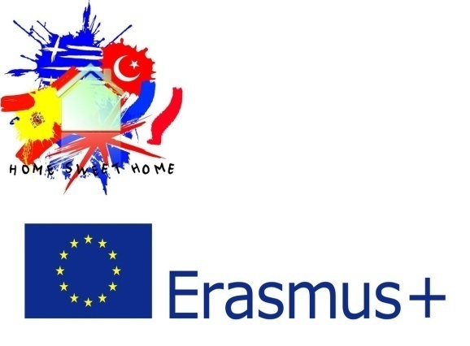
#erasmus+_team

