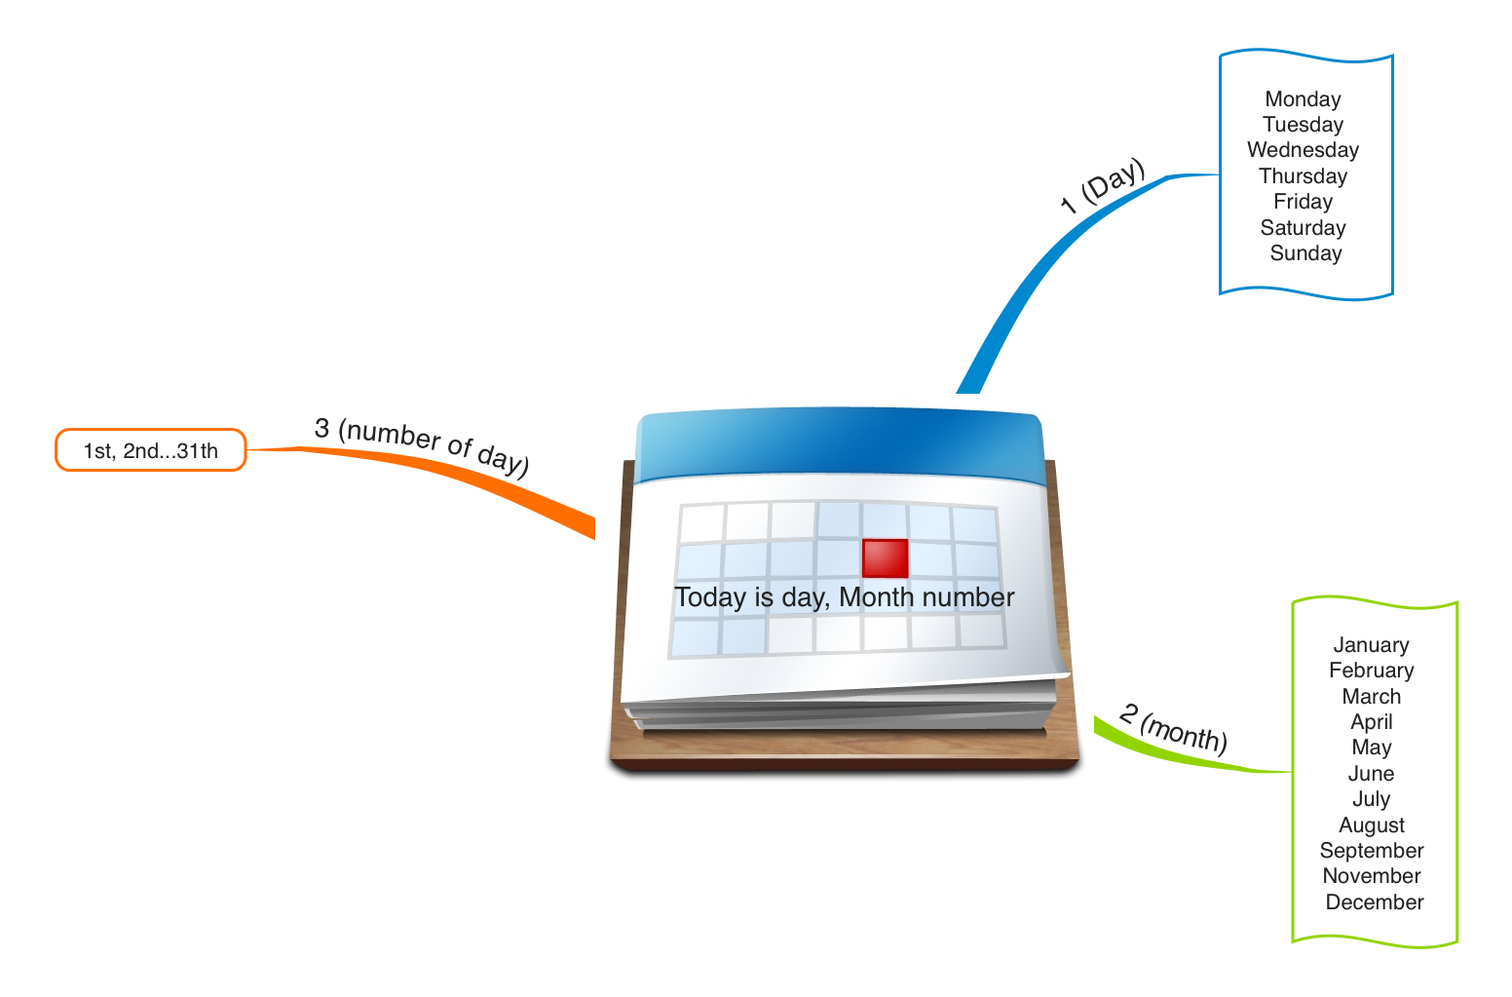

Exemple : Today is Saturday, October 12th (2013)

First 1st | Second 2nd | Third 3rd | Fourth 4th | Fifth 5th
Sixth 6th | Seventh 7th | Eighth 8th | Ninth 9th | Tenth 10 th
Eleventh 11th | Twelfth 12th | Thirteenth 13th | Fourteenth 14th | Fifteenth 15th
Sixteenth 16th | Seventeenth17th | Eighteenth 18th | Nineteenth 19th | Twentieth 20th
Twenty-first 21th | Twenty-second 22th | Twenty-third 23th | Twenty-fourth 24 th | Twenty-fifth 25th
Twenty-sixth 26th | Twenty-seventh 27th | Twenty-eighth 28th | Twenty-ninth 29th | Thirthyth 30th
Thirty-first 31st

