**TALKING ABOUT ANIMATION MOVIES**

**Read and complete this brief introduction with the words below:**

*characters and movies / motion / could be flashed quickly / flipbook / science /*

*pencils / painting / soot and earth drawings*

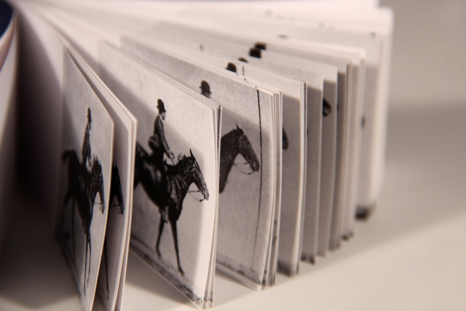Unlike many arts, animation isn't something that has grown organically from the beginning of time. If you trace the history of __________________for instance, you can look back to Neanderthal man and see his ___________________________ on cave walls. Animation, on the other hand, is an art form that evolved out of ______________ first.

People had to understand how series of pictures __________ ____________________ in succession to give the illusion of __________________ and then create the machinery to do that before they could even think about creating cartoon ____________________________.

Even though ancient man had paper, __________________ and all of the items to make a machine that would project an image or create a __________________, they didn't – simply because before 1824 it never occurred to anyone to do that.

**Example of a flipbook: a TRIBUTE TO MICHAEL JACKSON (watch video)**

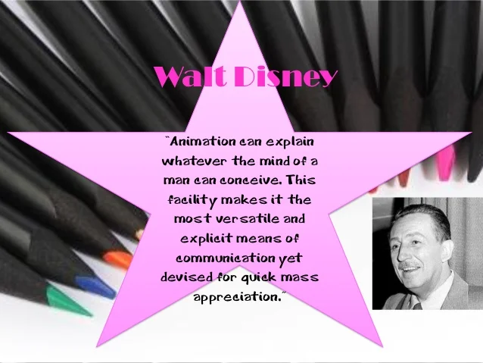

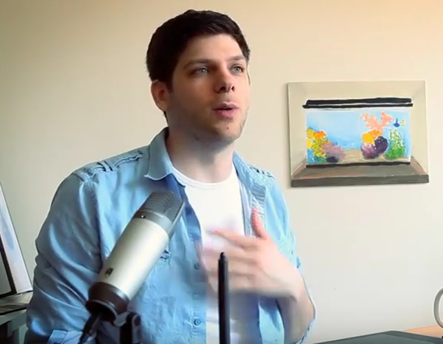**VIDEO TIME: HOW TO MAKE AN ANIMATED MOVIE**

Watch and find out the different steps in making an animated movie

<https://www.youtube.com/watch?v=rJaN643ri7s>

STAGE 1: **__________________**

It must be__________. It _________ and ___________ with the production.

STAGE 2: **__________________**

You have to ___________ your story.

Used application: CELTX

STAGE 3: **__________________**

Now, it’s time for ____________. The storyboard is like a _______________ but it shows you the ______________________ and ________________ of your characters in every scene. It doesn’t need to be super detailed. It has to give the __________ (= rhythm) of it.

STAGE 4: **__________________**

You put all your drawings in an ____________program and add ___________and ___________(…) This is the best time to make any last minute ________________.

STAGE 5: **__________________**

You have to _________ your models based on your _____________________.

What is a 3D model?

STAGE 6: **__________________** (montage)

You need to build a _____________to make the model ___________ in the 3D program.

STAGE 7: **__________________**

It’s a good time to have your final _____________________. This the last chance to make any kind of ______________________ to your film.

STAGE 8: **__________________**

It’s like playing with 3D ______________ but it’s very long and ______________ to do.

STAGE 9: **__________________________________**

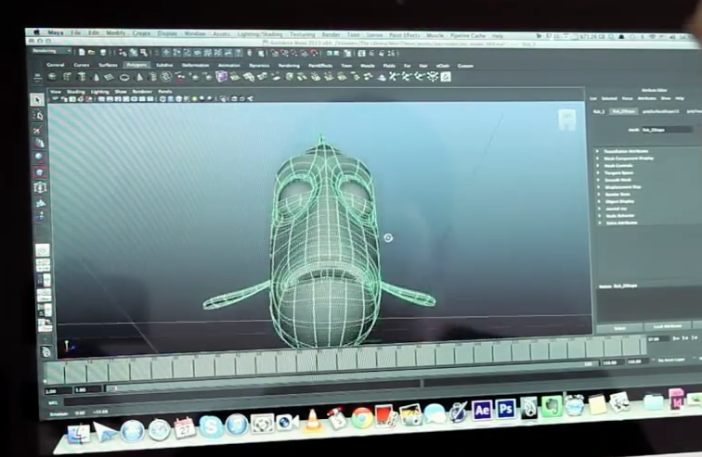_____________ are put in the right places, ______________ are placed on your models. It’s a very _______________ process.

STAGE 10: **_________________________**

You have to make all your colors ___________.

STAGE 11: **__________________**

Everything in your film needs to ___________ good.