« DREAM CRAZY » COMMERCIAL

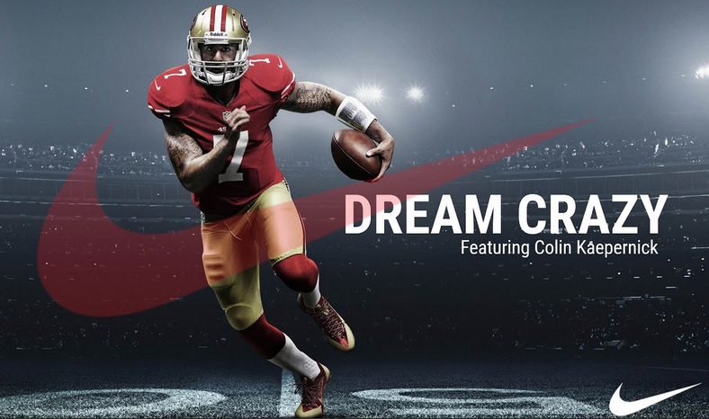Mission 1 : ‘Dream Crazy’ commercial

***Task 1 : Watch the commercial.***

→ Who and what did you see? List the various steps of the commercial.

*Then, in groups, gather the information you have found and share them with your class.*

|  |  |
| --- | --- |
| 1 | **Nyjah Houston, 23.**  The ad starts with a video of a |
| 2 | **Isaiah Bird, 10.** Then, we can then see a |
| 3+ 5 | **Zeina Nassar.** The next person is a ___________________ _________________________. We then learn she is a boxing champion. |
| 4 | **Kai Lenny** A surfer |
| 6 | **Megan Blunk** A young woman in a |
| 7 | **Eliud Kipchoge** A boy ______________________________ _______________________ and then, ending ______________________________. |
| 8 | A team of ___________________________ _______________________________. |
| 9 | **Alicia Woolcott** A ______________________________who is also _________________________________ _____________________________________ |
| 10 | **Charlie Jabaley** An ______________________boy who has lost ___________________ (lbs) then finishes the ___________________________ after beating ________________________. |
| 11 | **Lacey Baker** A skateboarder who is _____________ ________________but who is ___________**.** |
| 12 | **Alphonso Davies** ________________ playing s____________ with friends and then playing _________ ______________________ . |
| 13 | **James LeBron** A ___________________ player giving _________________________. |
| 14 | **Colin Kaepernick,** having his back _______________________**,** watching ___________________________________. |
| 15 | A _______________________________ playing and _____________________ a goal. |
| 16 | **Griffin** A ________________________ American football player scoring, as well. |
| 17 | The two _________________________ playing tennis in ______________________ ____________________________ . |

**Task 2 : What does the commercial say at the end in relation with the title?**

**Task 3 : What message is the commercial trying to convey?**

**Task 4 : Translate the following sentences :**

La publicité de Nike présentant des personnes communes brisant les barrières et réussissant contre toute attente, encourage quiconque à rêver en grand, ce qui signifie être persévérant, tenace et déterminé.

Elle encourage chacun, quelque soit sa couleur de peau, son handicap, sa sexualité, sa religion à dépasser les limites, à surmonter les obstacles sans craindre le jugement des autres / quoiqu'en pensent les autres.

Cette publicité met en lumière la grandeur quel que soit le nom, le niveau de renommée ou le sport choisi d'un athlète.

**CONCLUSION** : Nike’s commercial, released in 2018, has/ˈɡɑːnəd/  **_______________________** both /ˈkɒntrəvɜːrsi/ **_______________________** and /ˈkrɪt*ɪ*sɪzəm/ **______________________**, as it features /ˈfɔːrmər/ **__________________** San Francisco /ˈkwɔːrtərbæk/ **__________________________** Colin Kaepernick, who has been widely /ˈkrɪt*ɪ*saɪzd/**______________________** for /ˈniːlɪŋ/ **_________________________** during the national /ˈænθəm/______________________ in protest of police brutality in his country.

**HAVE YOU HEARD OF THIS STORY? Do research on the topic & be ready to explain what you have found out in class… ☺**