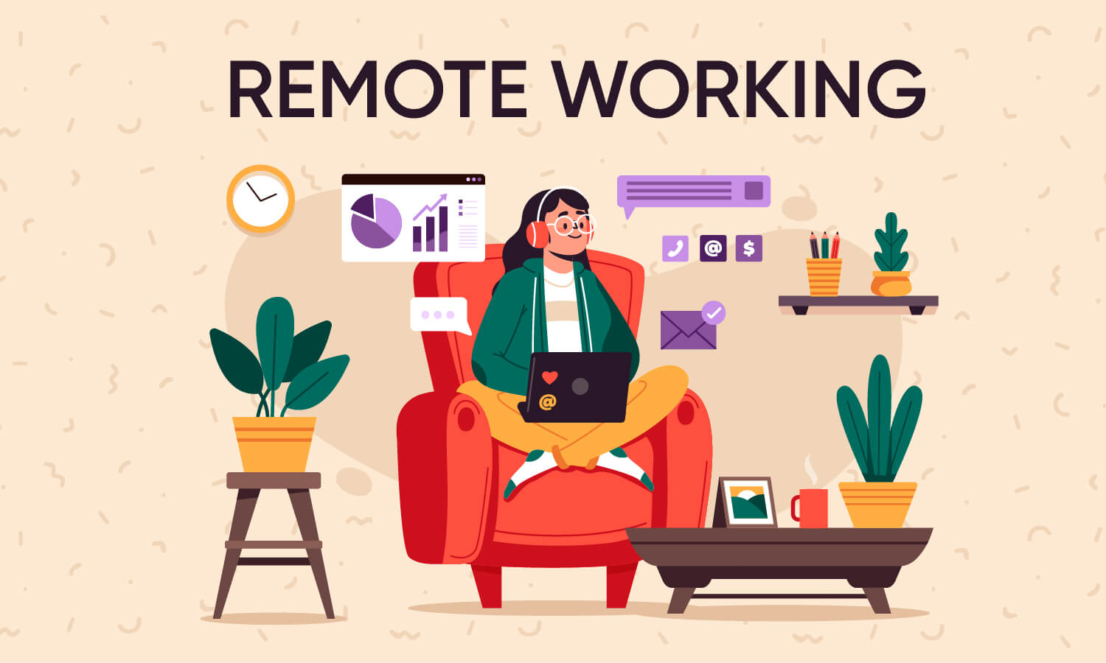
To what extent can REMOTE WORKING
INCREASE STRESS

Task 1: Warm-up

- What does ‘Remote working' mean to you? Give a definition.
- Now, complete this definition.
Remote work is a working style that /əˈlaʊz/__________________ professionals to work outside of a traditional /ˈɒfɪs/_________________ environment. It is based on the /ˈkɒnsept/___________________ that work does not need to be done in a /spɪˈsɪfɪk/ ____________________ place to be executed /səkˈsesfʊli/ ______________________________.
Think of it this way: instead of /kəˈmjuːtɪŋ/ _________________________ to an office each day to work from a /ˈdezɪgneɪtid/ _______________________ desk, remote employees can execute their projects and /sə^{r}ˈpɑːs/ ________________________ their goals /weərˈevə^{r}/ _____________________ they please. People have the /ˌfleksɪˈbɪlɪti/ ____________________ to design their days so that their professional and personal lives can be /ɪkˈspɪəriənst/ _____________________ to their fullest potential and coexist /ˈpiːsf^{u}li/ __________________.

- Do you agree or disagree with these statements about remote working? Explain why.

- Working remotely is more productive than working in the office.
- Most people would work remotely, if they could.
- If I worked from home, I would surely miss my colleagues.

Task 2: Reading for the main idea

You’re going to read about remote working. First skim-read the article quickly to get a general idea of the content and the organisation. Which of these topics is not mentioned in the article?

Benefits to workers Negative effects Solutions
Benefits to employers Types of stress

Task 3: Reading for detail

These sentences have been removed from the article. Read the article again and match each sentence with a numbered gap.

a. And, with no visible body language it is tricky to communicate our true meanings.
b. Employers need to put the right structures in place, such as scheduled video calls and regular team-building meetups.
c. One significant issue was the management of virtual working.
d. Some multinationals have all staff working remotely, with employees situated all over the world.
e. The benefits are important.
Task 4: Vocabulary
Match each word from the article with its meaning. Use the context of the article to help you - the words are in bold type in the text.

- Pitfalls a) a likeliness to take action or occur the same way many times
- burn out b) a typical attitude, or way of thinking
- millennials c) being alone or cut off from social interaction with others
- mentality d) copy, reproduce
- commonplace e) frequent and not seen as unusual
- tendency f) harmful or damaging
- isolation g) have more significance or a stronger effect than another
factor
- detrimental h) people who were born in the 1980s-2000s
- outweigh i) problems that are likely to occur in a particular situation
- replicate j) work too hard and become exhausted

1. … 2. … 3. … 4. … 5. …
6. … 7. … 8. … 9. … 10. …

Task 5: Match each phrase from the article with the best meaning

1. ... people’s mental health and well-being can take a hit when working remotely.
a. become complicated
b. make someone angry
c. suffer

2. ... working remotely leads to the blurring of work and non-work hours, particularly if you work from home.
a. asking someone to work overtime
b. a lack of a clear boundary
c. saying something without thinking

3. Navigating sensitive territory in a virtual team is an essential skill.
a. communicating a plan clearly
b. saying and doing the right thing in a difficult situation
c. taking your team in the right direction

4. ... virtual workers can feel like a cog in a machine, rather than an essential part of the team.
a. they are useless
b. they have an important role
c. they have to work without stopping

5. ... lack of feedback from line managers and senior colleagues gave them no benchmark to judge progress, which led to increased feelings of anxiety ...
a. support to do their job
b. sense of teamwork
c. way of measuring how well they were doing
Task 6: VOCABULARY to remember

ENGLISH | FRENCH | ENGLISH
a benchmark |  | to avoid
a blurring |  | to be likely to
a cog in a machine  a cog in a wheel |  | to be unlikely to
a commute |  | to burn out
a concern |  | to commute
a lecturer |  | to complete a task
a line manager |  | to cope with  to handle
a pitfall |  | to draw up
a senior colleague |  | to implement
childcare |  | to occur
emphasis |  | to outweigh
equally |  | to overcome
millenials |  | to replicate
out of sight, out of mind |  | to schedule
policies |  | to skim read
remotely |  | to take a hit
 |  | to value
 |  | to worsen

Task 7: Asking questions

Imagine you have successfully interviewed for a job with a company that requires you to work remotely at least several days a week. You have some concerns about this arrangement.
Write three questions to ask your new employer about how they handle remote working, using vocabulary from the exercises in this lesson.

Example: What pitfalls have you experienced with remote workers in the past, and how have you addressed these issues?

1.

2.

3.

Task 8: Speaking

Roleplay a conversation with a manager from the company. One student - the employee - will ask the questions they wrote, and the other - the employer - will answer the questions.
Try to use vocabulary from the lesson in the answers as well. Then, change roles.

