**Discover an editing technique: The Jump Cut**

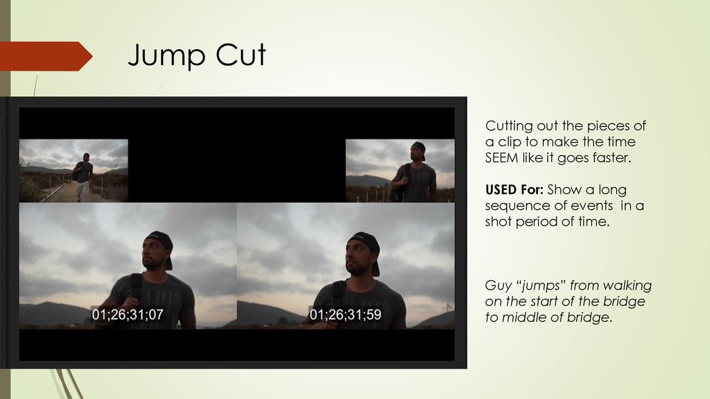

**noun *=* a jump cut: /ˈdʒʌmpkʌt/**

It’s an abrupt transition from one scene to another.

**verb *=* to make a jump cut**

Ex: "the camera jump-cuts to a head-and-shoulders shot of the girl"

**Mission 1: Read the following text.**

Editors are magicians. They cut films and TV shows together and help bring stories forward.

One of the boldest edits they do is the jump cut. It's a way to really command the audience and to take authority over the storytelling. It can help the editor pull the strings and push the viewers toward the set of emotions they want them to feel.

When the jump cut first appeared in Jean-Luc Godard's [*Breathless*](https://en.wikipedia.org/wiki/Breathless_(1960_film))*,* people thought the edit was a mistake. Then, after realizing it was a brand-new editing technique, they were amazed.

That's who Godard was, someone who seemingly effortlessly helped the art of cinema leap forward.

If there was a rule of cinema, Godard broke it. He mixed snobby topics with the urbane. And Godard never shied away from sharing his opinions far and wide.

Godard ushered in the modern era of cinema by being one of the pioneers of the [French New Wave](https://nofilmschool.com/what-is-the-french-new-wave). This movement not only changed the way film was seen around the world, but it shrunk the globe.

People began to seek out cinema from other countries. To study it, talk about it, and celebrate it.

**Mission 2 : Essaie de dégager les informations principales en français en te posant les questions suivantes :**

* De quoi et/ou de qui parle le document ?
* Que nous apprend-t-il ?
* Pourquoi et comment ?
* Quel est l’intérêt de l’auteur, son objectif, son but ?

**Mission 3: Now, watch examples of Jump Cuts in Godard’s “Breathless” movie on Miss’s blog.**