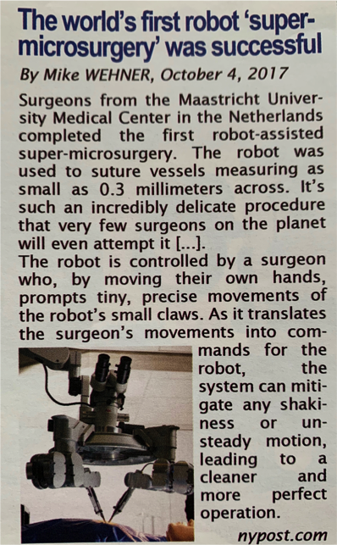**MORE AI-POWERED TECHNOLOGIES**

**AI in the medical field**

**Document 1:** Introduce this document:

The document under study is …………….………………… which ……………………………………. on October 2017 on the NYpost website.

It ……………………….…………… “The world’s first robot ‘super-surgery’ was successful” and it …………………..

……………………………………… Mike Wehner.

Now read this article and try to complete the missing information:

It deals with……………………………………………………

……………………………………………………………………

**What did this robot allow the surgeons to do?**

**GOAL of this document?**

**Deep sea exploration**

**Document 2:** Watch and complete the missing information in French.

**Nom:**

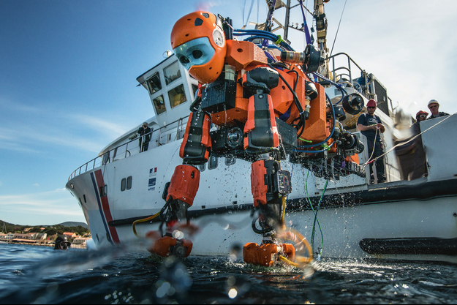**Caractéristiques:**

1.

2.

**Utilisation:**

1.

2.

**Mode de fonctionnement:**