**CO: ACTIVISTS ON WHY THEY MARCH?**

|  |  |
| --- | --- |
| un activiste |  |
| prôner |  |
| se batter en faveur de |  |
| prendre position contre |  |
| défiler |  |
| une marche (mouvement) |  |
| manifester |  |
| une manifestation |  |

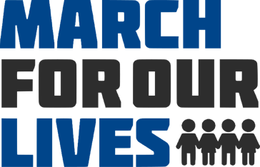

**Listen and find the following information**

1. **What do these teenagers want?**

Emma Gonzalez’s testimony:

1. **How old are the teenagers?**
2. **Where are they from?**
3. **Why do they march? Complete the following sentences:**

* I march because _____________________________________________________
* I’m marching ________________________________________________________
* I march because _____________________________________________________

1. **Who do they march for?** What happened?

Date?

1. **What do they want to change?**
2. **Why can’t politicians make these changes? Complete the following sentences:**

* Because
* Because
* Because

1. **Why does this keep on happening? Complete the following sentences:**

* because ___________________________________________
* more ___________________________________________
* ___________________________________________ the gun problem

**Emma: “we’ve done something wrong and we are too embarrassed to admit it”. Explain this statement.**

**The two main problems in the American society are:**

* ________________ school systems
* institutionalized ____________________

Emma’s last sentence: **“It’s about damn time someone did”.** “Did” what? : _________________________.