Art Everywhere project to create 'giant art gallery'
BBC News, published on June 7, 2013.

Posters of classic artworks will be displayed across the country this summer in a bid to turn the UK into the "world's largest art gallery".
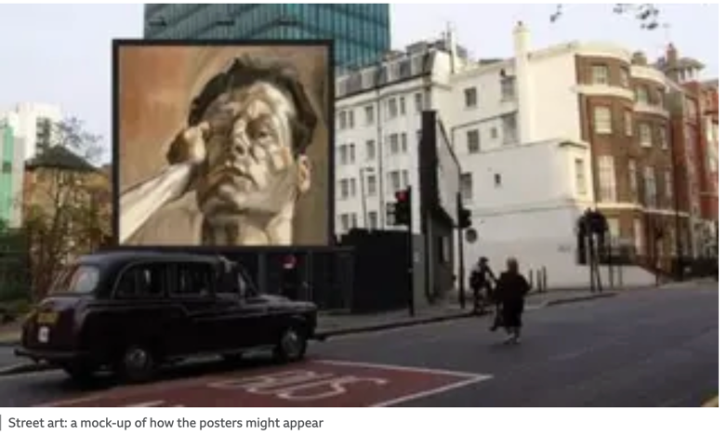

The Art Everywhere exhibition will transform thousands of poster sites and billboards for two weeks from 10-25 August.
The public can help curate the exhibition by choosing their top 50 British artworks.
A shortlist will be on the Art Everywhere website, from 24 June.

"Art is for everyone and everyone who has access to it will benefit from it," said Damien Hirst, one of the artists supporting the project.
"This project is amazing and gives the public a voice and an opportunity to choose what they want to see on their streets."
Another artist attached to the project is British artist Patrick Brill aka Bob and Roberta Smith.

Art Everywhere is a charitable project founded by Richard Reed, co-founder of Innocent Drinks, in collaboration with the Art Fund, Tate, and the poster industry.
"This is a joyful celebration with no agenda other than to flood our streets with art and celebrate the creative talents and legacy of this amazing country," Reed said.

Tate Director, Nicholas Serota said the scheme would "bring some inspiring images to our streets and provoke conversation and debate about the characteristics of Britain and qualities of British Art".

Members of the public are also invited to help "crowdfund" the project with donations.

Your mission: Find the following English equivalents to these French words in the article:

une exposition |  | exposer
un plan, un projet |  | financer de manière participative
un héritage |  | fonder
un projet caritatif |  | envahir, inonder
une tentative |  | profiter à
un panneau d’affichage |  | organiser, sélectionner
une arrière-pensée, une idée deriière la tête |  | également connu sous le nom de…, alias

!!! Fonder = /ˈfaʊnd/
Financer = /ˈfʌnd/
Inonder = /flʌd/

GOALS of this initiative:

