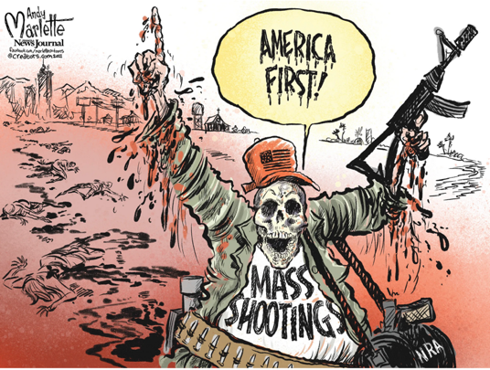
Mass Shootings in the US Fast Facts

By Janie Boschma, Curt Merrill and John Murphy-Teixidor, CNN
Last updated: Sept. ____, ________

(CNN) — There have been more than ________ mass shootings in the United States so far this year, leaving more than ________ people dead and ________ injured, according to the Gun Violence Archive /ˈɑrkaɪv/ (GVA).
The dangerous pace of mass shootings escalated in ________ during the Covid-19 pandemic and has persisted since then. Between ________ and ________, the total number of mass shootings each year jumped from ________ to ________. Then, ________ became the worst year for mass shootings since GVA began tracking them in ________, with ________ across ________ states and Washington, DC. There were ________ mass shootings last year in ________, which ranks second among most mass shootings in a year since ________.
To rank among = To be injured = to be wounded =

Mass Shootings in the US Fast Facts

By Janie Boschma, Curt Merrill and John Murphy-Teixidor, CNN
Last updated: Sept. ____, ________

(CNN) — There have been more than ________ mass shootings in the United States so far this year, leaving more than ________ people dead and ________ injured, according to the Gun Violence Archive /ˈɑrkaɪv/ (GVA).
The dangerous pace of mass shootings escalated in ________ during the Covid-19 pandemic and has persisted since then. Between ________ and ________, the total number of mass shootings each year jumped from ________ to ________. Then, ________ became the worst year for mass shootings since GVA began tracking them in ________, with ________ across ________ states and Washington, DC. There were ________ mass shootings last year in ________, which ranks second among most mass shootings in a year since ________.
To rank among = To be injured = to be wounded =

