ART…

“Art is powerful.  Art is meaningful.  It enriches our society”. *Keith Bond (Fine Arts Artist)*

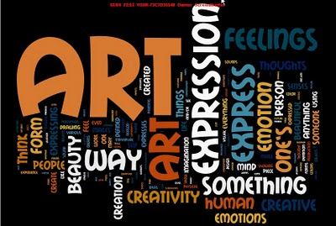

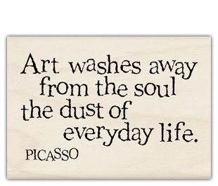

MISSION 1: What types of Art do you know? With the help of your classmates, fill in the grid in English.

|  |  |  |  |
| --- | --- | --- | --- |
| une peinture |  | une gravure sur bois |  |
| un autoportrait |  | la mosaïque |  |
| une nature morte |  | la poterie |  |
| un croquis |  | la sculpture |  |
| une bande dessinée |  | la céramique |  |
| un dessin humoristique |  | la photographie |  |
| un dessin |  | l’architecture |  |
| une gravure |  | le design (objets, vêtements…) |  |
| l’art de la rue |  | l’art numérique |  |
| les beaux-arts |  | la musique |  |
| les arts graphiques |  | le cinéma |  |
| les arts appliqués |  | le théâtre |  |

MISSION 2:1. Write a short definition on a piece of paper… What is Art for you? (30 words)

2. What would your life be without art? Why?

3. Which type of art is your favorite and why? (Use the tool box to justify) (20 to 30 words)

*TOOL BOX: fascinating, enthralling, necessary, useful, helpful, creative, interesting,*

*powerful, meaningful, expressive, moving, touching, stirring, affecting…*

MISSION 3: Complete your teacher’s definition of Art

Everyone has his/her own idea of what Art is and (en ce qui me concerne) ___________________________, Art is a way to express ourselves, (de s’échapper du monde réel) ____________________________________, to create our own world.

(A mon avis) ____________________, Art (n’a pas forcément besoin d’être) _____________________________

___________________________________(esthétique) _____________________ /iːsˈθɛtɪk/, (cependant) _________________________, it has to be (plein de sens, éloquent) _______________________, (subtile) _______________ and (émouvant) ____________________.

Art (reflète) ____________________ our identity, our personality. It (n’a pas de limites) ___________________ and can take different forms.

Art is (comme un rêve qui se réalise) ________________________________________ when you (réussir à) __________________________ (gagner sa vie) ________________________ from it.

Art is (complètement exceptionnel)_________________________________!