REVISIONS 1ère DESCRIBING A PICTURE

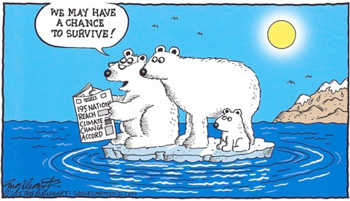1. Introduction

The document under study is a **pho**to(graph)/an ad**ver**tisement = an **ad**vert = an ad for … /an awareness campaign /a **pain**ting /a **draw**ing /a **ske**tch /a car**toon** /a **co**mic strip /a **mu**ral /

a **ma**gazine **co**ver/ a book **co**ver…

entitled “…” and released / published by / drawn by / created by / painted by a cartoonist / a painter / an artist… called …

It is extracted from. . . / It was taken from… / It appeared in… (a newspaper/ a magazine…) on… (december 1st, 2020) in ... (december, 2020).

It deals with Global warming.

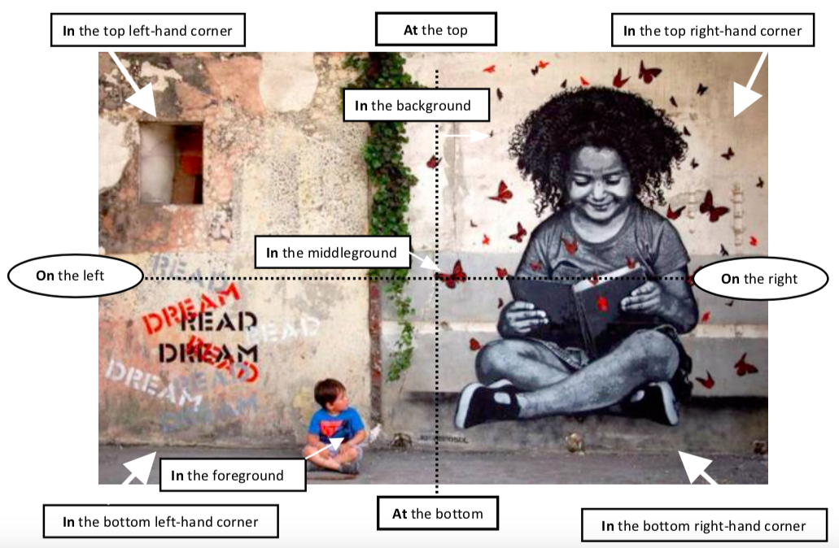

2. Describe the scene (place, characters, clothes, details…)

The scene takes place in/at/ near…. (a place)

We can see … + position (ex: on the left, in the background…)

* 💣 Emploi du présent en BE+ -ing!

S(he) is reading / sitting / lying / talking / having a rest / waiting for…

3. Recap what you understand (read the speech bubbles…)

+ talk about the characters’ attitude and explain what is happening or what has just happened…

He/ She/ **looks** + adjective They **look** + adjective

delighted ecstatic upset shocked appalled

amazed worried puzzled uneasy guilty

comfortable ashamed desperate proud

because / since ( puisque)…

4. What is the author’s goal? (= aim = purpose)

He aims at criticizing denouncing informing sending a message

warning promoting highlighting raising awareness of…

**DON’T FORGET TO USE LINKING WORDS** such as:

Firstly, then, after, on the one hand, on the other hand, moreover, however, whereas, therefore, indeed, even though, instead of, thanks to, to conclude…