**AXE 5: FICTIONS & REALITIES** **GUNS in the USA: Delusion or necessity?**

**KEY QUESTIONS: Are Americans safe?**

**Why do Americans feel the need to own a gun?**

**What is the social cost of gun ownership?**

**MISSION 1: BRAINSTORMING**

**What do you know about guns in the USA?**

Guns in the USA :

Consequences:

**MISSION 2 : THE II AMENDMENT**

1. Say what the picture shows.
2. What does the II Amendment say ?

It says that the Militia and the US citizens …

This right should…

**TO INFRINGE A RULE** =

3. Explain what a « militia is » ?

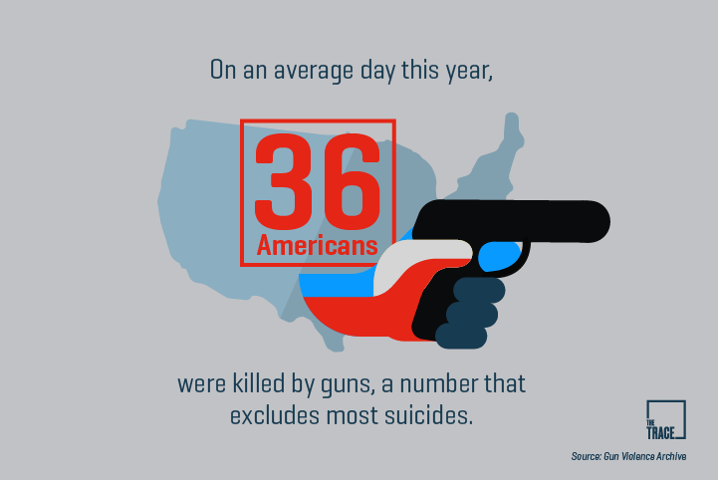4. Fill in the blanks with the right figures :

**100,000 – 20 times - one million – 30,000**

The firearms homicide rate in the US is **______________** higher than in other rich countries.

On average, more than **_________________** people are shot each year and **________________** of them die.

More than **___________________** people in the US have been killed with a gun since 1968, when Dr Martin Luther King Jr was assassinated.

**MISSION 3: The NRA, a very powerful lobby**

Listen to the recording and report about the National Rifle Association of America (NRA):

* a definition
* what they want.
* what they provide
* their arguments (3 arguments)
* what they do to counterbalance (compenser) their position
* their mode of action

**MISSION 4:** **On your own**

**Gun crime statistics**

1. say what the statistics show

2. explain the goal of this poster

RECAP : Complete the following text with the given words

**anybody / patriotic / awareness campaign / murdered by / easy access /**

**ashamed / on the other hand / God Bless America / higher rate / aims at /**

**notice / American flag / less than / pointing out / ironical /**

This poster shows the number of people _______________ guns in one year in various countries around the world. We can _______________ that most countries have ___________________a hundred gun murders a year. The US,________________ , has an incredibly ___________________ with nearly 10,000 people murdered with guns every year.

In the middle of this ______________________ , we can see a handgun with the colours of the ____________________ and the slogan “_________________”. Considering the statistics, we understand that this slogan is ___________________because the poster shows nothing to be _____________about. On the contrary, these numbers reveal that the US should be _______________and try to change things.

This campaign obviously ________________ fighting gun violence in America by ____________________the high gun murder rate in the US in contrast with other countries around the world. It might denounce the ______________ to guns in the country and the fact that ______________ can walk into a store and get a gun.