Chris Gilmour, a cardboard artist (born 1973)

**Before watching: 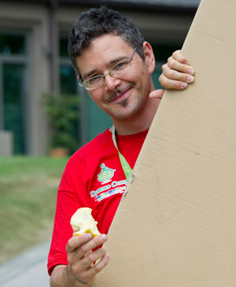Read this introduction aloud and try to find the equivalent sentence in English**

/krɪs Gilmour ɪz ə ˈbrɪtɪʃ ˈskʌlptə beɪst ɪn ˈɪtəli. Gilmour ɪz nəʊn fɔː hɪz

ˈskʌlpʧəz ðæt juːz ˈkɑːdbɔːd tuː ˈrekrɪeɪt ˈevrɪdeɪ ˈɒbʤɪkts ɪn ˈlaɪfˈsaɪzd skeɪl

ænd huː dʌz nɒt juːz ˈeni səˈpɔːtɪŋ freɪmz, wʊd ɔː ˈmetl./

He replicates cars, mopeds and bicycles as **painstakingly** (= …………………) detailed cardboard sculptures.

**Part 1: Watch, listen and complete or answer the questions…** (from 0.00 to 1.00)

What contrasts does he talk about?

1. Contrast between …………………..…………..and very……………………………………………………………objects.
2. Contrast between ………………………………… and a big, ………………….……………object, machine or car…

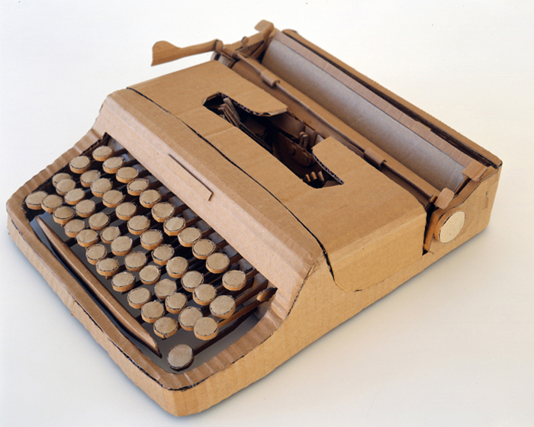Working on cardboard is for him, a game between l………………………... and s…………………………

**Part 2: His sculptures (from 1.00 to 2.05)**

TIME SPENT:

NUMBER OF PIECES:

Do people buy his artworks?

TYPES OF SCULPTURES:

METHOD USED: 1st: He **…………………** the **…………………………**of the original.

2nd: He **…………………** the **……………………..** with his **……………………..** knife.

3rd: He **………………….** the separate pieces with **…………………….. .**

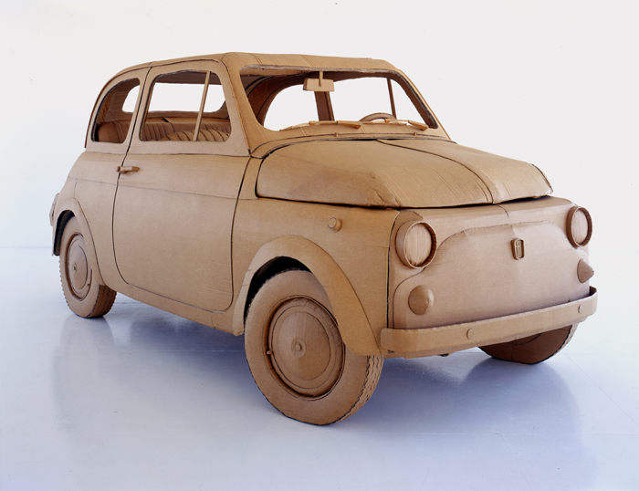**Part 3: His inspiration (2.05 to 2.35)**

Where did he study?

How come did he start using cardboard?

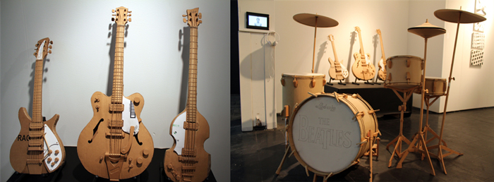

**Part 4: AND NOW (from 2.35 to the end)**

What has changed in his sculptures now?

Why does he use this new technique?