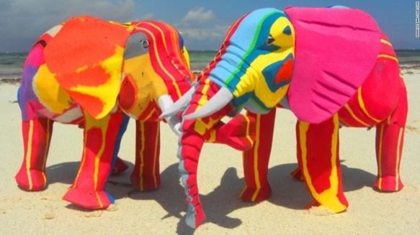**FROM TRASH TO ART**

**MISSION 1: EXPLORE**

1. Look at the photo on the right and imagine what these animals are made of?
2. Complete the following sentences with materials

* 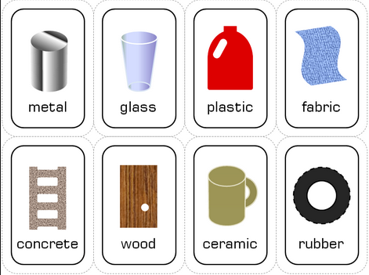Car tyres are made of …
* A window pane is made of …
* A cup of coffee is made of …
* The pavements are made of …
* A bottle of water is made of …
* A door is made of …
* Shoes are made of …

1. Fill in the blanks with one of the following verbs:

***scratch – break – stretch – bend – squash – soak up***

When something is:

a) flexible, you can ____________ or _______________it.

b) hard, you can't ____________ or ______________it.

c) absorbant, it ________________ water.

d) brittle, you can easily ________________ it.

1. Talking about materials. Find the corresponding French equivalents:

|  |  |  |  |  |
| --- | --- | --- | --- | --- |
| **flexible** | **elastic** | **bending** | **malleable** | **solid** |
|  |  |  |  |  |
| **stiff** | **hard** | **inelastic** | **firm** | **soft** |
|  |  |  |  |  |

**MISSION 2: VIDEO TIME: Kenya’s flipflop recycling company**

1. Watch the video, check your hypotheses and pick out more information about the project.

**Focus on:**

* The type of artwork:
* The material used:
* The origin of the project:

1. Reorder the different steps of the project and use the verbs to rephrase the process.

n° … carve / n° … collect / n° … glue  /. n° … sell / n° … wash

1. Focus on the places mentioned and say what they correspond to:

PARIS

NAIROBI

INDONESIA

AMERICA

1. Comment on the impact of the project

* In the country:
* Abroad:

1. Explain who Dan Wambui is and how he feels about the project?