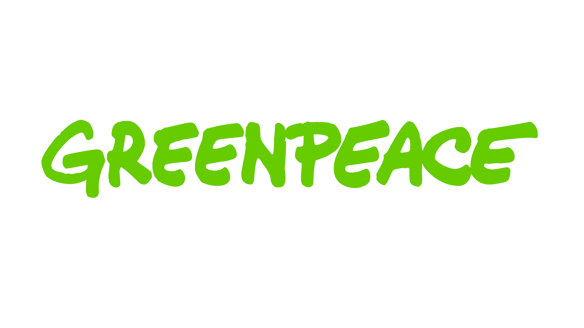

*Greenpeace is an independent global campaigning organization, founded in Canada in 1971 by a group of environmental activists.*

*Turtle Journey* ‘Turtle Journey’ shows us why we urgently need to protect the oceans’

Will McCallum , 17 January 2020

Greenpeace UK __________________ a powerful ______________________ about ocean destruction, working with Aardman Animations and Oscar-winning actors.

Climate __________________, plastic, __________________and overfishing have driven our oceans to a __________________, but it’s a story that doesn’t get told often enough.

Which is why we’ve worked with Aardman Animations (the makers of Wallace and Gromit and Shaun the Sheep) to create a __________________ short film revealing the __________________ our oceans are facing, and the importance of protecting them.

The film – titled Turtle Journey – directed by Aardman’s Gavin Strange, tells the ______________ story of an __________________ turtle family __________________ get home, in an ocean that is under __________________ pressure from climate change, plastic __________________, __________________ and__________________.

**The** __________________ **of sea turtles represents the suffering of our oceans as a whole**

Like the family in Turtle Journey, sea turtles in real life are under __________________from __________________ industries. Six out of the seven sea turtle __________________ are __________________extinction due to the pressures of multiple ocean threats.

__________________, it’s more than just turtles at risk. In fact, studies have shown that marine life is __________________ at twice the speed of life on land.

Our oceans face __________________ from all angles. Climate breakdown is causing the oceans to __________________ and __________________, which is disrupting food __________________ for marine life and __________________ ecosystems. Overfishing, oil drilling, plastic pollution and destructive industries are then adding more pressures on an already __________________ and __________________ ocean.

**The oceans affect all of us**

__________________ our oceans is about more than just __________________. Ocean life plays a __________________ role! Protecting the oceans and __________________ a safe home for marine life is a crucial piece in the puzzle in fighting the __________________, and in _________________ a safer future for all of us.

“The story of this turtle family trying to get home in a damaged and changing ocean is a reality for so many marine creatures that are having their __________________destroyed by human activities. I hope this film inspires more people to __________________ to protect our oceans.”  
– Olivia Colman

We can save our oceans, but we need people to know that they’re in crisis. Help us __________________ by watching the video and sharing with your friends!