BREAKING AMISH Meet Bates

**TASK 1: Vocabulary to find and remember**

Try to find the English equivalents for these words. Task 2 can help you.

|  |  |  |  |
| --- | --- | --- | --- |
| être rejeté, mis de côté |  | accomplir |  |
| se soumettre à, respecter |  | s’adapter, appartenir à |  |
| Je ne supporte pas… |  | prendre les choses en main |  |
| en avoir marre de |  | un paria |  |
| mériter |  | une grange |  |
| mettre quelqu’un à la porte |  | nauséabond |  |

**TASK 2: Read and complete the following summary of Bates’ life.**

Focus on Bates’ living conditions, feelings and how he ended up living like this. Sum up Bates’ story and say what he wants to do.

**Mohawk comply with**

**consequently made of straw bales a 21-year-old**

**was shunned by an ex-Amish does not deserve**

**a barn can’t stand it bare necessities**

**except for take matters in hand foul-smelling**

**after having partied has never had an outcast**

**kicked him out to fit in, to belong to fulfil (UK), fulfill (US) has had enough of living**

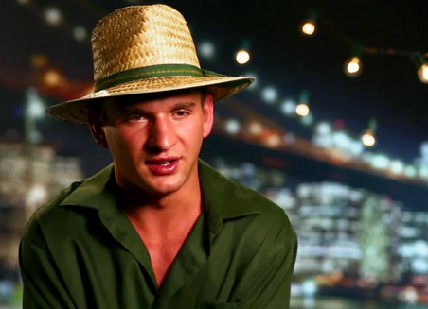Bates is _____________________ Amish boy who _____________________ among the Amish community. His authoritarian parents _____________________ of their house because he did not _____________________ the Amish rules.

One day, _____________________ with friends and drunk, he came back home with a new haircut: a _____________. _____________________, he _____________________ his own parents!

As a result, he has to live in _____________________ with only the _____________________ and no comfort _____________________ a rudimentary bed _____________________ and a sheet. He tells us he _____________________ to live like an animal in this _____________________ barn. He feels like _____________________ among his own family, yet, he is determined to _____________________ and get out of his community to live with his girlfriend who is _____________________, and _____________________ his dream. He says he _____________________ the feeling _____________________ to the Amish community and he _____________________ any longer.

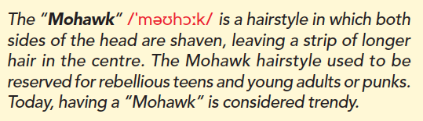

**TASK 3: Do you understand Bate’s reactions ? Why (not)?** Justify your answer.