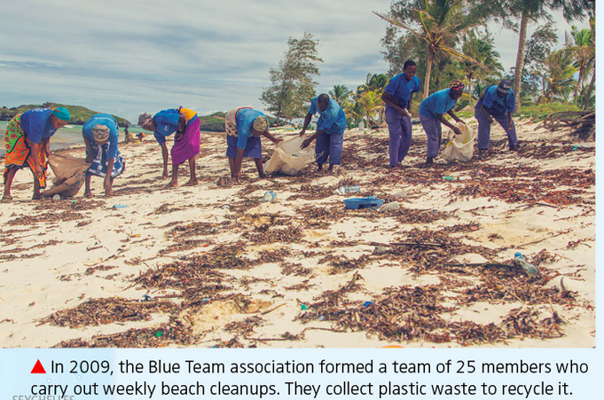**MISSION 3: The Blue Team Association**

**Document C: A photo**

* Type of document?
* Describe it
* Talk about the Blue Team association and its goal.

**MISSION 4: READING COMPREHENSION**

Lis et essaie de répondre aux questions suivantes en français :

**PART 1 :**

Quels sont les 3 objectifs de l’association « The Blue Team » ?

Qu’est-ce que cette association a fait en 2015 ? Pourquoi ?

**PART 2 :**

Quel problème rencontrent les tortues de mer ?

Que leur arrive-t-il de dramatique ? Sois précis.

**PART 3 :**

Quel impact le plastique a-t-il sur les coraux ?

**CONCLUSION :**

Quels sont les 2 problèmes majeurs évoqués dans la conclusion ?

Pour quelles raisons le tourisme est-il important au Kenya ?

**PART 1: Taking Action -**In Watamu we are making a difference by fighting back a tide of waste. The Blue Team is Kenya's answer to recycling waste, promoting health and increasing the community wealth.

The 25 Blue Team members carry out weekly beach clean-ups and work to keep the village roadsides free of rubbish. They are mostly sponsored by local hotels and businesses which sustain their operations.

In September 2015 we collected 3,124 kg of marine debris from our beaches to preserve sea turtle nesting areas.

**PART 2: The threat - Non-biodegradable waste in the form of marine debris is polluting our Marine Park beaches and threatening vulnerable marine life.**

Plastic bags and materials are ingested by endangered sea turtles who mistake them for jellyfish which are part of their natural diet.

The turtles eventually die due to internal problems and starvation due to the gut being blocked.

**PART 3: Plastics are also ingested by cetaceans (dolphins and whales).**

Whales, dolphins and whale sharks can all be found in Watamu waters. Plastics smother corals and other marine creatures living on the sea bed, inhibiting them from breathing and feeding and resulting in loss of health or death.

**CONCLUSION:** The impact of solid waste is deteriorating our local environment resulting in threats to human health and welfare and potentially discouraging tourists from visiting the area. The latter is a serious concern as many coastal communities depend on tourism as their primary source of income and employment.

## 