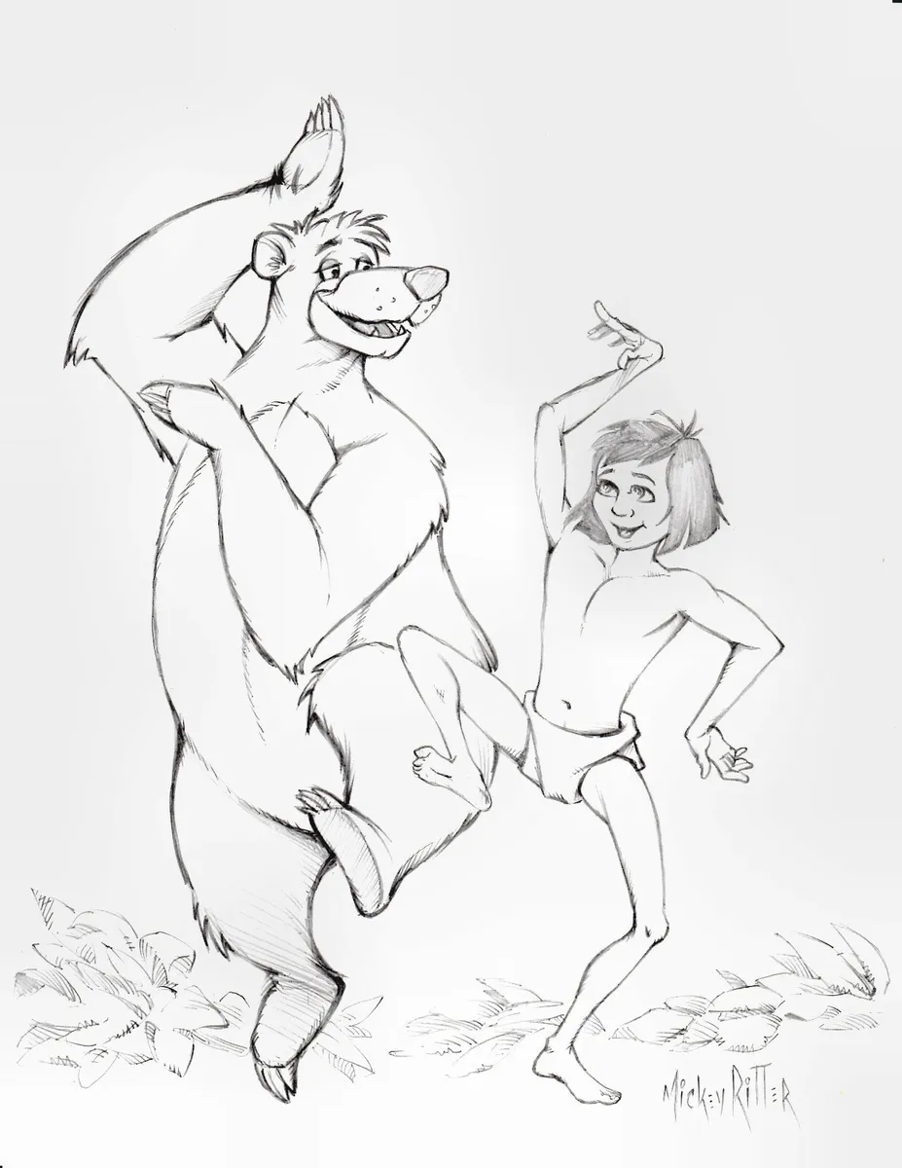
Look for the bare necessities
CHORUS:
Look for the bare necessities
The simple bare necessities
Forget about your worries and your strife
I mean the bare necessities
Old Mother Nature's recipes
That bring the bare necessities of life
---------------------------------------
Wherever I wander, wherever I roam
I couldn't be fonder of my big home
The bees are buzzin' in the tree
To make some honey just for me
When you look under the rocks and plants
And take a glance at the fancy ants
Then maybe try a few
The bare necessities =

A strife =

To wander =

To roam =

To take a glance at =

To tickle =
[Interlude 1]
(You eat ants!?)
Haha, you better believe it
and you're going to love the way they tickle
(Mowgli, look out!)
The bare necessities of life will come to you
They'll come to you!
----------------CHORUS-------------------
a pawpaw =

a paw =

a prickly pear =

to prick =

to pick =

raw =

a claw =
(1.18) Now when you pick a pawpaw
Or a prickly pear
And you prick a raw paw
Next time beware
Don't pick the prickly pear by the paw
When you pick a pear
Try to use the claw
But you don't need to use the claw
When you pick a pair of the big pawpaw
Have I given you a clue?

