(adapted from) A Day in the Life of a Film Editor
The Princeton Review, May 2021 (source: https://www.princetonreview.com)
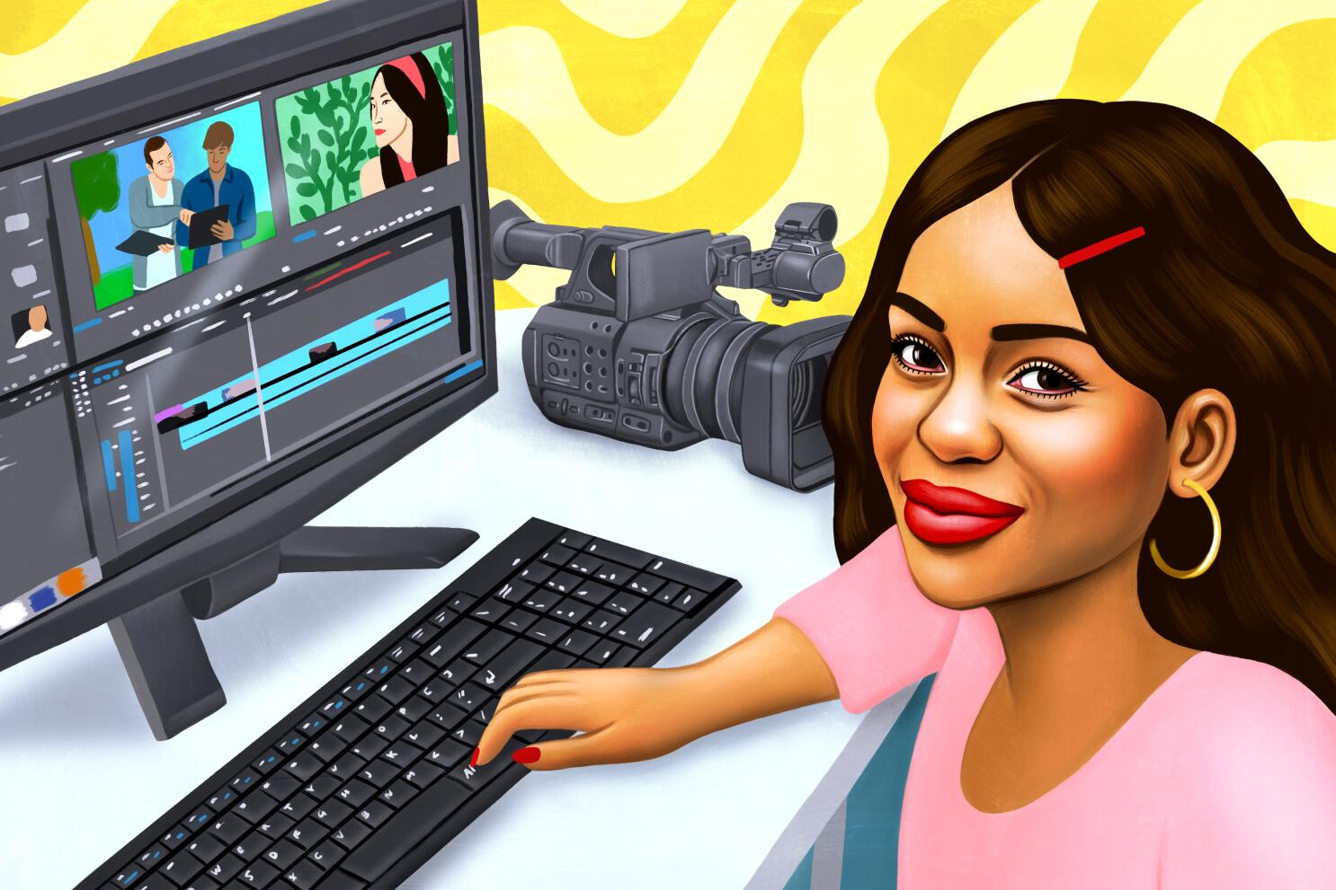
Expressions

To steer away
remuer
détourner

To pay your dues
Faire ses preuves
Payer ses factures

For all intents and purposes
dans les faits
dans le but de

Plain sailing
du gâteau, de tout repos
de la voile
Play with words

Read from line 1 to 11 and find the equivalent words in the article:

a)a section of film or video that's been shot or recorded =

b)smooth and continuous, with no apparent gaps or spaces between one part and the next =

c)make minor changes so as to improve or clarify =

d) moderate or average =

e) to offer, to give = to lend
1  5  10  15  20  25  30  35  40 | Film editors assemble footage of feature films, television shows, documentaries, and industrials into a seamless end product. They manipulate plot, score, sound, and graphics to refine the overall story into a continuous and enjoyable whole. On some films, the film editor is chosen before cast members and script doctors; people in Hollywood recognize that the skills of a good film editor can save a middling film. In the same way directors use certain actors they appreciate over and over again, they also use film editors they know and are comfortable with. Building relationships lends stability to a film editor’s life; otherwise, they must be prepared to submit video resume after video resume, in the struggle to get work.  Like most industries, the film industry has embraced new technology. Assistant editors must now have strong computer skills to work in the industry. While some editors stay removed from the project during the filming process so as not to steer the director away from his or her concept of the film, many of them do visit the director on set while production is under way. Nevertheless, the majority of a film editor’s work is done alone. Despite that solitude, interpersonal skills are just as important as endurance is in an editor’s career. Film editors work closely with sound editors and musical directors as the film nears completion. Long hours and significant isolation while actually editing can make even the most positive-minded film editor question the career choice. But an interesting, well-edited film can restore faith in the profession.  Film editors need extensive academic and professional experience. Standard coursework should include filmographies, basic editing, and commercial editing. Some aspiring editors may take directorial courses and direct plays or films; this training typically proves helpful in the working world. They should also work as interns, production assistants, or animation-editing assistants while in graduate school. Once out of school, editors usually work in the production field or for an established film editor for little money.  People who want to pay their dues and become independent, self-supporting film editors take note: 4–10 years of on-the-job training before making enough connections, building up a significant body of work, and being able to start your own editing service is more than common. For the most part, it’s the only way to succeed in this profession.  In 1980, the average feature film had one film editor assigned to it, and that person, for all intents and purposes, exerted as much influence over the final product as the director of the film did. Now, with the increasing complexity of film editing, graphic overlays, computer animation sequences, and rising budgets, an average of nine editors are attached to each feature film. Editors will continue to enjoy strong demand for qualified professionals who produce quality work. Editors who have ability and a willingness to work with others will be rewarded with good jobs.
A Day in the Life of a Film Editor Show you understand

- Introduce the document.

- Say if the following statements are true or false and highlight (yellow colour) your choices by quoting the article.
a. Film editors only mechanically put pieces of a film together.
True False.

b. Film editors are among the last crew members to be recruited.
True False
c. Failing to build up a network of contacts means anxiously waiting for job offers all your working life.
True False
d. Working long hours on one’s own can prove difficult and disheartening.
True False
e. On-the-job training is an unnecessary step to become an independent film editor.
True False

- Highlight (in green) the elements showing that …
a. Experience is a key factor in film editing.
b. becoming a successful editor is not all plain sailing.
c. working in the production field is a necessary step.
d. film editors need to be comfortable with new technology.
e. your editing skills, once recognised, will ensure a stable and regular job.

- Your opinion: Answer the following questions in complete sentences.
a. Why do film editors work closely with sound editors and musical editors mainly when the film nears completion?

b. To what extent is it acceptable for film editors to visit producers on set?

c. In your opinion, why are there up to 9 film editors working on a project today when only one was necessary in the 1980s?

