SOUND EFFECTS IN COMICS AND GRAPHIC NOVELS?

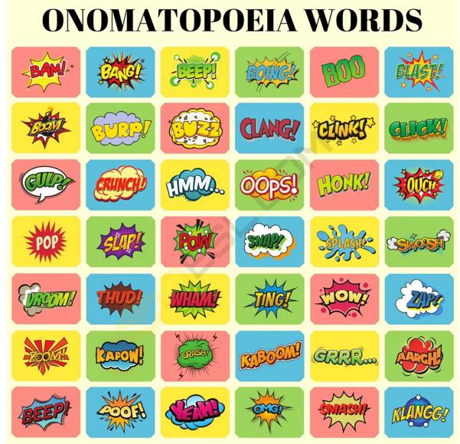
You can think of onomatopoeia /ˌɒnəmætəˈpiːə/ almost like a sound effect. For example, the word sizzle (= ____________) is a form of onomatopoeia because the sound that the word makes actually sounds like a sizzle.
Many onomatopoeic words fall into groups depending on what it is they are describing, for example, words such as splash (= __________), drip (= ________________), drizzle (= _____________________) and can all be used to describe water and therefore are grouped together.
These words can give a more detailed description of an item or a situation by actually allowing the listener to hear the sound of what is being talked about.
MISSION 1: find the onomatopoeia corresponding to the definitions
An explosion =
A car signal =
Something heavy landing on the ground =
Something vibrating =
Gas leaking =
Evoking sudden disappearance =
A shattered window =
A door closing strongly =
Drop into water =
You are homesick =
You feel disappointed =
You feel pain =
After meals. Very bad manners =
Eating greedily =
You didn’t mean to do something wrong, but you did =
English | French
Slurp
Splash!
Thump!
Poof!
Ouch!
Oops!
Hiss
buzz
Sigh!
Sniff
Smash!
Wham!
Bang!
Honk!
Burp

MISSION 2: Fill the gaps. Find the odd one.
crunch twang
splash scratch chatter
buzz
pop
squeak
sizzle

My cat often purrs when I _________________ his tummy.
The corn went _________________ in the microwave.
I heard the _________________ of the sausages in the pan.
My teeth _________________ each time I stand freezing in the snow.
The leaves _________________ under my feet as I walk through the woods.
The mouse made a _________________as it skittered across the floor.
The guitar goes _________________ when you pluck the strings.
The bees _________________ through the air.

