CO What is a graphic novel?
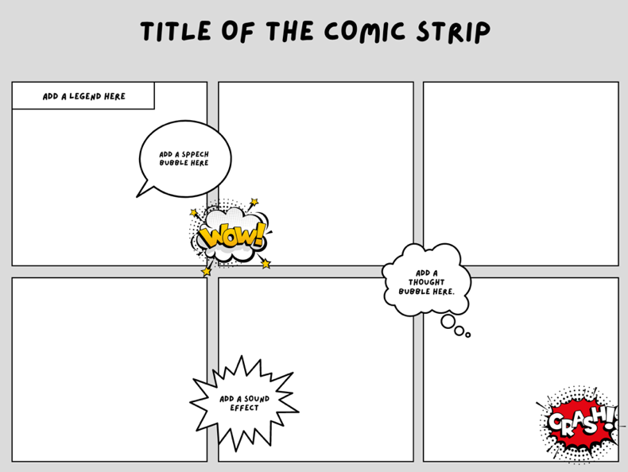
Listen and complete:

A graphic novel tells a story in a ___________
________________. Basically, it’s just another way to tell a story.
Graphic novels are ___________________ on their own. They can ___________________any genre, fiction, non-fiction, history, fantasy… Any genre can be made into a graphic novel.
Graphic novel is ___________________, not a genre.
In other words, the term “graphic novel” describes HOW a book content is put together.

What does a graphic novel actually look like?
Authors and illustrators who create graphic novels tell their stories in ___________________ or ___________________.
They use ___________________to communicate dialogue between characters.
___________________ follow the sequence of ___________________ and the story has a beginning middle and end.
When you read a graphic novel, you ___________________just like you would when you read a chapter book or a picture book. You read from ___________________and ___________________.

Elements in a graphic novel

The ___________________ of a graphic novel is very important. Instead of long paragraphs of text like a chapter book, graphic novels ___________________.

The frames are the ___________________or segments that contain the illustrations and text.

In between the frames are the ___________________. The gutters are just the ___________________ that separate the frames.

When the creator of a graphic novel wants to show dialogue between characters, they use ___________________________. This is a way to visually show which character is speaking.

___________________are used to show what a character ___________________rather than what they’re ___________________.

Sometimes, a story calls for some ___________________. Instead of using speech bubbles, the illustrator might use ___________________or ___________________ to describe what a certain scene might sound like.

Other times, a scene might need ___________________than what the characters are saying in their dialogue. The author might choose to ___________________to fill in the gaps and help the reader understand what’s happening in the story.

