CO HISTORY OF COMIC BOOKS & GRAPHIC NOVELS

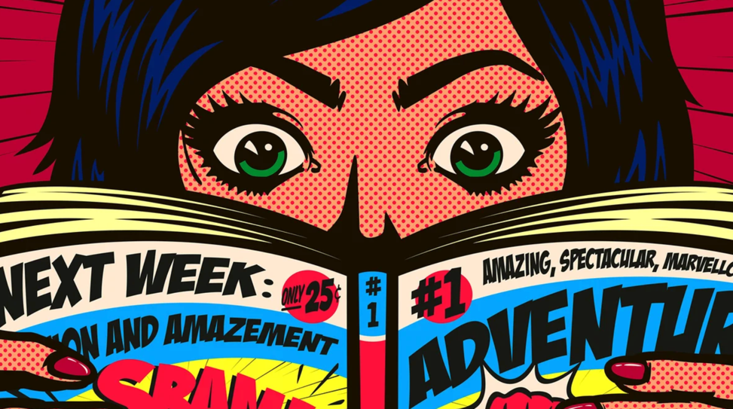

PART 1: From 0.33 to 2.14

Listen and the try to fill the missing information

- In Ancient Egypt: Egyptians already ______________________ (= ) over a thousand images called ______________________ to communicate and represent ideas.

- In Medieval European times: ______________________ told stories through scenes depicted on ______________________ (= ) textiles.

- The Mass production of paper allowed ______________________to emerge.

- The First American example of a comic strip was called ______________________by Richard Outcault who ______________________ the comic _____ (= ) political and social commentary.

19_ _: Famous Funnies was a collection of serialized newspaper strips into a book format which was ______________________ (= ) by many historians as being the first comic book even though this collection included reprintings.

19_ _: THE______________________AGE
Listen and get information

PART 2: from 2.14 to 2.52

What happened? What do you learn about horror comics?

PART 3: from 2.53 to 3.43

19_ _: THE ______________________ AGE

PART 4: from 3.44 to 4.43

19_ _’s: THE ______________________ ERA

Two big publishers, MARVEL and DC _________________________________ (= )
They battled for ______________________ (= )
Their characters appeared on :
-
-
-

Graphic novels: longer works which are sometimes printed comic story arcs of many featured original unseen material.
This longer form allowed for more _____________________________ and the ____________________ often won ______________________ awards.

19_ _’s: The comic book artists grew in popularity and it allowed them to ______________________ _________________________ (unseen before in this industry).
Todd Mc Farlane, Jim Lee, Rob Liefeld and Jim Valentino formed their own company IMAGE and ______________________ (= ) the comic book world.

PART 5: from 4.44 to the end

The comic book took new shape in ______________________.
Most of the comics we read are now made into films.
Ex: ____________________________ used comic books as a source of inspiration

