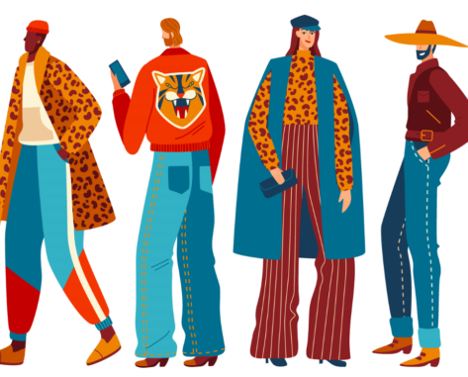
Clothes, jewels and accessories

Je sais dire ce que je porte aujourd’hui ( PRESENT BE + -ING)
Today, I’m wearing black jeans, silver trainers,
a white blouse and jewels.

Remember: 1. L’adjectif se place avant le nom.
Ex : un t-shirt rouge = a red t-shirt
2. je dois mettre le déterminant a ou an devant un nom au singulier.
Ex : un pull noir = a black jumper
un pull orange = an orange jumper
3. je ne dois pas mettre de déterminant devant les noms au pluriel ( ex : trousers, jeans, shorts… sont toujours au pluriel !)
Ex : un pantalon blanc = white trousers
un jean bleu = blue jeans

Je sais dire ce que mon/ma meilleur(e) ami(e) porte aujourd’hui
Today, he/she is wearing a white shirt, blue jeans, green and red trainers and sunglasses

a blouse = ________________
a blouson = ________________
a bonnet = ________________
a bracelet = ________________
a cap = ________________
a coat = ________________
a dress = ________________
a hat = ________________
a jacket = ________________
a jumper = ________________
a necklace = ________________
a ring = ________________
a scarf = ________________
a shirt = ________________
a skirt = ________________
a suit = ________________
a sweater = ________________
a sweatshirt = ________________
a tee-shirt = ________________
a tie = ________________
a tracksuit = ________________
a watch = ________________
boots = ________________
earrings = ________________
glasses = ________________
gloves = ________________
jeans = ________________
shoes = ________________
silver = ________________
sneakers (U.S) = ________________
socks = ________________
tights = ________________
trainers (G.B) = ________________
trousers = ________________

