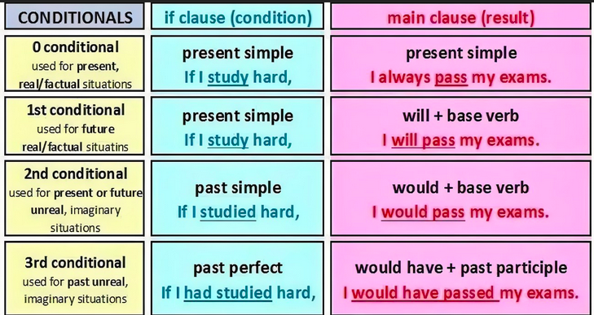

Conditional Sentences All types

Fill in the correct tense

1. The towns _________________________ (not/be destroy) if the volcano hadn’t been so destructive.
2. If the inhabitants ________________ (evacuate) early enough, the terrible disaster would have been averted.
3. If the weather is gloomy, we _______________ (stay) in the hotel and read.
4. If I heard a loud, shrill, frightening noise while at the beach, I _______________ (return) to the hotel immediately.
5. A tsunami would be set off, if a nearly volcano _________________ (erupt).
6. If the curious children and adults hadn’t gone on the beach to investigate the strange sound, they _____________________ (lose) their lives.
7. The disaster wouldn’t have been so terrible, if all the hotels ______________________ (prepare) for the possibility of a tsunami.
8. If you want to be safe during a tsunami, you ___________________ (move) miles inland.
9. When the sea draws back it means that a tsunami ___________________ (come) soon.
10. Many lives would have been saved, if the guest at the hotel ______________ (take) precautions.
11. If there is a serious tsunami, the coastline __________________ (be) damaged.
12. If the scientists who had observed the ash from volcano had alerted the nearby countries, the extent of the disaster ___________________ (be) much less.
13. If there were strong winds along with a tsunami, there _________________ (be) tremendous damage to the coastline.
14. If scientists predict tsunamis, they __________________ (save) many lives.