**CARTOON CHARACTERS Superlatives and comparatives**

Complete the descriptions with comparatives or superlatives

Velma is __________________________(short) person in the gang but she is __________________________ (intelligent), as well. Daphne is _________________________ (fashionable) and ___________________________ (slim) than Velma. She is also _____________________________ (wealthy) person in “Mystery Inc.” Shaggy is _________________________________ (tall) person in the team and he is also ________________________ (funny) one. Fred is ____________________________ (brave) and _______________________ (strong) than Shaggy.

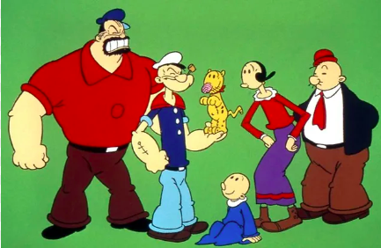

Brutus is ___________________ (big) and ____________________ (nasty) person in the group. Popeye is ______________________ (short) than Brutus but he is ______________________________ (strong) man in town. Swee’pea is ________________________ (young) in the picture. Olive is ____________________________ (thin) than Wimpy. He is _________________________________ (fat) and _________________________________ (lazy) than Popeye.

Homer is ____________________________ (old) person in the family while Maggie is ___________________________ (young). Lisa is _____________________________________ (smart) than Bart but he is ___________________________ (funny) than she is. Bart is ___________________________ (tall) than his sisters. Marge is ________________________ (intelligent) than her husband.

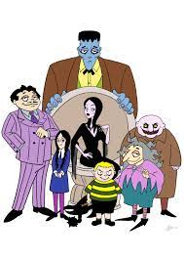

Gomez Addams is _________________________________ (handsome) than his brother Fester. Granny is _________________________________ (ugly) than Morticia and she is the _________________________________ (old) person in the family. Lurch is _____________________ (strong) and _________________________________ (tall) than Gomez. Uncle Fester is _______________________ (fat) person in the family and he is ________________ (short) than his brother. Wednesday’s hair is ____________________ (long) than Pugsley’s and she is ____________________________ (thin) than her brother.