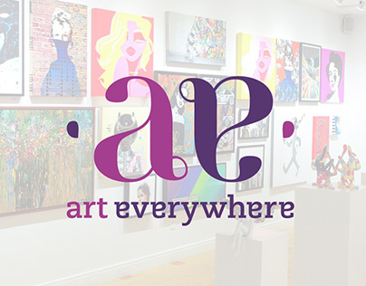
CO THE ART EVERYWHERE PROJECT

1st LISTENING

MISSION 1: List the adjectives you hear at the beginning.

-
-
-
-

MISSION 2: Fill the information

Type of document:
Protagonists, who?
Where?
When?
What?
Tone used:
Target audience:

2nd and 3rd listenings

TESTIMONIES

Guy with a yellow safety vest
1st reaction:
2nd reaction:
Conclusion:

Marc Sands (Tate Galleries) = he is likely to be a _ _ _ _ _ _ _.
Opinion:
Implicit:

Richard Reed, founder of Art Everywhere

Cornelia Parker (Artist)
Opinion:
GB : /mjuːˈziːəm/ US) : /mjuˈziəm/
Mood:

Sir Peter Blake (Artist)
“It’s _______________ there, they’re ________________ it and I hope __________________ it!”

Young woman with a yellow safety belt

Mark Sands (again)

Goals of this video report?
-
-
-
-

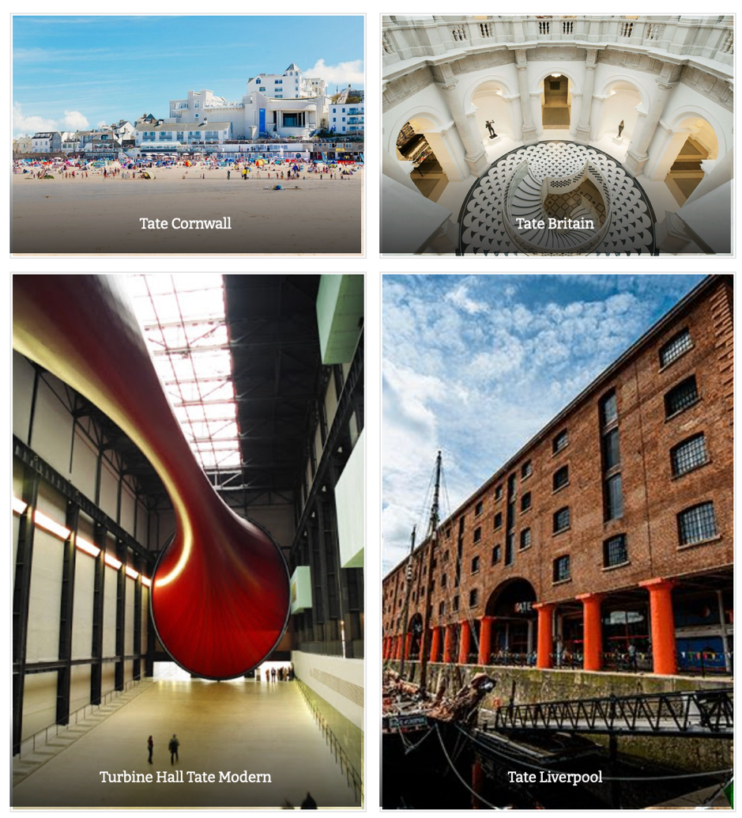
EXTRA INFORMATION:

There isn’t only one Tate gallery.
There are in fact four:
- two in London (Tate Britain and Tate Modern)
- one in Liverpool
- the fourth in St. Ives, Cornwall.

Tate Britain is the permanent collection of British paintings, sculptures and prints.
Tate Modern is one of the largest museums of modern art in the world.

Given the choice, which Tate would you visit first? Why?

