**READING COMPREHENSION The Importance Of Music In Films**

**PART 1:**

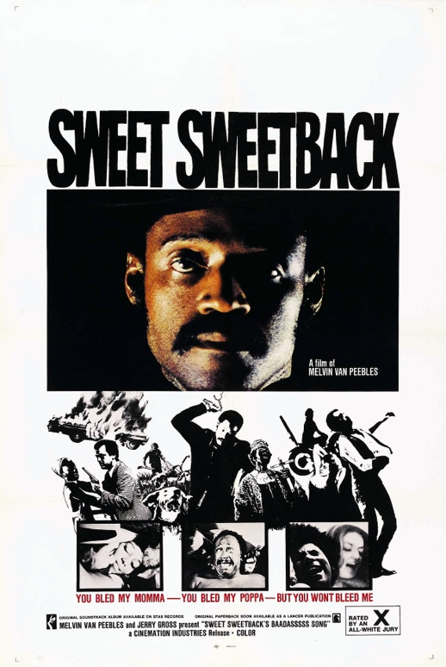**MISSION 1: Discuss these statements in pairs. What do they have in common?**

“***Music Is Half The Film”***

Matthew Vaughn (English filmmaker: *X-men: First Class, 2011*)

***“Where words fail, music speaks.”***

Hans Christian Andersen (Danish master of the literary fairy tale: *The Little Mermaid*)

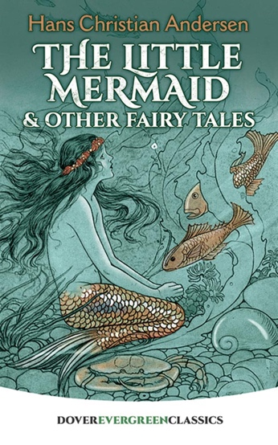

***“Music or sound in a film is a character as important as another character”***

Melvin Van Peebles (American actor, filmmaker, writer and composer)

The three men **…**

**MISSION 2: Read the first paragraph and find the words corresponding to these definitions or synonyms**

1. the action of providing or being provided with amusement or enjoyment =
2. feeling of unease or awkwardness =
3. stirring, stimulating =
4. succeed in persuading or leading someone to do something or think something =

**MISSION 3: Recap the main point in this paragraph by finishing the following prompts:**

Music and films go …………………………………………………. .

They are ………………………….…………………………………………………………………………………. to the storytelling process.

A movie without a score or a soundtrack would be:

* …………………………………………………… (inefficace),
* …………………………………………………… (qui perd de l’intensité),
* …………………………………………………… (vide de sens),
* …………………………………………………… (sans âme),
* …………………………………………………… (insipide, ennuyeux),
* …………………………………………………… (vide)

**PART 2 : So what does music do in a film?**

Read the rest of the article and find the corresponding verbs.

* …………………… the audience.
* …………………… and creates emotions.
* …………………… a rhythm to scenes and segments.
* …………………… our perception.
* …………………… the overall mood and narrative of a film.
* …………………… depth to the visuals.
* …………………… the emotions related to visuals.
* …………………… storytelling.
* …………………… an emotional chord with the audience.
* …………………… the audience connect with the character.
* …………………… in setting the mood and the scene of a film.
* …………………… the tone.
* …………………… the audience in the right direction.
* …………………… a plot relationship.
* …………………… to understand characters.
* …………………… sequences.
* …………………… contradictions.
* …………………… and …………… the audience.
* …………………… life to the story.
* …………………… the action in a film.

**SPEAKING TIME: Speak for about 30 seconds in pairs.**

**WHAT ABOUT YOU?**

**What movie score or soundtrack has stirred** /ˈstɜːrd/**, affected you the most and why?**

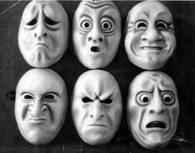To cause a stir =

To stir up trouble =

To stir up public interest =