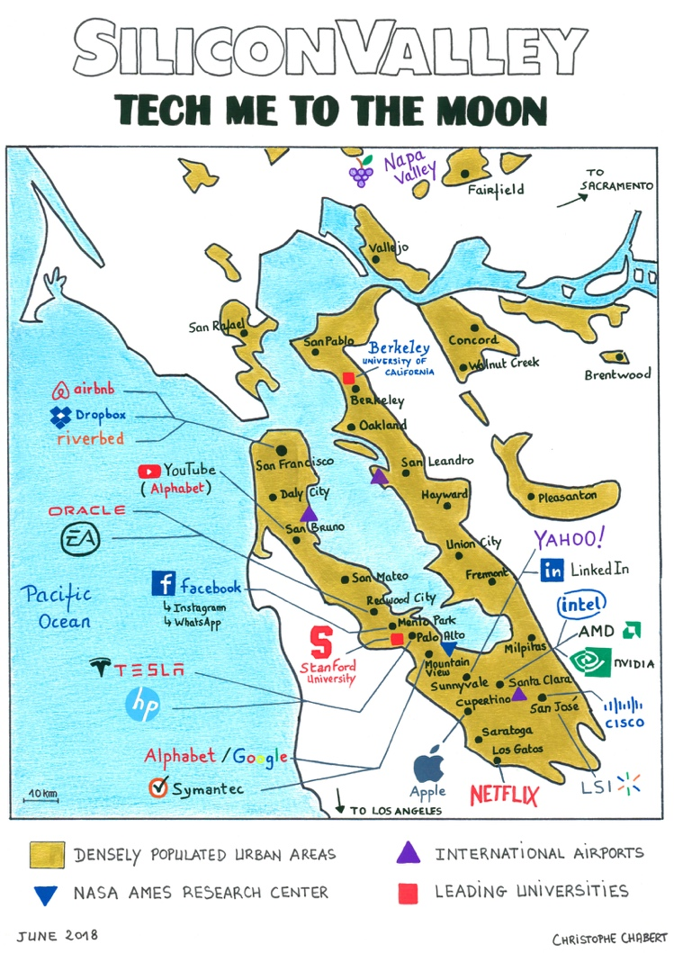**LISTENING COMPREHENSION**

**WELCOME TO SILICON VALLEY**

**Mission 1: Complete with adjectives from the video**

__________________ San Francisco Bay

__________________ Pacific Ocean coastline

__________________ Silicon Valley

__________________ climate

__________________ real estate

__________________ higher-learning institutions

__________________ hub for high-tech innovation

__________________ culture

__________________ quality of life for international families and individuals

__________________ beaches

__________________mountain ranges

__________________ area

__________________ population of immigrants from Europe, Asia & other parts of the world

__________________ high-quality lifestyle options

**Mission 2: Make comparatives or superlatives**

Today, Silicon Valley is (rich) ______________ & (powerful) __________________________ than ever. It’s one of (dynamic) ___________ __________________________ places on earth and one of (beautiful) ______________ __________________________ and exclusive places in the USA to live in.

Silicon Valley is also (innovative) _______________________________ place on earth since it is the home of technology. It is also renowned for having (good) ________ universities in the world.