CO KEY GRIP ( = )

PART 1 : ROLE ( from 0.37 )

Position:
Role, missions: Responsible for…

- CAMERA POSITION (1.02)

Grips are in charge of …

- Name the different RIGS (= ) where cameras can be attached to:
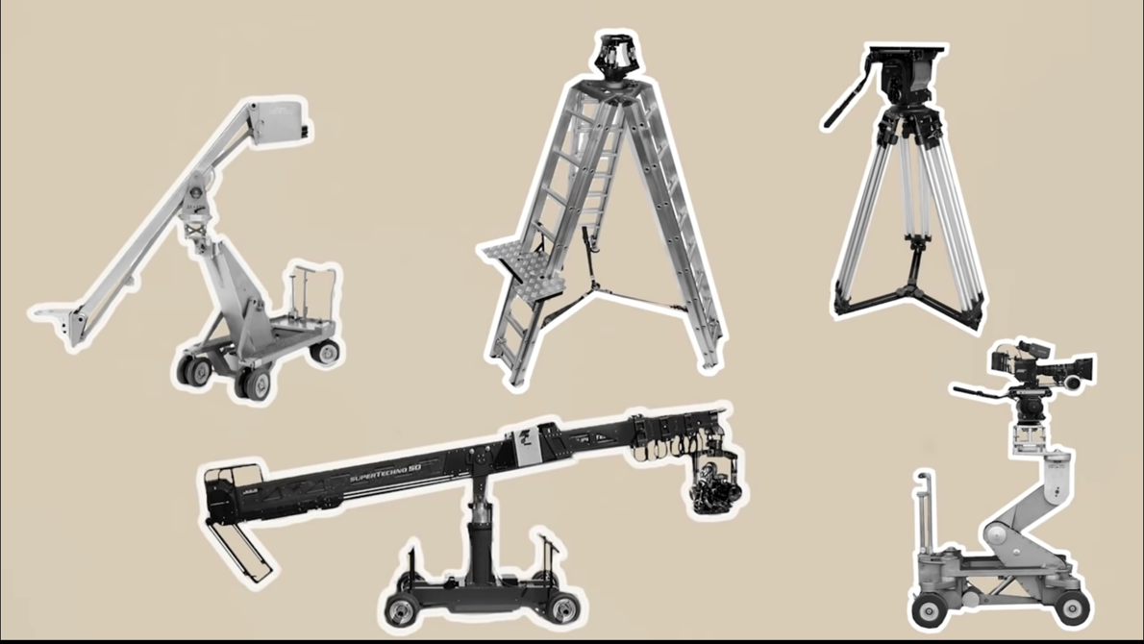

- Cameras can also be mounted (or set up) on objects like:

- RIGGING (1.37) (montage, installation)
Their mission depends on …
In the USA, grips are expected to …
In other countries like South Africa …
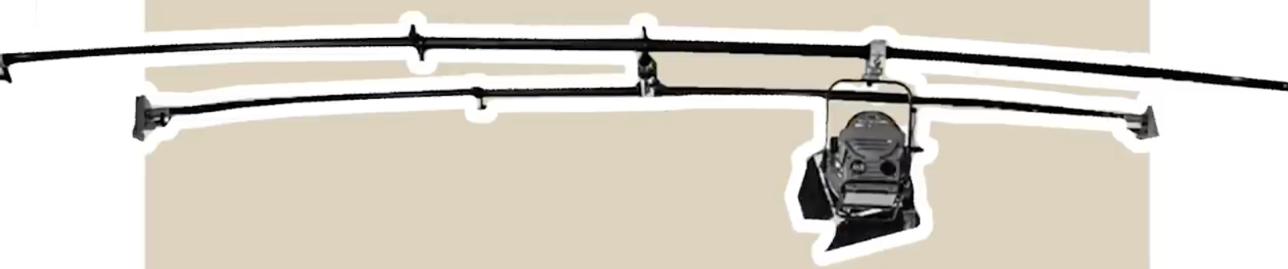

The key grips also have to SECURE the rig above which is called a _ _ _ _ _ _ _ .
Also called autopoles, they are sturdy ( = ) lighting supports made from extendable metal tubes that wedge (= ) between two walls or between floor and a wall or ceiling to provide mountings (= ) for lights.

- SAFETY (2.27)

Listen and complete the missing information:

Grips also have to _________________ the safety of a _________________or the people ______________ for complicated shots, difficult___________________or placing crew or ___________________ on film equipment.
Having an ___________________ grip on the crew is important in this regard to ___________________ that most importantly there are no ___________________ or ___________________ to property, sets or ___________________ (= ).

What do rental companies insist upon?

Use one adjective to qualify the role of the key grip:
Explain:

FROM 3.22 to 4.16 Advertisement for MILANOTE, a platform to help you schedule a project.

PART 2: AVERAGE DAY ON SET

Your mission AT HOME: Listen from 4.20 to 7.00 and list 5 things that the key grip has to do in this section.

-
-
-
-
-

PART 3: TIPS (from 7.04 to the end)

In this section, discover tips to be time-saving and not time-consuming when shooting a movie.

- Be ready to explain at least one of them in the oral.
- Name the following equipment.
