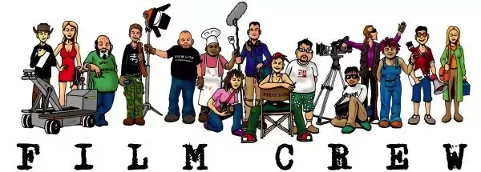
CREW POSITIONS

In addition to the director, screenwriter, line producer,
and executive producers whose work carries over from
preproduction into the production process, there are many jobs
on the film production team. Read and guess who’s who?
___________________________________

He is the head of the wardrobe department. In collaboration with the director, he crafts the creative drive behind all clothing that the audience sees on screen.

___________________________________

He reports directly to the film's director and oversees all visual artistic and design elements of a film, from set design to costumes to hair and makeup to props. The Art director is his second-in-command.
___________________________________

He casts, supervises stunt performers, designs and supervises all on-set stunts in collaboration with the director and the DP.
___________________________________

He is responsible for planning makeup designs for the leading and supporting cast, including special effects makeup or prosthetic work, and hiring assistants to recreate these looks on the rest of the cast.
___________________________________

He furnishes the set created by the set designer, oversees a swing crew that includes on-set dressers, a leadman (the head set dresser), and a greensman (in charge of living plant material).
___________________________________

They report to both the director and the production manager. Their job is to handle logistics and keep things running smoothly for the director.
1st AD : Organizes the crew and ensures that the film comes in on schedule.
2nd AD : Helps the 1st AD supervise the set and also manages and hands out important documents such as scripts and call sheets. Depending on the size of the crew, there may even be a 3rd AD.

___________________________________

He is in charge of creating character hairstyle designs and styling actors’ hair on set. He works in both film and television and are an integral part of the entertainment industry.

___________________________________

Also known as a cinematographer, he is in charge of all camerawork and commands a large crew.
___________________________________
He works under the line producer and is the chief administrator of all film crew positions. He may be called to deal with an array of challenges, but the UPM is primarily concerned with the management of all cost-related decisions.

___________________________________

They may work in any department. They often acquire specialized skills in managing paperwork and handling certain budgetary elements. As such, working as an Office PA is an excellent segue into working in one of the other production department film crew positions.

___________________________________

In charge of finding and keeping track of all the props that appear on screen to add authenticity.

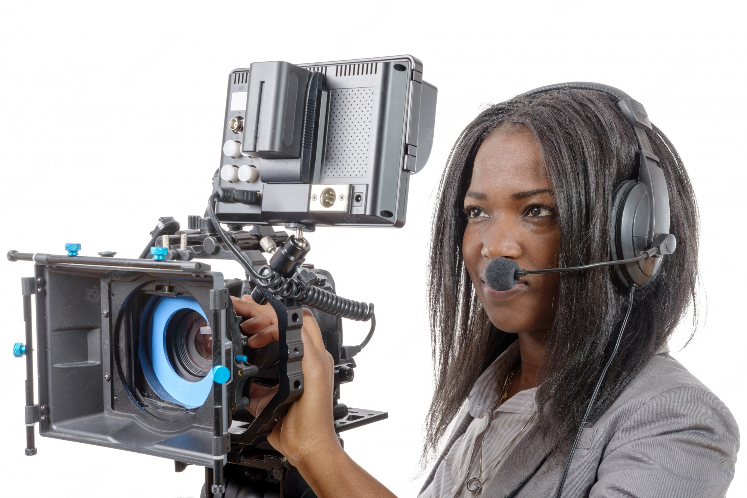
___________________________________

He is the chief lighting technician of a film and works very closely with the director of photography. Actually, he is responsible for the design of a production's lighting plan.
___________________________________

He holds the boom microphone and is responsible for mic (or mike) placement and movement during filming. He also has to make sure the mic doesn’t show up in the shot. On smaller sets, the production sound mixer might do this job.
___________________________________

He ensures the sound is properly recorded and mixed on set. He also selects microphones, operates sound recording devices, and sometimes mixes audio signals.
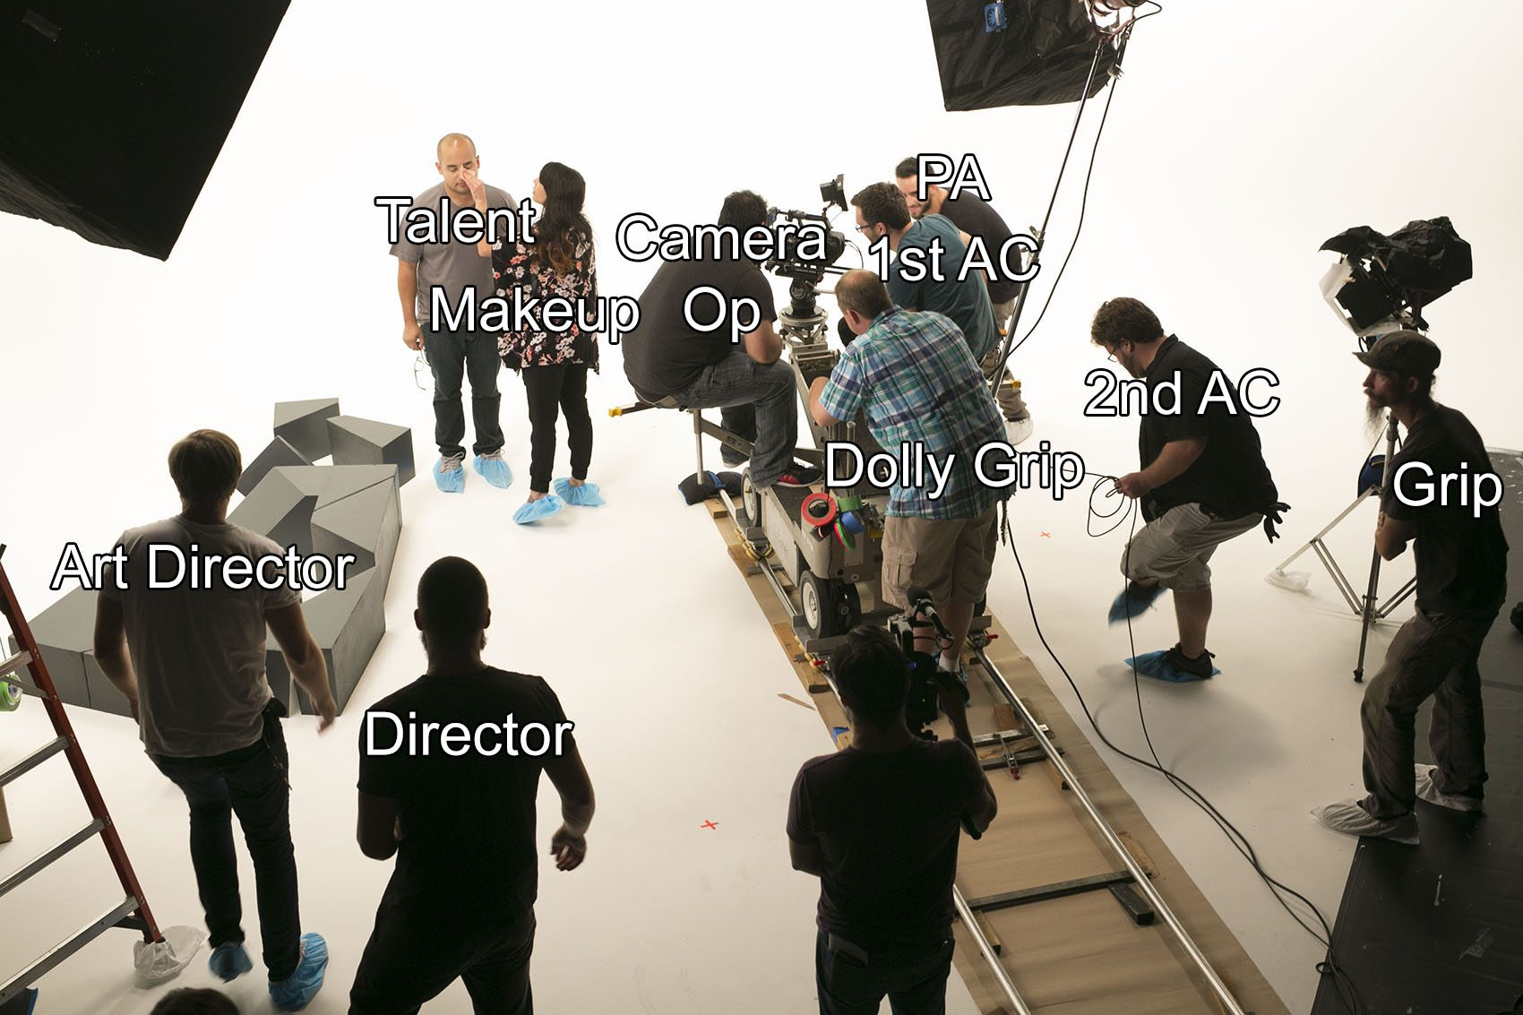
___________________________________

He is the chief in charge of grips on set. He oversees the grip department, which sets up lighting and electrical rigging on a film set, working in concert with cinematographers and gaffers.
Grips are technicians who move and set up non-electrical equipment—such as flags, overheads, and bounces—in coordination with the lighting department.

___________________________________

He works under a DP and executes shots that the director and DP call for and frame.
He works with:
- the first assistant camera, the 1st AC (who ensures every shot is clear and in focus, also called the focus puller)
- the second assistant camera, the 2nd AC (who in charge of the slate, shot number, take number and holds it in front of the camera before each shot.

___________________________________

They are lead-assistants to the gaffer or key grip. They typically specialize in logistics thus, are responsible for the electric truck, rentals, staffing, and other electrical issues.
___________________________________

He specializes in camera dollies and crane shots and is responsible for the movement and placement of dollies, cranes and other heavy equipment on which cameras and camera operators are placed.
CREW POSITIONS
___________________________________

Using an arsenal of props, he devises and records the everyday sounds heard in films, television shows, and video games—noises like footsteps, a sword being drawn from a sheath, or the swishing of clothing as two people walk past each other.

___________________________________

He assembles footage of feature films, television shows, documentaries, and industrials into a seamless end product. He manipulates plot, score, sound, and graphics to refine the overall story into a continuous and enjoyable whole.

___________________________________

He oversees both creative and technical elements for the special or visual effects on a project (such as fire or puppetry—and captured in camera).
Visual effects are added in post-production, such as computer-generated imagery.

